英语 2018年高三试卷
英语
考试时间：____分钟
题型 | 单选题 | 简答题 | 阅读理解 | 书面表达 | 总分
得分

单选题 （本大题共15小题，每小题____分，共____分。）
1.第一节单项填空(共15小题;每小题1分,共15分)
从每题所给的A、B、C、D四个选中,选出可以填入空白处的最佳选项,
并在答题卡上:将该项涂黑。
-Hi,
-I'm Peter. Are you new here? I haven't seen you around？
-Hello, Peter. I'm Bob. I just＿＿on Monday.
A. start
B. have started
C. started
D. had started
2. ＿＿we don't stop climate change, many animals and plants in the world will be gone.
A. Although
B. While
C. If
D. Until
3. ＿＿along the old Silk Road is an interesting and rewarding experience
A. Travel
B. Traveling
C. Having traveled
D. Traveled
4. Susan had quit her well-paid job and ＿＿as a volunteer in the neighborhood. when I visited her last year
A. is working
B. was working
C. has worked
D. had worked
5. She and her family bicycle to work, helps them keep fit
A. which
B. who
C. as
D. that
6. During the Mid-Autumn Festival, family members often gather together＿＿a meal, admire the moon and enjoy moon cakes.
A. share
B. to share
C. having shared
D. shared
7. China's high-speed railways from 9,000 to 25,000 kilometers in the past
few years.
A. are growing
B. have grown
C. will grow
D. had grown
8. In any unsafe situation, simply＿＿the button and a highly-trained agent will get you the help you need.
A. press
B. to press
C. pressing
D. pressed
9. A rescue worker risked his life saving two tourists who＿＿in the mountains for two days.
A. are trapping
B. have been trapped
C. were trapping
D. had been trapped
10. Ordinary soap, ＿＿correctly, can deal with bacteria effectively.
A. used
B. to use
C. using
D. use
11. Without his support, we wouldn't be＿＿we are now.
A. how
B. when
C. where
D. why
12. In today's information age, the loss of data＿＿cause serious problems for a company.
A. need
B. should
C. can
D. must
13. They might have found a better hotel if they＿＿a few more kilometers.
A. drove
B. would drive
C. were to drive
D. had driven
14.-Good morning, Mr. lee's office.
-Good morning. I'd like to make an appointment＿＿next Wednesday afternoon.
A. for
B. on
C. in
D. at
15. This is＿＿my father has taught me-to always face difficulties and hope for the best.
A. how
B. which
C. the
D. what
简答题（综合题） （本大题共1小题，每小题____分，共____分。）
第二节 完形填空（共20小题；每小题1.5分，共30分）
阅读下面短文，掌握其大意，从每题所给的A、B、C、D四个选项中,选出最佳选项，并在答题卡上将该项涂黑。
The Homeless Hero
For many，finding an unattended wallet filled with £400 in cash would be a source（来源）of temptation（诱惑）.But the____ would no doubt be greater if you were living on the streets with little food and money. All of this makes the actions of the homeless Tom Smith____more remarkable.
After spotting a ____ on the front seat inside a parked car with its window down，he stood guard in the rain for about two hours waiting for the ____ to return.
After hours in the cold and wet, he ____ inside and pulled the wallet out hoping to find some ID so he could contact（联系）the driver， only to____it contained £400 in notes，with another £50 in spare change beside it.
He then took the wallet to a nearby police station after ____ a note behind to let the owner know it was safe. When the car’s owner John Anderson and his colleague Carol Lawrence returned to the car-which was itself worth £35，000—in Glasgow city centre， they were ____ to find two policemen standing next to it. The policemen told them what Mr. Smith did and that the wallet was ____.
The pair were later able to thank Mr. Smith for his____ .
Mr. Anderson said：“"I couldn’t believe that the guy never took a penny. To think he is sleeping on the streets tonight____ he could have stolen the money and paid for a place to stay in. This guy has nothing and ____he didn't take the wallet for himself；he thought about others ____ it’s unbelievable. It just proves there are ____ guys out there.”
Mr. smith’s act ____ much of the public’s attention. He also won praise from social media users after Mr. Anderson ____ about the act of kindness on Facebook.
=Now Mr. Anderson has set up an online campaign to____money for
Mr. Smith and other homeless people in the area, which by yesterday had received ￡8,000. “I think the faith that everyone has shown____him has touched him. People have been approaching him in the street; he's ha I job____and all sorts, ”Mr. Anderson commented.
For Mr. Smith, this is a possible life-changing____. The story once again tells us that one good turn deserves another.
16.A. hope
B. aim
C. urge
D. effort
17.A. still
B. even
C. ever
D. once
18.A. wallet
B. bag
C. box
D. parcel
19.A. partner
B. colleague
C. owner
D. policeman
20.A. turned
B. hid
C. stepped
D. reached
21.A. discover
B. collect
C. check
D. believe
22.A. taking
B. leaving
C. reading
D. writing
23.A. satisfied
B. excited
C. amused
D. shocked
24.A. safe
B. missing
C. found
D. seen
25.A. service
B. support
C. kindness
D. encouragement
26.A. when
B. if
C. where
D. because
27.A. rather
B. yet
C. already
D. just
28.A. too
B. though
C. again
D. instead
29.A. honest
B. polite
C. rich
D. generous
30.A. gave
B. paid
C. cast
D. drew
31.A. learned
B. posted
C. cared
D. heard
32.A. borrow
B. raise
C. save
D. earn
33.A. of
B. at
C. for
D. in
34.A. details
B. changes
C. offers
D. applications
35.A. lesson
B. adventure
C. chance
D. challenge
阅读理解 （本大题共小题，每小题____分，共____分。）
第一节(共15小题:每小题2分,共30分)
阅读下列短文,从每题所给的A、B、C、D四个选项中,选出最仁选项,并
在答题卡上将该项涂黑。
A
My First Marathon(马拉松)
A month before my first marathon, one of my ankles was injured and this meant not running for two weeks, leaving me only two weeks to train. Yet, I was determined to go ahead.
I remember back to my 7th year in school. In my first P.E. class, the teacher required us to run laps and then hit a softball. I didn't do either well. He later informed me that I was“ not athletic”.
The idea that I was "not athletic" stuck with me for years. When I started running in my 30s，I realized running was a battle against myself, not about competition or whether or not I was athletic. It was all about the battle against my own body and mind. A test of wills!
The night before my marathon, I dreamt that I couldn't even find the finish line. I woke up sweating and nervous, but ready to prove something to myself.
Shortly after crossing the start line, my shoe laces (鞋带)became untied. So I stopped to readjust. Not the start I wanted！
At mile3, I passed a sign:“ GO FOR IT, RUNNERS!”
By mile 17, I became out of breath and the once injured ankle hurt badly. Despite the pain, I stayed the course walking a bit and then running again.
By mile 21, I was starving！
As I approached mile 23, I could see my wife waving a sign. She is my biggest fan. She never minded the alarm clock sounding at 4 a.m. or questioned my expenses on running.
I was one of the final runners to finish. But I finished! And I got a medal. In fact, I got the same medal as the one that the guy who came in first place had.
Determined to be myself,, move forward, free of shame and worldly labels(世俗标签)， I can now call myself a "marathon winner”.
36. A month before the marathon, the author____.
A. was well trained
B. felt scared
C. made up his mind to run
D. Lost hope
37. Why did the author mention the P.E. class in his 7th year?
A. To acknowledge the support of his teacher.
B. To amuse the readers with a funny story.
C. To show he was not talented in sports.
D. To share a precious memory.
38. How was the author's first marathon?
A. He made it.
B. He quit halfway.
C. He got the first prize.
D. He walked to the end.
39. What does the story mainly tell us?
A. A man owes his success to his family support.
B. A winner is one with a great effort of will.
C. Failure is the mother of success.
D. One is never too old to learn.
B
Find Your Adventure at the Space and Aviation (航空)Center
If you're looking for a unique adventure, the Space and Aviation Center(SAC)is the place to be. The Center offers programs designed to challenge and inspire with hands-on tasks and lots of fun.
More than 750,000 have graduated from SAC, with many seeking employment in engineering, aviation, education, medicine and a wide variety of other professions. They come to camp, wanting to know what it is like to be an astronaut or a pilot, and they leave with real-world applications for what they're studying in the classroom.
For the trainees，the programs also offer a great way
to earn merit badges(荣誉徽章). At Space Camp, trainees can earn their Space Exploration badge as they build and fire model rockets, learn about space tasks and try simulated (模拟) flying to space with the crew from all over the world. The Aviation Challenge program gives trainees the chance to earn their Aviation badge. They learn the principles of flight and test their operating skills in the cockpit(驾驶舱)of a variety of flight simulators. Trainees also get a good start on their Wilderness Survival badge as they learn about water-and
land-survival through designed tasks and their search and rescue of “downed" pilot.
With all the programs, teamwork is key as trainees learn the importance of leadership and being part of a bigger task.
All this fun is available for ages 9 to 18. Families can enjoy the experience together, too, with Family Camp programs for families with children as young as 7.
Stay an hour or stay a week--there is something here for everyone!
For more details，please visit us online at www.oursac.com.
40. Why do people come to SAC?
A. To experience adventures.
B. To look for jobs in aviation.
C. To get a degree in engineering.
D. To learn more about medicine.
41. To earn a Space Exploration badge, a trainee needs to____.
A. fly to space.
B. get an Aviation badge first.
C. study the principles of flight.
D. build and fire model rockets.
42. What is the most important for trainees?
A. Leadership.
B. Team spirit.
C. Task planning.
D. Survival skills.
C
Plastic-Eating Worms
Humans produce more than 300 million tons of plastic every year. Almost half of that winds up in landfills(垃圾填埋场)， and up to 12 million tons pollute the oceans. qSo far there is no effective way to get rid of it, but a new study suggests an answer may lie in the stomachs of some hungry worms.
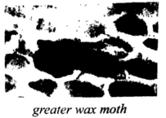
Researchers in Spain and England recently found that the worms of the greater wax moth can break down polyethylene, which accounts for 40% of plastics. The team left 100 wax worms on a commercial polyethylene shopping bag for 12 hours, and the worms consumed and broke down about 92 milligrams, or almost 3% of it. To confirm that the worms' chewing alone was not responsible for the polyethylene breakdown, the
researchers made some worms into paste(糊状物) and applied it to plastic films. 14 hours later the films had lost 13% of their mass--apparently broken down by enzymes(酶)from the worms' stomachs. Their findings were published in Current Biology in 2017.
Federica Bertocchini, co-author of the study, says the worms' ability to break down their everyday food-beeswax--also allows them to break down plastic "Wax is a complex mixture, but the basic bond in polyethylene, the carbon-carbon bond, is there
as well, "she explains. "The wax worm evolved a method or system to break this bond. "
Jennifer Debruyn, a microbiologist at the University of Tennessee, who was not involved in the study, says it is not surprising that such worms can break down polyethylene. But compared with previous studies, she finds the speed of breaking down in this one exciting. The next step, DeBruyn says, will be to identify the cause of the breakdown. Is it an enzyme produced by the worm itself or by its gut microbes(肠道微生物)?
Bertocchini agrees and hopes her team’s findings might one day help employ the enzyme to break down plastics in landfills. But she expects using the chemical in some kind of industrial process-not simply "millions of worms thrown on top of the plastic.”
43. What can we learn about the worms in the study?
A. They take plastics as their everyday food.
B. They are newly evolved creatures.
C. They can consume plastics.
D. They wind up in landfills.
44. According to Jennifer DeBruyn, the next step of the study is to____.
A. identify other means of the breakdown
B. find out the source of the enzyme
C. confirm the research findings
D. increase the breakdown speed
45. It can be inferred from the last paragraph that the chemical might____.
A. help to raise worms
B. help make plastic bags
C. be used to clean the oceans
D. be produced in factories in future
46. What is the main purpose of the passage?
A. To explain a study method on worms.
B. To introduce the diet of a special worm.
C. To present a way to break down plastics.
D. To propose new means to keep eco-balance.
D
Preparing Cities for Robot Cars
The possibility of self-driving robot cars has often seemed like a futurist's dream, years away from materializing in the real world. Well, the future is apparently now. The California Department of Motor Vehicles began giving permits in April for companies to test truly self-driving cars on public roads. The state also cleared the way for companies to sell or rent out self-driving cars, and for companies to operate driverless taxi services. California, it should be noted, isn't leading the way here. Companies have been testing their vehicles in cities across the country. It's hard to predict when
driverless cars will be everywhere on our roads. But however long it takes, the technology has the potential to change our transportation systems and our cities, for better or for worse, depending on how the transformation is regulated.
While much of the debate so far has been focused on the safety of driverless cars(and rightfully so), policymakers also should be talking about how self-driving vehicles can help reduce traffic jams, cut emissions(排放) and offer more convenient, affordable
mobility options. The arrival of driverless vehicles is a chance to make sure that those vehicles are environmentally friendly and more shared.
Do we want to copy- or even worsen- the traffic of today with driverless cars? Imagine a future where most adults own individual self-driving vehicles. They tolerate long, slow journeys to and from work on packed highways because they can work, entertain themselves or sleep on the ride, which encourages urban spread. They take their driverless car to an appointment and set the empty vehicle to circle the building to avoid paying for parking. Instead of walking a few blocks to pick up a child or the dry cleaning, they send the self-driving minibus. The convenience even leads fewer people to take public transport——an unwelcome side effect researchers have already found in ride- hailing(叫车) services.
A study from the University of California at Davis suggested that replacing petrol-powered private cars worldwide with electric, self-driving and shared systems could reduce carbon emissions from transportation 80% and cut the cost of transportation infrastructure
(基础设施) and operations40%by2050. Fewer emissions and cheaper travel sound pretty appealing. The first commercially available driverless cars will almost certainly be ____ by ride-hailing services, considering the cost of self-driving technology as well as liability and maintenance issues(责任与维护问题).But driverless car ownership could increase as the prices drop and more people become comfortable with the technology.
Policymakers should start thinking now about how to make sure the appearance of driverless vehicles doesn't extend the worst aspects of the car-controlled transportation system we have today. The coming technological advancement presents a chance for cities and states to develop transportation systems designed to move more people，and
more affordably. The car of the future is coming. We just have to plan for it.
47. According to the author，attention should be paid to how driverless cars can__________.
A. help deal with transportation-related problems
B. provide better services to customers
C. cause damage to our environment
D. make some people lose jobs
48. As for driverless cars，what is the author's major concern？
A. Safety.
B. Side effects.
C. Affordability.
D. Management.
49. What does the underlined word “fielded” in Paragraph 4 probably mean？
A. Employed.
B. Replaced.
C. Shared.
D. Reduced.
50. What is the author's attitude to the future of self-driving cars？
A. Doubtful.
B. Positive.
C. Disapproving.
D. Sympathetic
51.第二节（共5小题；每小题2分，共10分）
根据短文内容，从短文后的七个选项中选出能填入空白处的最佳选项。选项中有两项为多余选项。
Why Do We Get Angry？
Anger seems simple when we are feeling it， but the causes of anger are various. Knowing these causes can make us examine our behavior，and correct bad habits. The main reasons we get angry are triggering（触发）events，personality traits（特征），and our assessment of situations.____
Triggering events for anger are so many that to describe them all would take hundreds of pages. However, here are some examples: being cut off in traffic, a deadline approaching, experiencing physical pain, and much more.____ The reason why someone is triggered by something and others are not is often due to one's personal history and psychological traits.
Each person. no matter who they are, has psychological imbalances. People who have personality traits that conncct with competitiveness and low upset tolerance are much more likely to get angry.____ Also, sometimes pre-anger does not have to do with a lasting condition, but rather a temporary state before a triggering event has occurred.
____Sometimes even routine occurrences become sources of pre-anger, or anger itself. Sometimes ignorance and negative (消极的)outlooks on situations can create anger.
____However, anger can easily turn violent, and it is best to know the reasons for anger to appear in order to prevent its presence. With these main reasons in mind, we can evaluate our level of anger throughout the day and prevent cases of outbursts by comprehending the reasons for our feelings.
A. Our attitude and viewpoint on situations can create anger within us as well.
B. But some types of situations can help us to get rid of the occurrence of anger.
C. Anger is rarely looked upon as a beneficial character trait, and is usually advised to reduce it.
D. Anger is a particularly strong feeling and maybe people think that they have reasons to feel angry.
E. Having these personality traits implies the pre-anger state, where anger is in the background of your mind.
F. Understanding these reasons will control our own anger if we are willing to evaluate ourselves with a critical eye.
G. Not everyone acts the same in response to events, and that is why what triggers one person may or may not trigger another.
书面表达 （本大题共____分。）
56.第一节(15分)
假设你是红星中学高三学生李华,你的英国朋友Jim在给你的邮件中提到他
对中国文化感兴趣,计划明年来北京上大学。他向你咨询相关信息。请给他回邮件,内容包括:
1表示欢迎；
2推荐他上哪所大学;
3建议他做哪些准备工作。
注意:1词数不少于50；
2开头和结尾已给出,不计入总词数。
Dear Jim，
___________________________________________________________________________________________________________________________________________________________________________________________________
Yours
Li Hua
书面表达 （本大题共____分。）
57.第二节(20分)
假设你是红星中学高三学生李华,请根据以下四幅图的先后顺序,写一篇英
文周记,记述你们上周接待外国学生,带领他们体验中国茶文化的全过程。
注意:词数不少于60。
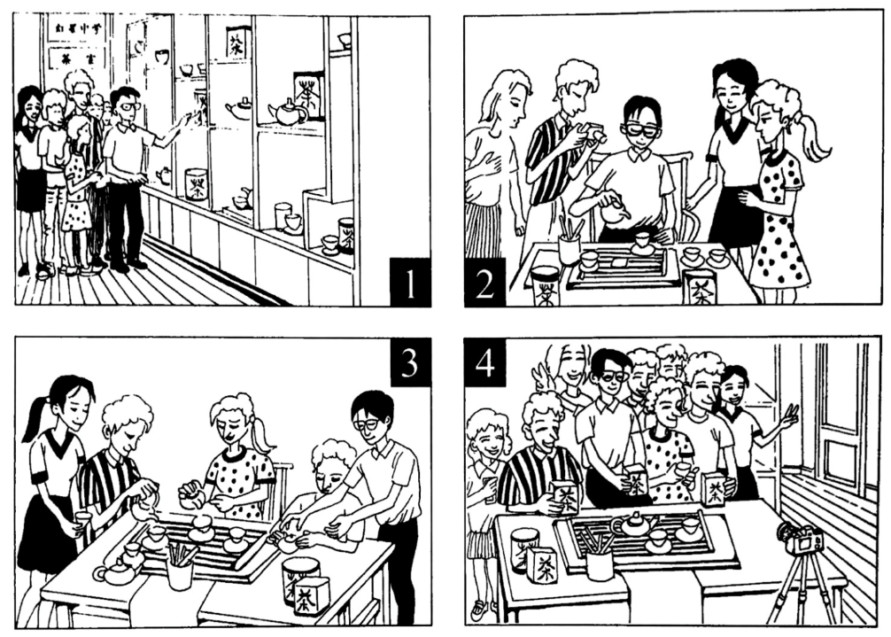

答案
单选题
C C B B A B B A D A C C D A D
简答题
C B A C D A B D A C A B D A D B B C C C
阅读理解
C C A B A D B C B D A C D D B
FGEAD

书面表达
答案略
答案略

