[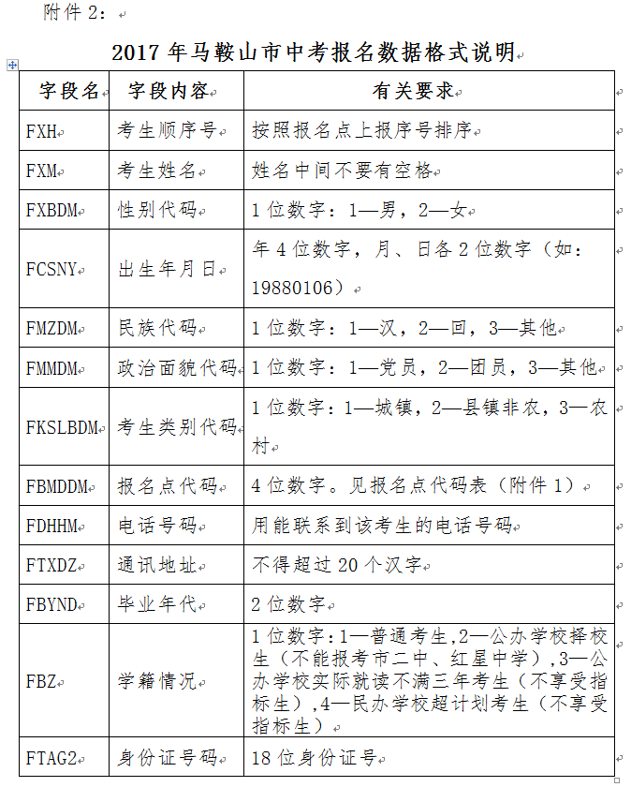](http://www.maseea.cn/Article/UploadFiles/201703/2017030211395592.png" \t "http://www.maseea.cn/Article/xlks/zhongk/2017-03-02/_blank)