Unit 1 favourite teachers
Period 1 Looking Ahead and getting ready
Teaching aims: to make students know the learning purposes of the unit and make some preparations for the learning of this unit.
Teaching methods: talking freely , discussing with your partner and show what you think.
Teaching procedure:
Step 1:
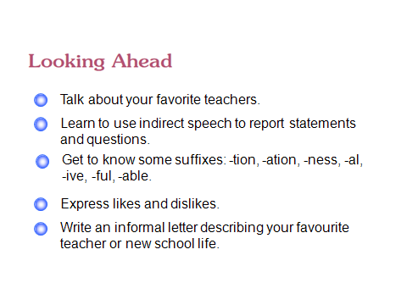
Step 2:
The teacher should introduce the purposes of this unit to students, and ask them to try to finish task 1 now. They can talk with their partner freely about their favourite teachers. Then ask someone to show what they think. The teacher should comment when necessary .
Period 2 Getting Ready
Step 1:
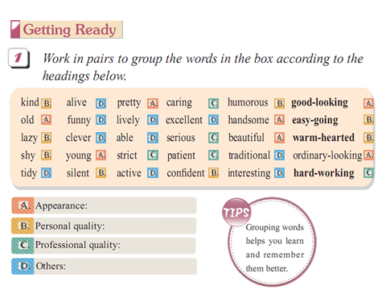
Step 2:
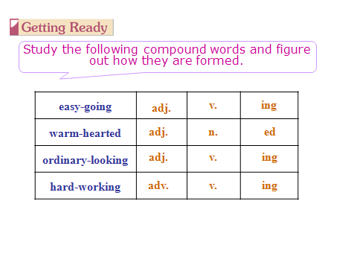
Step 3:
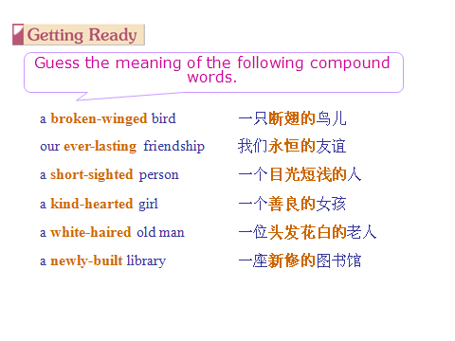
Step 4: Getting ready
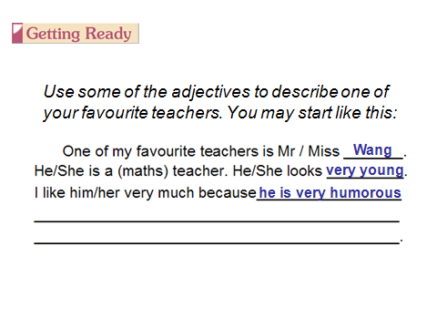
Period 3 reading (1)
Teaching aims: to let students master some reading skills and get the main structure of the reading passage .
Teaching method: talking freely ,discussion, and group work
Teaching procedure:
Step 1: predication
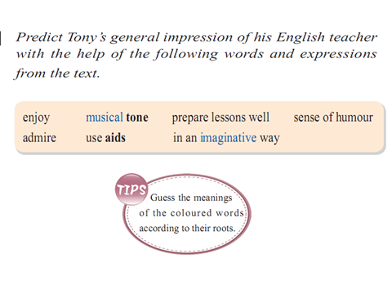
Step 2: Skimming
Skim the text to check your prediction and find out how tony thinks of his new school life. Students may have different opinions. The teacher should let them express themselves fully.

Step 3: Scanning
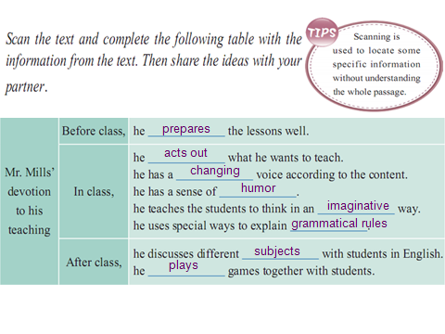
Step 4: True or False
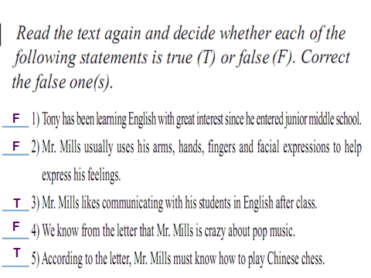

Period 4 Reading (2)
Teaching aims: to let students master some reading skills and get the main structure of the reading passage .
Teaching method: talking freely ,discussion, and group work
Teaching procedure:
Step 1: Questions
Because he was lucky to meet Mr. Mills, his new English teacher after he entered senior middle school. His English teacher’s personal qualities and teaching methods gave Tony a deep impression and changed his attitude towards English learning.
It means that Mr. Mills is so devoted to his teaching and he is good at changing his voice to attract his students.
He believes that a class is a success if the students and the teachers can share several chuckles and at least one loud laugh.
are as good as they are because some unsung teachers were t there when needed?”

Step 2: Retell the text
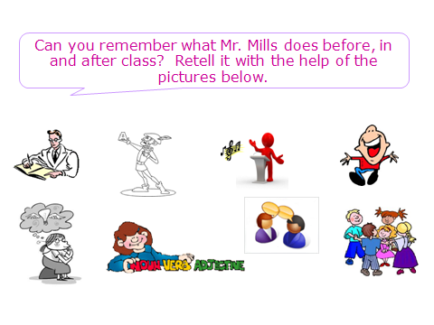
Step 3: Discussion
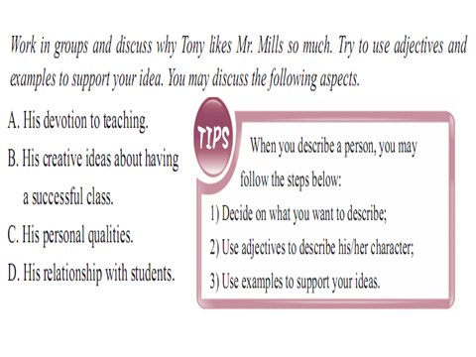

Period 5 word power
Teaching aims: to let students master some important words and know how to use them correctly.
Teaching method: talking freely , group work and competitions.
Teaching procedure:
Step 1: Word Match
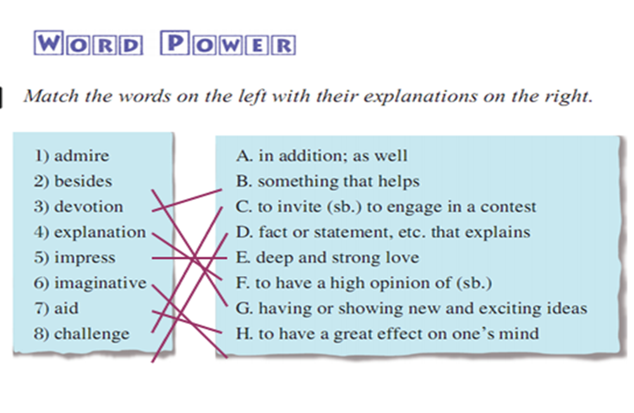
Step 2: Word Cloze
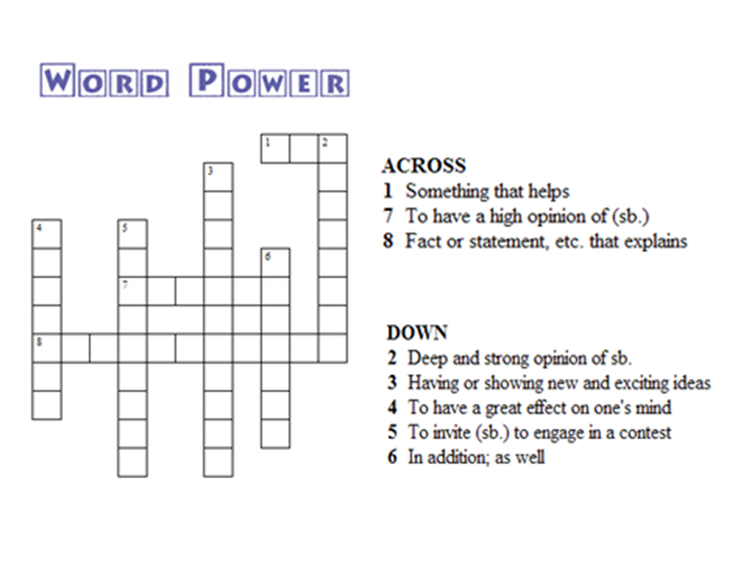
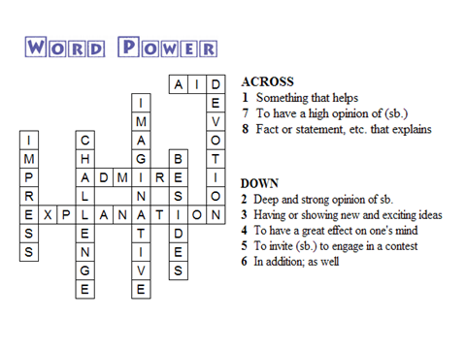
Period 6 Grammar
Teaching aims: to let students master some important grammar rules and know how to use them correctly.
Teaching method: talking freely , group work and competitions.
Teaching procedure:
Step 1: Studying the Rules
Step 2: Finding the Rules
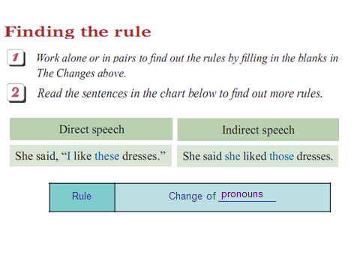
Step 3: Applying the Rules
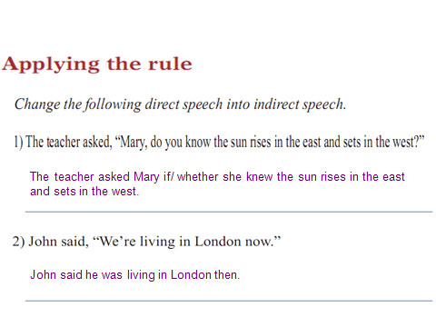

Period 7: Listening and speaking

Teaching aims: to let students master some important grammar rules and know how to use them correctly.
Teaching method: talking freely , group work and competitions.
Teaching procedure:

Step 1: Listening and Practice
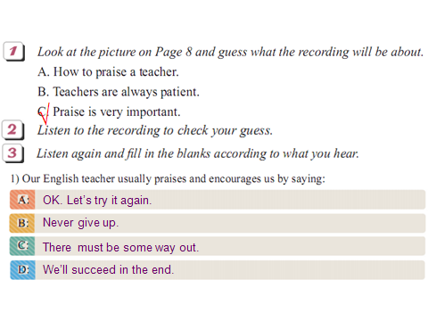
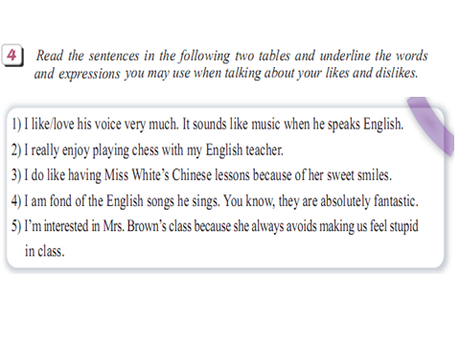

Step 2: Speaking Practice
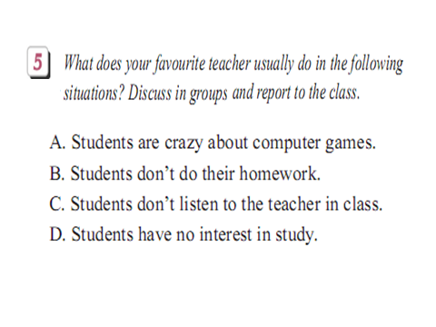
Period 8: writing
Teaching aims: to let students master some writing skills and know how to write an informal letter correctly.
Teaching method: talking freely , group work and competitions.
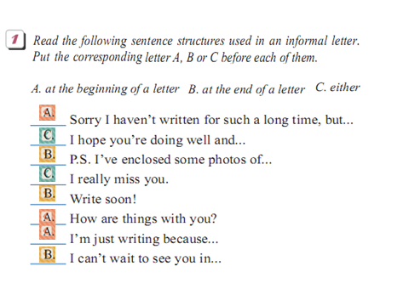

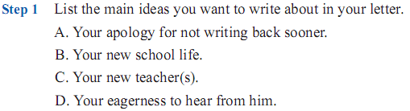
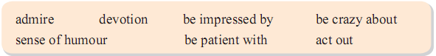
It for you.
Step 4 write your final draft

Period 9 further reading (1)
Teaching aims: to let students master some reading skills and get the main structure of the reading passage .
Teaching method: talking freely ,discussion, and group work
Teaching procedure:
Step1:
personal qualities.
Step 2:
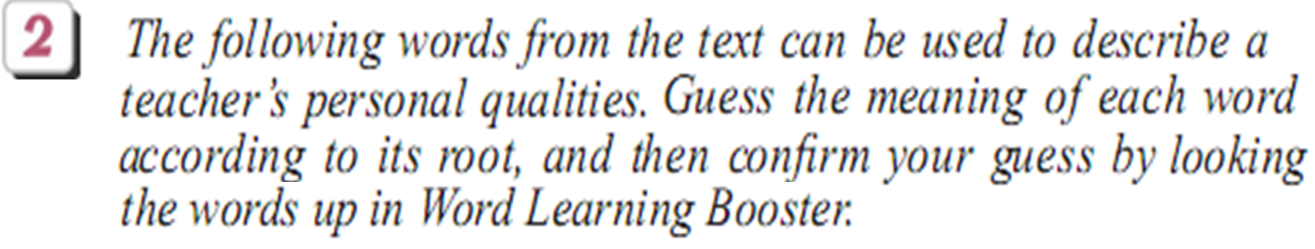

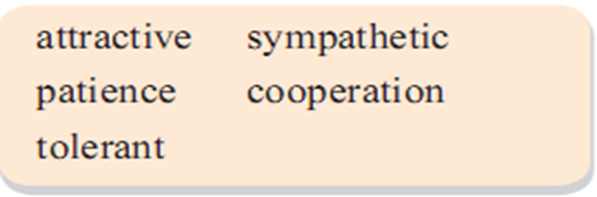

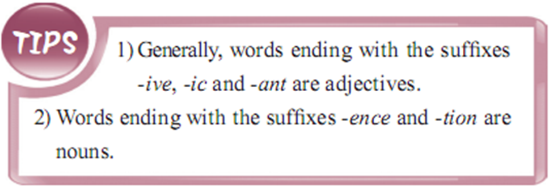
Period 10 further reading (2)
Teaching aims: to let students master some reading skills and get the main structure of the reading passage .
Teaching method: talking freely ,discussion, and group work
Teaching procedure:
Step 1:
the statements.
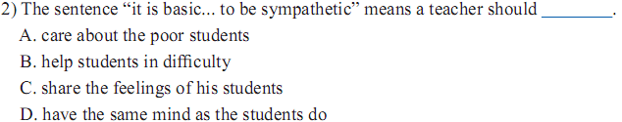
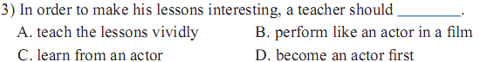
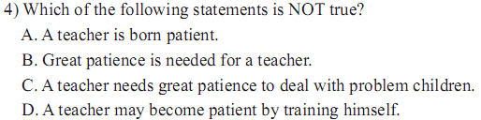
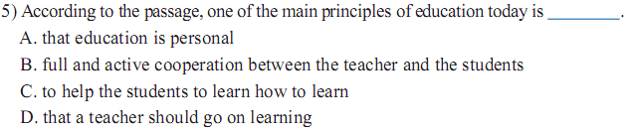
Step 2:
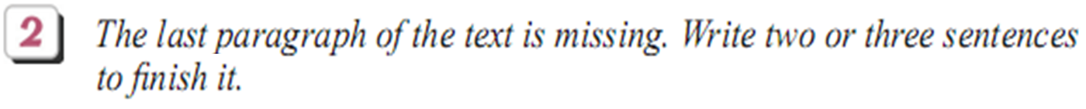

Period 11: Notes to the Unit(1)
Teaching aims: to let students master some important language points and know how to use them correctly.
Teaching method: talking freely , group work and competitions.
Teaching procedure:
一、 Useful expressions:
1．prepare lessons well 把课准备好 2. a sense of humor 幽默感 3. in an imaginative way 以一种富于想象的方式 4. quite a lot of 许多 5. be pretty crazy about 对…相当着迷 6.change one’s attitude towards/to 改变对…的态度 7. be impressed by 对…印象深刻 8. devotion to 奉献于… 9.act out 把…表演出来 10. according to 根据，按照 10. at least 至少 11. range from…to…从…到…变化 12.forget to tell sb.忘记告诉某人… 13. can’t wait to do 等不及做… 14. facial expressions 面部表情 15. communicate with 和…交流 16. share sth. with sb.与某人分享… 17. as good as 和…一样好, 几乎 18. in addition 除…之外 19. as well 也 20. have a great effect on 对…有很大影响 21. not only …. but also ….不但…而且… 22. such…as…例如 23. run out 用完 24. tell a lie/lies 说谎 25. on the contrary 正相反 26. because of 由于 27. enjoy playing chess 喜欢下棋 28. be fond of 喜欢 28. be interested in 最…感兴趣 31. avoid doing sth. 避免做… 32 have no interest in 对…没兴趣 33. walk about 四处走动 34.in the end 最后 35. be kind to 对…..友好 36. find bones in an egg.鸡蛋里挑骨头 Further Reading: The Personal Qualities of a Teacher 教师的个人品质 37. be patient with 对…有耐心 38. personal qualities 个性 39. be closely related to 与…紧密相关 40. a matter of …事情 41. be born like 生来就像… 42. take great energy 花费很大力气 43. deal with 处理 44. go on learning 继续学习 45. give up 放弃 46.above all 首要的是 47.make mistakes 犯错误 48. every now and then 进而,有时 49. be tolerant of 容忍 50. be perfect in 在……方面完美
Period 12: Notes to the Unit(2)
Teaching aims: to let students master some important language points and know how to use them correctly.
Teaching method: talking freely , group work and competitions.
Teaching procedure:
二、Key sentence patterns
1. It’s been a long time since we left our junior middle school.
2.I do enjoy the new school life here.
3. Through his sense of humor, he has made learning more enjoyable.
三、Analyse and translate the long and difficult sentences:
1. While he is teaching, he walks about, using his arms, hands and fingers to help him in his explanations ne of his face to express feelings.
上课时，他在教室里走动着，利用手臂、手和手指帮助讲解，还利用他的脸部表 情来表达他的情感。
2. We can hear the loudness and the musical tone of his voice always changing according to what he is talking about. 我们能听到他音乐般的声音，而且总是随着他所谈论的内容而变化。
3. He believes that no class hour is successful if the students and the teachers can’t share several chuckles and at least one loud laugh.
在他看来， 如果师生在一堂课上没有几次会心的笑声或至少一次开怀大笑，就不 是一堂成功的课。

