Unit 2 English around the world
【美文阅读】
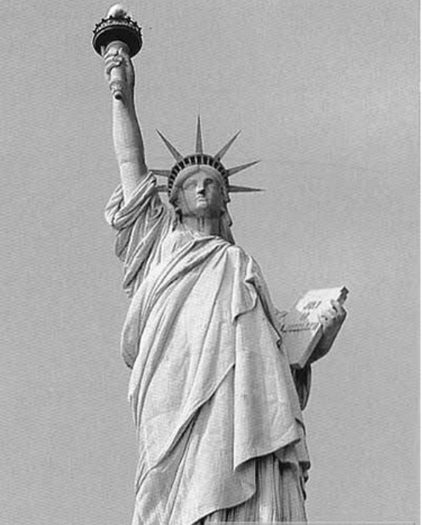
There are many kinds of English；they are different in their vocabulary，grammar，pronunciation and intonation.These different kinds of English developed from history，geography，politics and the influence of other languages.Some of the major kinds of English are British English，American English，Canadian English，Australian English，Indian English and Caribbean English.The English spoken in Africa is different from country to country.Thus there is Nigerian English，South African English，Kenyan English and so on.
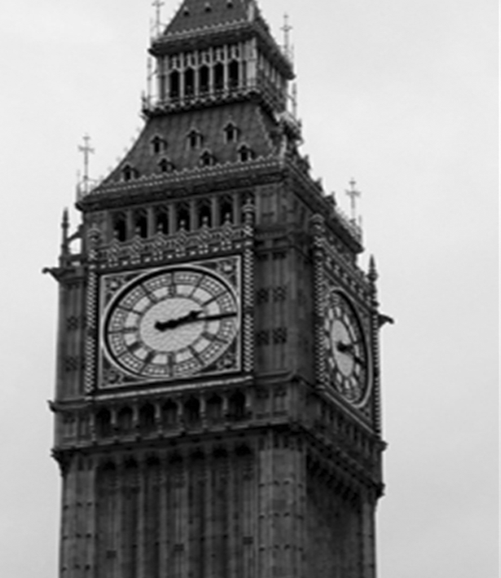
All types of English originated from the English spoken in England.American English has now replaced British English.This is mostly because of the influence of the United States through the cinema，music，technology and trade.The most noticeable differences between American and British Eng
lish are in spelling，pronunciation and vocabulary.Many words that end in our in British English end in or in American English.Words ending in se are British English while their American ones end in ze.Some vocabulary items，too，are different.There are also many differences in expressions.The Americans would say “I just ate” as opposed to “I've just eaten” in British English.In American English，Mary is “on the team”，while in British English，Mary is “in the team”．
【诱思导学】
1．Which kind of English do you like best？Why？Give your reason.
________________________________________________________________________
________________________________________________________________________
2．Do you think Chinese will become the international language instead of English one day?
________________________________________________________________________
________________________________________________________________________
【答案】 1.I like British English best.Because it is the source of other kinds of English.
2．I don't think so.Because there are only a few people speak Chinese outside China.

Period ⅠPreviewing
(教师用书独具)
●教学目标
本课时主要是通过学生对学案所给出的内容的学习，了解本课文中所出现的词汇，初步了解课文以及相关的背景知识，对下一堂课全面理解课文起到一个铺垫作用。
●教学地位
本单元主要讲的是英语的发展和英语的种类。学生作为英语学习的学习者，有必要较为深刻地了解英语语言的相关信息，减少学生在英语学习中的一些障碍，所以说本单元在书中有非常重要的地位。
(教师用书独具)
●新课导入建议
可以通过下面两种不同类型的活动热身，根据教学实际选择使用。
活动一：以笑话引入话题。
活动二：放几段来自不同国家的母语为英语的外国人的录音。不同的发音特点会激发学生兴趣从而引发思考。
●教学流程设计
导入新课。→学生阅读“美文阅读”与“诱思导学”(见学案第18页)。→学生就“美文阅读”进行讨论，统一答案。 ↓
学生阅读课文(见课本第9、10页)并完成“语篇理解”(见学案第19页)。←师生共同讨论并统一答案。←让学生快速阅读课文(见课本第9、10页)，并完成“篇章结构”(见学案第18页)。
↓
学生共同讨论，并让学生发表各自见解，最后统一答案。→学生再次仔细阅读课文(见课本第9、10页)，进行深度理解，并完成“课文缩写”(见学案第19页)。→老师指导学生讨论，共同找出答案。
↓
让学生根据所给出的表格进行自我评估(见学案第19页)。←学生讨论，并让学生代表发表他们讨论得出的答案。老师予以更正。←让学生完成“知识初探”部分(见学案第19页)。
↓
老师布置作业，让学生看课本第9、10页并完成课本第11页第1、2、3、4题，预习学案Period Ⅱ(见学案第20页)。
(见学生用书第18页)

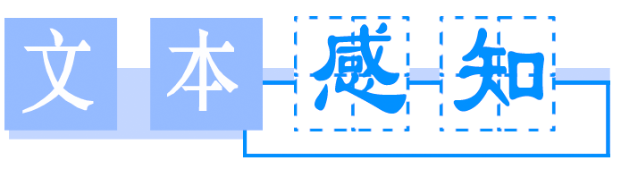
Ⅰ.篇章结构
阅读P_{9－10}的Reading部分，完成下列表格

Time | Events
at the end of the 16th century | About five to seven million people spoke English and nearly all of them lived in 1.________.
Between AD  450 and 1150 | It was 2.________more on German.
Between about  AD 800 and 1150 | English became less like 3.________because of the rulers.
In the 1600's | Shakespeare made use of a wider 4.__________，which caused a big 5.________in English usage.
In the 18th century | English was taken to 6.________.
From 1765 to  1947 | English became the language for 7.________and 8.________in India.
At present | China has the largest number of English 9.________.
In the future | Chinese English may develop its own 10.________.
【答案】 1.England 2.based 3.German 4.vocabulary 5.change 6.Australia 7.government 8.education
9．learners 10.identity
Ⅱ.语篇理解
阅读P_{9－10}的Reading部分，从每题所给的3个选项中选择最佳答案
1．Some British people were taken to Australia and English began to be spoken in both countries in ________.
A．the 18th century
B．the 1600's
C．the 19th century
2．What will happen to the native English speakers if they speak different kinds of English?
A．They can understand each other.
B．They can't understand each other at all.
C．They may not be able to understand everything.
3．Who gave a separate identity to American English spelling?
A．Shakespeare.
B．Samuel Johnson.
C．Noah Webster.
4．What's the text mainly about?
A．Why English has changed since AD 450.
B．A brief history of the English language.
C．The differences between old and modern English.
5．The last sentence “Only time will tell” in the text probably means that ________.
A．English may develop its own identity in China combined with Chinese
B．Chinese people may help change English a great deal
C．there may be more and more English learners in China
【答案】 1－5 AACBA
Ⅲ.课文缩写
阅读P_{9－10}的Reading部分，完成下面课文缩写
English，which was only spoken by the people living in England in the 1.________century，began to be spoken by many other countries from the next century with the English colonists 2.________to other countries around the world.As a result，there are a lot of countries who speak English as their 3.________，such as the U．S.，Canada，Australia.There are also other countries speaking English as a foreign or 4.________language than ever before.
Though there are different Englishes in the world，the 5.________speakers can have almost no difficulty in communicating with each other 6.________they don't use the same kind of English.However，sometimes they do have some trouble in understanding each other's words，spelling，pronunciation and dialects.
English is an allthetime 7.________language，for example，the English of AD 450 to 1150，which was 8.________German，was quite different from the English spoken from 1150 to 1500，which was based more on 9.________.Thanks to Shakespeare's efforts，English had a big change in usage.American English got its own 10.________with the help of Noah Webster.
【答案】 1.16th 2.moving 3.first language 4.second
5．native 6.even if 7.changing 8.based more on
9．French 10.identity
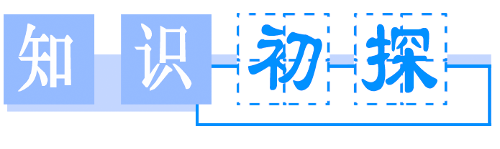
Ⅰ.词义搭配
1．base A．taking place by a series of small changes over a long period
2．gradual B．who or what sb./sth.is
3．identity C．nearer to the end of a period of time than the beginning
4．latter D．in fact
5．voyage E．total number of words that make up a language
6．actually F．a person born in a place，country，etc.，and associated with it by birth
7．native G．a long journey，especially by sea or in space
8．vocabulary H．the part on which it rests or stands
【答案】 1－8 HABCGDFE
Ⅱ.短语填空
because of，such as，come up，at present，make use of，be based on
1．This song________an old folk song.
2．He came to work late________getting up late.
3．He didn't ________the chance given to him.
4．A girl ________to ask for help.
5．Chances ________this did not come every day.
6．Alex is standing at the crossroads________.
【答案】 1.is based on 2.because of 3.make use of 4.came up 5.such as 6.at present
Ⅲ.句型背诵
1．Do you know that there is more_than one kind of English?
你知道英语不止一种吗？
2．Native English speakers can understand each other even_if they don't speak the_same_kind_of English.
以英语作为母语的人，即使他们所讲的语言不尽相同，也可以相互理解。
3．Today the_number_of people learning English in China is increasing rapidly.
目前在中国学习英语的人数正在迅速增长。

Period ⅡWarming Up & Reading
(教师用书独具)
●教学目标
(1)熟记学案中所列出的单词和短语。
(2)通过对学案中所给出的重点单词和重点短语的学习，让学生能够正确理解和使用这些单词和短语，能够运用这些词语造句。
(3)通过对这些词汇的理解能够更深层次的理解课文，并通过课文加深对这些词汇的理解，更加熟练地运用这些词汇。
(4)通过对本课文的理解，让学生学会用英语写告示，以提高学生的书面表达能力。
●教学地位
单词和短语是构成句子的最小单位，在语言学习中起着至关重要的作用，所以全面理解和正确运用英语单词和短语是英语学习的重点所在。
(教师用书独具)
●新课导入建议
老师让学生展示他们对英语语言的了解程度，可以通过表演等形式。
●教学流程设计
导入新课。→老师检查上堂课所布置的作业，检查学生对学案预习的情况。→让学生就“互动探究”(见学案第20页)进行讨论，让学生各自发表自己的见解，然后让各个讨论组派代表汇报各自讨论结果。 ↓
让学生再次阅读课文(见课本第9、10页)以加深对所学单词与短语的理解。←老师针对难点和重点词汇进行讲解，并补充学案中所遗漏的重点词汇，补充一些必要的练习。←让学生针对各自不同的意见展开讨论，然后老师给出详细正确答案。
↓
让学生完成“自我评估”(见学案第24页)。→老师布置作业。让学生完成课本第12页第1、2、3题，“课时作业”(见学案第83页)和预习Period Ⅲ(见学案第24页)。
(见学生用书第20页)

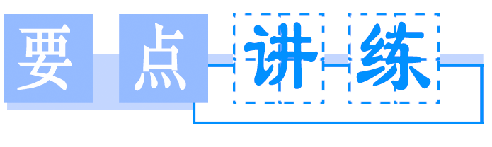
1．more than超过，多于
Do you know that there is more than one kind of English？(P₉)你知道英语不止一种吗？
More than one person has made the suggestion.
不止一人提过这个建议。
I'll stay here not more than three days.
我将待在这里最多不超过三天。

more than后跟的词性不同，其意思也不同。
注意下列归纳：
①more than＋数词，意为“比……多；超过”，相当于over。
②more than＋名词，意为“不只是，不仅仅”，相当于not only，表示程度和加强语气。
③more than＋形容词或副词，意为“十分；非常”。
④more than＋动词，意为“岂止是……；不仅仅……”。
⑤more than＋从句，意为“比……更”。

Modern science is more than a large amount of information.现代科学不只是大量的信息。
I assure you I am more than glad to help you.
我向你保证我非常愿意帮助你。
The beauty of the place is more than I can describe.
那个地方美得我简直不可以言表。
He is more diligent than clever.
与其说他聪明，不如说他勤奋。
【提示】 more than one意义上是复数，但形式上是单数，作主语时，谓语动词用单数形式。同类用法的词组还有many a“许多，大量”。
【教师备课资源】
①no more than仅仅，不过
not more than不超过，至多
②no more...than...和……一样不……
not more...than...不比……更……
③more...than...比……更……，与其说……倒不如说……

句型转换
①Many a person was injured in the accident.
→________________________person was injured in the accident.
②We were more than willing to take your advice on this matter.
→We were willing to take your advice on this matter________________.
③Dogs are more than a kind of pet to us；they are our friends.
→Dogs are ________________a kind of pet to us；they are our friends.
【答案】 ①More than one ②very much ③not only
2．Later in the next century，people from England made voyages to conquer other parts of the world and because_of that，English began to be spoken in many other countries.(P₉)
在下一世纪晚期，英国人远洋去征服世界其他地区，正因为如此，其他许多国家开始说英语。
(1)voyage n．航行，航海
A sea voyage is a healthy way to travel.
航行是一种有益于健康的旅行方式。
The voyage from America to France used to take two months.
从美国到法国的航行过去要花二个月时间。
make/take a voyage进行航行
be on a voyage to正往……航行
go on a voyage去航行

The ship is not in a condition to make a long voyage.
这船不适于远航。
I'm looking forward to going on a voyage.
我期待着去航海。

voyage/journey/trip/tour/travel
voyage | 主要指远距离的水上旅行，也可以指空中旅行，意思为“航海、航空、航行”等。
journey | 指从一地到另一地，通常指陆地上的远距离“旅行”，有时也可以表示经常走的或长或短的“路程”。
trip | 一般指时间短、距离近的“旅行、远足”，也可以指长途旅行。在非正式用语中可代替journey。
tour | 着重指旅行线路比较曲折，常表示“(周游各地的)参观、访问、(巡回)旅游、视察、购物、演出”等意思。
travel | 作“旅行、游历”解，一般表示从一地到另一地旅行这一总的概念。常指长时间、远距离的“旅行”。尤指出国旅行。
选词填空：voyage，journey，trip，tour，travel
①They are going on a world________.
②Before the 20th century，long sea________were common.
③He met many interesting people in his ________.
④They planned to make a wedding ________to Paris.
⑤With a pleasant land ________，you'll find life full of pleasure.
【答案】 ①tour ②voyages ③travels ④trip ⑤journey
(2)because of因为，由于
Because of his long illness，he is backward in his studies.因为长时间生病，他的功课落后了。
The price of vegetables has been doubled because of bad weather.因为天气不好，蔬菜价格上涨一倍。
【提示】 because of和because都表示原因，但是because of是介词短语，后面接名词或代词等作宾语；而because是从属连词，引导原因状语从句
句型转换
⑥Because of his carelessness，he failed the test again.
→________________，he failed the test again.
⑦The sports meet had to be put off because it rained.
→The sports meet had to be put off________________________________________________________________________.
【答案】 ⑥Because he was careless ⑦because of rain
3．Native English speakers can understand each other even_if they don't speak the same kind of English.(P₁₀)以英语作为母语的人，即使他们所讲的语言不尽相同，也可以相互理解。
(1)native adj.本国的，本地的n.本地人，本国人
This shop sells native produce.
这家商店出售土特产品。
Are you a native of Chinese?
你是土生土长的中国人吗？
be native to...产于……
a native of...是……的本地人

The giant panda is native to China.
大熊猫是中国特有的动物。
The kangaroo is a native of Australia.
袋鼠是产于澳洲的动物。
完成句子
①大熊猫产于中国西部。
The panda________________________________________________________________________.
②那里的参观者是俄罗斯本地人。
The visitors there are ________________________________________________________________________.
【答案】 ①is native to the west of China ②natives of Russia
(2)even if即使，尽管
相当于even though，引导让步状语从句。
Even if it should rain tomorrow，they will go for an outing.纵使明天下雨，他们也要去游览。
Even if we don't like it，we must do it.
即使我们不喜欢，也必须去做。
【对接高考】
(2012·北京高考)—Look at those clouds!
—Don't worry.________ it rains，we'll still have a great time.
A．Even if B．As though
C．In case D．If only
【解析】 首先了解四个选项的汉语意思。even if“即使”，引导让步状语从句；as though“好像”，引导方式状语从句；in case“以防，万一”，引导条件状语从句；if only“要是……就好了”，引导虚拟条件句。由题干中的关键信息Don't worry.和．..we'll still have a great time.可知此处填Even if“即使”。句意：——看那些乌云！——别担心。即使下雨，我们仍然会玩得很开心。
【答案】 A
完成句子
③He will come tomorrow ________________(即使明天下雨)．
④________________(即使我们很想去看这个戏剧)，we will not have time to do it.
【答案】 ③even if it rains ④Even if we want to see the play very much.
4．come up走近；上来；提出；破土而出；发芽
I'd like to come up to your apartment.(P₁₀)
我很乐意到你的公寓去。
Come up to the fire，and you will feel warm.
到火炉边来，你就会觉得暖和。
The snowdrops are just beginning to come up.
雪花莲刚刚开始长出地面。
But the issue did not come up in quite this way.
但是问题并没有按照这个样子提出来。
come about发生
come across偶遇
come on快点儿；加油
come out发行；透露
come to(指看法等)被某人想出；总额达到

Many a quarrel came about through a misunderstanding.许多争执都是由于误会产生的。
He never remembered having come across a man like that.他怎么也记不起曾碰到过这样一个人。
Come on，we'll be late for the movie.
快点吧，我们看电影要迟到了。
A pocket edition of the dictionary will come out soon.
这一字典的袖珍版即将问世。
【提示】 (1)come up“被提出”，其主语是被提出的内容，主动形式表示被动的意义。
(2)come up with“提出”，其主语是提出动作的发出者，后面的宾语是被提出的内容，无被动语态。
介、副词填空
①The spring is coming and flowers are coming________.
②He has just finished writing his book and it will come________next month.
③No one knows how the accident came________yesterday.
④Come________，the bus leaves in two minutes!
⑤The total cost that they had spent on their clothes this month came________nearly 2,000 yuan.
⑥I came________an old friend during my shopping in the supermarket.
【答案】 ①out ②out ③about ④on ⑤to ⑥across
5．actually adv.实际上，事实上
Actually all languages change and develop when cultures meet and communicate with each other.(P₁₀)
事实上，当不同文化互相渗透时，所有语言都会有所变化，有所发展。
Actually eating habits can vary a good deal over the centuries.
实际上，饮食习惯在几个世纪内可以发生很大变化。
They actually got mad about it.
他们实际上为此感到很生气。
表示“实际上，事实上”还可用以下词汇：
in fact；in actual fact；as a matter of fact；in reality；as it is；really；truly

He seems very serious，but in fact he has a delightful sense of humour.
他看上去很严肃，其实他十分诙谐。
As a matter of fact，I know nothing about this book.
其实我对这本书一无所知。
—Have you ever ________been to England?
—Yes.I have been there for two years.
A．gradually B．actually
C．extremely D．presently
【解析】 句意：——你确实去过英国？——是的。我在那儿待过两年。gradually逐渐地；actually实际上，事实上；extremely极其；presently目前。
【答案】 B
6．It was based more on German than the English we speak at_present.(P₁₀)当时的英语更多是以德语为基础，而我们今天说的英语不是。
(1)base vt.以……为根据n.基部；基地；基础
The family base was vital to my development.
家庭基础对我的发展至关重要。
One should always base one's opinion on facts.
一个人应当把看法建立在事实基础上。
base...on/upon把……建立在……的基础上
be based on/upon以……为基础/依据

Based on a true story，the novel is highly thought of.
以一个真实的故事为基础，这部小说受到了高度评价。
The figures are based upon average market prices.
这些数字是基于平均市场价格而得出的。
【对接高考】
(2012·江苏高考)________ an important decision more on emotion than on reason，you will regret it sooner or later.
A．Based B．Basing
C．Base D．To base
【解析】 前后两部分之间没有连词且用逗号连接，因此空格处只能填非谓语动词形式，主语you与base之间为主动关系，动词不定式只能作目的状语，或与only一起表示意外的结果，故空格处应使用现在分词表条件。句意：如果你把重要决定更多地建立在情感而不是理性基础上，你迟早会后悔的。
【答案】 B
The famous film is ________a Chinese fairy tale and directed by a famous director.
A．basing at B．based on
C．bases on D．to base on
【解析】 句意：这部有名的电影是基于中国神话故事，且由著名导演执导的。be based on基于……，为固定搭配。
【答案】 B
(2)at present目前，现在
You're not fit to travel alone at present.
你目前一个人出门不合适。
He seems to be quite content with his life at present.
他似乎对目前的生活心满意足。
①present adj.目前的，出席的，在场的
be present at出席……
②present n．礼物(＝gift)
③present v．把……交给；提出；赠送
present sth.to sb./present sb.with sth.把某物交给/赠与某人
④for the present目前，暂时

The present situation concerns all the students present.
目前状况关系到所有在场的学生。
Please accept my belated birthday present.
请接受我的这份迟到的生日礼物。
A vivid picture was presented to his mind.
一幅生动的画面出现在他的脑海里。
【提示】 用present的形容词作定语时，如果表示“目前的”意思，则放在所修饰的名词前面；如果表示“出席的，在场的”意思，则放在所修饰的名词后面。
写出下面句子中present的词性及含义
At his birthday party，he received many good books as a ② present from his parents and he promised in front of his guests ③ present that he would ④ present the books to those in great need.
________________________________________________________________________
【答案】 ②n.礼物 ③adj.出席的，在场的 ④v.赠送，把……交给
7．make use of利用
So by the 1600's Shakespeare was able to make use of a wider vocabulary than ever before.(P₁₀)所以到17世纪，莎士比亚所用的词汇量比以前任何时期都大。
We train them to make use of reference books.
我们训练他们使用参考书。
Make full use of every chance you have to speak English.要充分利用一切机会说英语。
充分利用
利用

Time is so precious that you must make full use of it.
时间很宝贵，你必须充分利用它。
Waste material must be made full use of.
废弃材料必须充分利用。
We should make the best ofour opportunities to speak English.我们应该尽量利用机会讲英语。
【教师备课资源】
make use of短语的构成特点为：动词＋名词＋介词。
此类短语通常作以下变化：
①把use提前使用被动语态。
②of的宾语提前时句子也用被动语态。
③把use提前用作先行词，其后接定语从句。
本单元的短语play a part in也可作同样变化。
【对接高考】
(2011·浙江高考)The school isn't the one I really wanted to go to，but I suppose I'll just have to ________it.
A．make the best of B．get away from
C．keep an eye on D．catch up with
【解析】 选项A意为“充分利用；尽力而为；妥善处理”；选项B意为“避免，摆脱；逃离”；选项C意为“照看；密切注视”；选项D意为“赶上，追上；逮捕”。题干是转折句(逗号后有but)，前半句完整表达“这所学校不是我真正想去的”，后面“但是我将不得不……”应该选表示肯定的、积极的意思“尽力而为或者善用它”。
【答案】 A
完成句子
他充分利用业余时间学习英语。
①He ________________his spare time to learn English.
②His spare time has ________________to learn English.
【答案】 ①made good/full use of或made the best/most of ②been made good/full use of或been made the best/the most of
8．latter adj.较后的；后半的；(两者中)后者的
The latter gave a separate identity to American English spelling.(P₁₀)
后者体现了美国英语拼写的不同特色。
Of the two the latter is better than the former.
二者中后者比前者好。
I hold with the latter viewpoint.我赞同后一种观点。
①late adj.& adv.迟(的)，晚(的)
later adj.后期的，较后的
adv.后来，较晚地
latest adj.最新的，最近的
lately adv.(＝recently)最近，近来
②former adj.前者的

He found happiness in later life.
他在晚年找到了幸福。
Latest reports say another five people have been killed.
最新报道称又有5人被害。
Dad's health hasn't been too good lately.
爸爸的健康状况近来不太好。
选词填空：late，later，latest，latter，lately
①Have you heard the ________news?
②We were ________for the theatre and missed the first act.
③________she went to college and became a teacher.
④I prefer the ________picture to the former.
⑤We haven't heard from him ________.
【答案】 ①latest ②late ③Later ④latter ⑤lately
9．such as例如……，像这种的
English is also spoken in Singapore and Malaysia and countries in Africa such as South Africa.(P₁₀)
在新加坡、马来西亚和非洲的一些国家，比如南非，人们也说英语。
I used to catch small birds such as sparrows.
我曾常常捕捉麻雀等小鸟。
He bought a lot of fruit such as apples and peaches.
他买了许多水果，如苹果、桃子等等。
for example/such as/that is
for example | 用来举例说明某一论点或情况，一般只举同类人或物中的“一个”为例，作插入语，可位于句首、句中或句末。
such as | 用来列举事物时，一般列举同类人或事物中的几个例子。插在被列举的事物与前面的名词之间，as后面不用逗号。
that is | 后面列举的事物的数量等于它前面所提到的总和。
选词填空：that is，such as，for example
①I have three good friends，________，John，Jack and Tom.
②They planted flowers________roses in the garden.
③Many countries，________，Mexico，have a lot of earthquakes.
【答案】 ①that is ②such as ③for example

Period ⅢLearning about Language
(教师用书独具)
●教学目标
(1)熟记学案中所列出的单词和短语。
(2)通过对学案中所给出的重点单词和重点短语的学习，让学生能够正确理解和使用这些单词和短语，能够运用这些词语造句。
(3)通过对语法的教学让学生能够理解并能够运用这些语法知识，能够把直接引语变为间接引语，同时也能够将间接引语变为直接引语。
●教学地位
语法是学生感到比较难以掌握的东西。让学生正确理解和掌握语法知识是让学生学好英语的关键，所以应给学生创设一个语境，让学生理解该语法的应用，而不要让学生死记硬背语法条文，应从理解的基础上去运用这些语法。
(教师用书独具)
●新课导入建议
通过对学生作业的检查导入本堂新课。
●教学流程设计
导入新课。→老师检查上堂课所布置的作业，检查学生对学案预习的情况。→让学生就“互动探究”(见学案第24页)进行讨论，让学生各自发表自己的见解，然后让各个讨论组派代表汇报各自讨论结果。 ↓
让学生讨论完成“语法精析”部分(见学案第25页)，并让各个讨论组发表各自见解。←老师针对难点和重点词汇进行讲解，并补充学案中所遗漏的重点词汇，补充一些必要的练习。←让学生针对各自不同的意见展开讨论，然后老师给出详细正确答案。
↓
老师对语法部分给以点拨。让学生掌握本单元语法知识。→让学生完成“当堂双基达标”。(见学案第25页)→师生共同讨论“当堂双基达标”并给出答案，并对难以理解的或有争议的地方给出详解。
↓
老师布置作业。让学生完成课本第13页1、2、3题，预习学案Period Ⅳ (见学案第26页)。←自我评估(见学案第26页)。
(见学生用书第24页)

Can you find the following command and request from Reading？(P₁₂)你能从Reading里面找到如下表示命令和请求的句子吗？
(1)command vt.& vi.命令；指挥；支配n.命令；指令；掌握
He raised his hand as if to command silence.
他举起手来似乎要命令大家安静下来。
The army is under the command of General Smith.
这支部队由史密斯将军指挥。
①under the command of/one's command在……指挥下
take command of指挥/控制……
have a good command of精通
②command sb.to do sth.命令某人做某事
command that sb.(should)do sth.宾语从句要用虚拟语气，should可以省略。

He has a good command of French.他的法文很好。
I command that he go at once.我命令他立即就去。
He commanded his troops to attack.他命令部队发起进攻。
句型转换
①He commanded that we should take quick action to stop it.
→He commanded ________________take quick action to stop it.
②The general took command of the War.
→The War was ________________________________the general.
【答案】 ①us to ②under the command of
(2)request n. & vt.请求，要求
I did not have the heart to refuse the child's request.
我不忍心拒绝孩子的要求。
I request her to dine with me tonight.今晚我请她吃饭。
①at sb.'s request＝at the request of sb.应某人之请求
make a request for sth.要求得到……
make a request that从句 做出请求
②request sth.from/of sb.向某人要求某物
request sb.to do sth.要求某人做某事
request＋that从句 从句中谓语用(should＋)do

I came at your request.我是应你要求而来的。
I request that he should leave.我恳请他离开。
I request them to stop making such a noise.
我请求他们别这样吵闹。
完成句子
老师要求同学们不要在草地上走。
③The teacher requested the students________________________________________________________________________.
④The students are requested ________________________________________________________________________.
⑤The teacher requested that the students ________________________________________________________________________.
【答案】 ③not to walk on the grass ④not to walk on the grass ⑤should not walk on the grass
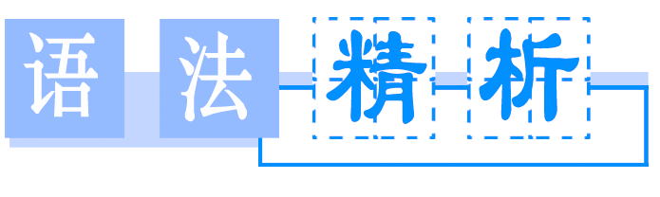

观察并研究下面两组句子，总结它们的语法形式及语意，并注意它们的不同。
①a.“Put your coat in the closet，”she said to him.
b．The father said to his children，“Don't move！”
②a.She asked him to put his coat in the closet.
b．The father told his children not to move.
[自我总结]
1．第一组是__________，前后要加引号，且直接引语为________；
2．第二组是________，不用引号。在用间接引语转述祈使句时，通常将原句中的动词变为________，构成ask/tell/order sb.to do sth.的形式。
【答案】 1.直接引语；祈使句 2.间接引语；动词不定式

直接引语和间接引语(Ⅱ)
祈使句和疑问句
1．当祈使句作直接引语表示要求和命令时，变间接引语时常采用ask/tell/order sb.to do sth.的形式。
“Follow his instructions，”she said to me.
→She told me to follow his instructions.
她告诉我要听他的指令。
2．若直接引语中祈使句是否定形式，变间接引语时，不定式符号to前要加not或never。
She said，“Don't make so much noise，children！”
→She told the children not to make so much noise.
她告诉孩子们不要弄出这么多噪音。
3．当直接引语为表示建议、提议的祈使句或表示请求、提议、劝告、建议的疑问句时，多采用“suggest＋doing/that从句(如suggest后接that从句时，从句使用虚拟语气should＋动词原形，should也可省略)，offer to do和ask/advise/want sb.＋to do”等结构。
Jack said，“Let's go to the cinema tonight.”
→Jack suggested that we should go to the cinema that night.
＝Jack suggested our going to the cinema that night.
那天晚上杰克建议我们去看电影。
4．如果直接引语部分是感叹句，改为间接引语时，引导词可以用该感叹句的感叹词(即what或how)引导，也可以用that引导。
She said，“What a lovely day it is！”
→She said what a lovely day it was.
她说天气不错。
5．若直接引语中的一般疑问句是由表示委婉语气的would，could等构成的疑问句，转换为间接引语时句子的谓语动词常用asked。
“Can you lend me two yuan？”he asked me.
→He asked me if I could lend him two yuan.
他问我是否能借给他两元钱。
【注意】
祈使句直接引语变间接引语时，人称、指示代词，时间、地点状语及直接引语中从句的时态应根据陈述句直接引语变间接引语的方法进行相应的改变。
(见学生用书第25页)

Ⅰ.单项填空
1．You can never know________when she received our nice birthday presents.
A．how she was pleased B．how excited she was
C．how happy was she D．she was how interested
【解析】 句意：你不知道当她收到我们的生日礼物时，她是多么的激动。know后接的是how引导的感叹句作宾语从句，从句应用陈述语序。
【答案】 B
2．The gardener ________us to keep off the grass.
A．told B．let
C．pleased D．hoped
【解析】 若直接引语是表示命令的祈使句，变为间接引语时，应使用tell/order sb.(not)to do sth.结构。let后作补语的不定式省略to；please不用于该结构；hope不能用不定式作补语。
【答案】 A
3．Smoking can do great harm to health，so the headteacher clearly told the boy student ________any more.
A．not smoke B．not to smoke
C．smoked D．smoking
【解析】 句意：吸烟会极大地危害健康，因此班主任老师明确地告诉那个男生不要再吸烟了。tell sb.not to do sth.意为“告诉某人不要做某事”。
【答案】 B
4．John was very angry about it and ________me ________that again.
A．said to；not to do B．said to；don't do
C．told；don't do D．told；not to do
【解析】 句意：约翰对此非常生气并告诉我不要再那样做了。ask/tell sb.not to do sth.意为“不让某人干某事”。
【答案】 D
5．In order to improve our English，our teacher asked us ________English articles every morning.
A．to reading B．to be read
C．to be bringing D．to read
【解析】 句意：为了提高我们的英语水平，英语老师让我们每天早晨读英语文章。“让某人干某事”用ask sb.to do sth.。
【答案】 D
6．The manager told her ________to post the letters by 3：00 in the afternoon.
A．do remember
B．be sure to remember
C．to remember
D．remembering
【解析】 动词tell表示“命令”或“要求”时，tell sb.to do sth.告知某人做某事；tell sb.not to do sth.告知某人不要做某事。故选C。
【答案】 C
7．The old man suggested ________the village at once.
A．leaving B．leave
C．to leave D．left
【解析】 suggest doing sth.意为“建议做某事”。
【答案】 A
8．—What did her brother say to her?
—He ________her ________weight to stay fit.
A．suggested；to lose B．offered；to lose
C．advised；to lose D．advised；lose
【解析】 祈使句的间接引语，可以用advise sb.to do sth.或suggest sb.doing sth.或offer to do sth.；故只有C项符合。
【答案】 C
9．The leader of the company ________the donated(捐赠的)money should be sent to those in need.
A．declared B．said
C．expressed D．commanded
【解析】 句意：公司领导命令捐款应送给那些需要的人。command后跟的宾语从句用“should＋动词原形”，should可以省略，故选D。
【答案】 D
10．Now I come here at the ________of Mr.Smith to help him to finish the work.
A．require B．remark
C．demand D．request
【解析】 句意：现在我来这里是应史密斯先生的要求协助他完成工作。at the request of应某人的要求。
【答案】 D
Ⅱ.句型转换
1．He said to the boy，“Keep quiet.”
→He told the boy________________.
2．The audience said to the singer，“Would you sing us a song？”
→The audience asked the singer________________.
3．“Be quiet！”the teacher said to the students.
→The teacher told the students________________.
4．All the people cried，“How beautiful the clothes are！”
→All the people cried________________________________________________________________________.
5．“Write a letter to your parents，”the teacher said to me.
→The teacher reminded me________________________________________________________________________.
6．The chairman said to us，“Don't make any noise.”
→The chairman warned us ________________________________________________________________________.
7．The woman said to her husband，“Could you help me do the housework？”
→The woman asked her husband ________________the housework.
8．“Don't look out of the window，”she said to me.
→She told me ________________________out of the window.
【答案】 1.to keep quiet 2.to sing them a song 3.to be quiet 4.how beautiful the clothes were 5.to write a letter to my parents 6.not to make any noise 7.to help her do 8.not to look

Period ⅣUsing Language
(教师用书独具)
●教学目标
(1)掌握本学案中所给出的词汇，能够理解并能熟练运用。
(2)理解课文。
(3)听懂课文中所给出的听力材料。
(4)能够根据课文中所提出的问题，发表自己的看法。
(5)掌握海报的格式。
●教学地位
本课时的内容是感悟各地英语的差异，学会使用所学的日常交际用语克服语言交流中的障碍，增强用英语与人沟通的能力。通过习作，掌握设计海报的技巧。
(教师用书独具)
●新课导入建议
老师将学过的英美说法不同之处，按实际生活或根据想象编写一段对话，引导学生探讨各地英语的不同之处。
●教学流程设计
检查上堂课所布置的作业。→导入新课。→学生快速阅读课文(见课本第14页)并根据学案所设置的问题做出判断。 ↓
学生共同讨论。师生统一答案。←让学生再次仔细阅读课文，并完成学案中“语篇理解”部分(见学案第26页)。←学生就学案中的问题相互交换意见。老师指导学生统一答案。
↓
学生完成“要点讲练”部分(见学案第27页)。→学生共同讨论，并让学生发表各自见解，最后统一答案。→学生完成“情景交际”部分(见学案第29页)。
↓
自我评估(见学案第30页)。←学生完成“写作提升”部分(见学案第29页)。←老师指导学生共同找出答案。讲解本单元交际话题，并从高考命题角度来分析本交际话题。
↓
让学生做“课时作业”(见学案第85页)。→老师布置作业：让学生课下做“单元归纳提升”部分(见学案第30页)和Workbook 第49页Using Words and Expressions第1题、第3 题。
(见学生用书第26页)

Ⅰ.判断正误
阅读P₁₃课文，判断正误
1．Standard English is spoken in Britain.( )
2．A dialect is different from “standard language”．( )
3．As many Americans move all over the country，they change their dialects.( )
【答案】 1－3 FTF
Ⅱ.语篇理解
阅读P₁₃课文，选取最佳答案
1．People think the English spoken on TV and the radio is standard English，because ________.
A．people believe those who reported the news speak excellent English
B．they speak the same English
C．they speak it to all the people
2．How many dialects are mentioned(提到)in the text?
A．Three. B．Two. C．Four.
3．American English has so many dialects because________.
A．people have come from all over the world
B．the USA is made up of so many states
C．Americans move from one place to another
【答案】 1－3 ACA
(见学生用书第27页)

1．Believe_it_or_not，there is no_such thing as standard English！(P₁₃)信不信由你，没有什么标准英语。
(1)believe it or not信不信由你
Believe it or not，we were left waiting in the rain for two hours.信不信由你，我们冒雨一直等了两个小时。
Believe it or not，it was a hug that changed my mind.
信不信由你，是一个拥抱改变了我的心情。
类似插入语还有：
to tell(you)the truth说实话
to be honest说实话
generally speaking一般说来

To be honest，I don't think we have a chance of winning.
说实话，我认为我们没有获胜的可能。
To tell the truth，I don't agree to your plan.
老实讲，我不同意你的计划。
完成句子
①信不信由你，这个淘气的男孩喜欢读书。
The naughty boy enjoys reading，________________________________.
②说实话，我不认识他。
________________________________，I don't know him.
③一般说来，学英语很容易。
________________，it is easy to learn English.
【答案】 ①believe it or not ②To tell the truth
③Generally speaking
(2)句中“no such＋单数名词”意为“没有这样的……”，其中单数名词前不可再加冠词，相当于“not such a/an＋单数名词”。
No such person but Peter can perform so perfectly.
除了彼得没有这样的人能表演得如此完美。
There are no such foods as “slimming” foods.
根本就没有“减肥”食物。
There is no such book as you want.
没有像你所要的这种书。
①such与a/an连用时要放在a/an的前面；与all，no，some，any，few，little，many，much，several，one等词连用时，应位于它们的后面。
②such＋that...
如此……以至于……

I have met many such people before.
我以前遇见过许多这种人。
The news gave her such a shock that her face turned white.这消息使她非常吃惊，脸都变白了。
完成句子
④He made ________________(这样一个错误)in his composition.
⑤There is ________________(没有这样的人)in this office.
【答案】 ④one such mistake ⑤no such person
2．This_is_because in the early days of radio，those who reported the news were expected to speak excellent English.(P₁₃)
这是因为在早期的电台节目里，人们期望新闻播音员所说的英语是最好的英语。
This/That is because...这/那是因为……；because在这个句型中引导表语从句。
This is because everything is connected.
这是因为所有的事情都是相互关联的。
He was sent to the hospital.That's because he was ill.
他被送到医院，是因为他生病了。
①This/That is why...这/那就是……的原因
②The reason...is that...……的原因是……

The reason was that you don't trust her.
原因是你不信任她。
He was ill.That's why he was sent to the hospital.
他病了，所以被送到医院来。
【对接高考】
(2011·山东高考)I am afraid he's more of a talker than a doer，which is ________he never finishes anything.
A．that B．when
C．where D．why
【解析】 句意：我恐怕他相比一个实践家更算是一个空谈家，那就是他一事无成的原因。本文“which is...”引导的一个非限定性定语从句中有一个表语从句，根据句意用“why”引导。
【答案】 D
完成句子
①他被雨淋了，这就是他感冒的原因。
He was caught in the rain.________he caught a cold.
②他感冒了，那是因为他被雨淋了。
He caught a cold.________he was caught in the rain.
【答案】 ①That's why ②That is because
3．play a part (in...)(在……中)起作用，扮演某个角色
Geography also plays a part in making dialects.(P₁₃)
在方言产生的问题上地域发挥了一定的作用。
He played a small part in the play.
他在这出戏里演一个小角色。
Childhood experience often play a big part in shaping one's character.
童年经历在形成一个人的性格方面起重要作用。
play a role(in)(在……中)起作用；(在……中)扮演角色
play the part/role of...扮演……的角色
take part in参加

In the play，I played the role of a policeman.
在这出戏中，我扮演警察的角色。
He played the part of a father in the play.
他在剧中饰演父亲。
We should realize the important part that women are________in building our country.
A．playing B．taking
C．making D．doing
【解析】 play a part in“在……中起作用”。
【答案】 A
4．So people from the mountains in the southeastern USA speak with almost the_same dialect as people in the northwestern USA.(P₁₃)
来自美国东南部山区的人与来自美国西北部的人几乎说同样的方言。
the same...as...意为“和……一样”
Could you buy me the same pen as you gave Mary yesterday?
你能给我买一支和你昨天给玛丽的那支一样的钢笔吗？
You should show my parents the same respect as you show me.你应该像尊重我一样尊重我的父母。
the same...as.../the same...that...
 | 异 | 同
 |  |  | 此两结构中的as与that皆为关系代词
the same...  as... | as指同类事物，不是指同一个事物
the same...  that... | that指同一个事物
选词填空：as，that
①I'll buy the same car________you bought.
②This is the same dictionary ________I lost last week.
【答案】 ①as ②that/as
5．recognize vt.辨认出，承认，公认
Although many Americans move a lot，they still recognize and understand each other's dialects.(P₁₃)
虽然许多美国人经常搬家，但是他们仍然能够辨别和理解彼此的方言。
I recognize your right to ask that question.
我承认你有权提出这个问题。
My hometown had changed so much that I could hardly recognize it.我几乎认不出故乡来了。
recognize...to be/as认为……是；把……看作……
recognize that意识到……

He recognized the painting as an early work by Picasso.
他认出了这幅画是毕加索的早期作品。
I recognize that she works harder than I do.
我认识到她比我用功。
完成句子
①We all ________________________________(承认他是)our leader.
②Even though he has ever done wrong to them，they ________________________________(仍把他看作)their friend.
【答案】 ①recognize him to be ②still recognize him as
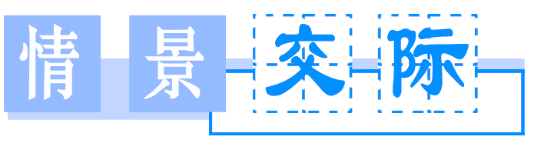

1．没听清楚请求重复：
Pardon？/I beg your pardon？/Sorry?
Would you please say that again？/Would you mind repeating that？/Would you please say that more slowly？/What do you mean by...in Chinese?
2．询问是否听清：
Is that clear？/Have I made myself clear？/Do you see what I mean?
3．澄清错误：
I'm sorry I've made a mistake.
I'm sorry.I should have said...
What I mean is...
That's not what I meant.
I'll try to explain that again.

1．(2011·安徽高考)—Oh，you sounded just like a native.
—________，I still have trouble expressing myself.
A．Well，not quite B．I don't care
C．Yes，you're right D．I'm glad you like it
【解析】 句意：——你的口音听起来像本地人。——也不完全是这样，我在自我表达方面还有困难。A项意为“不是很……，不完全是……”，符合句意。
【答案】 A
2．—________I can't follow you.
—I asked if you were a native of Shanghai.
A．Excuse me. B．Pardon?
C．I'm sorry. D．Thank you.
【解析】 由“I can't follow you”及答语看出，问句表达的是想让对方再重复一遍所说的话。故B项符合语境。
【答案】 B
3．—Tom，our English teacher asked you to go to his office as soon as you arrived.
—________What did you say?
A．I've got it.
B．I beg your pardon?
C．Excuse me.
D．Thank you.
【解析】 由答语中What did you say？这一信息可知，Tom没听清楚所说内容，故选B项。
【答案】 B
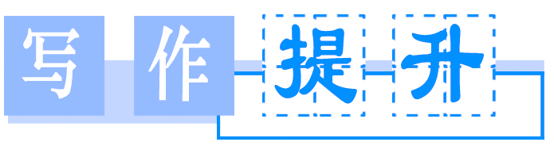
海报
海报是我们日常生活中极为常见的、告知公众有关信息的招贴。主要用于宣传电影、戏剧、比赛、文艺演出等活动。
海报要求语言简明扼要，形式新颖美观。海报要写清楚活动的性质(目的)、活动的主办单位、时间、地点等内容。
海报一般由标题、正文和落款三部分构成。
1．标题(Subject Line)
标题是海报的窗户，因此标题要做到简洁明了，新颖醒目，能够引起读者的兴趣和注意力。标题一般有两种形式：一种是直接用“Poster”一词，另一种是根据海报的内容写标题。
2．正文(Text)
正文是海报的核心，它是对海报标题的具体描述。语言要求生动形象，简明扼要。表现形式有说明式、美术设计式、图表式等。
3．落款(Signature of Sponsor)
落款要写明主办单位以及写海报的日期。海报的落款通常写在海报正文的右下角，日期位于主办单位名称的下方。

假设你是李华，是你校的学生会主席。请你根据以下提示信息写一则海报：
1．时间：2013年9月9日(星期一)晚上7点。
2．地点：学校报告厅。
3．活动：为即将到来的教师节举行文艺演出。
a．要提前10分钟入场；b.校长讲话，教师和学生代表(delegate)发言及学生文艺演出；c.不要乱扔垃圾。
注意：1.海报要包含以上要点。2.词数100左右。
词汇：civilized文明的
[思路分析]
1．将标题或“Poster”写在正文上方居中位置。
2．正文部分写明正文内容——；活动时间——；地点——；要求——；组织者——。
3．出海报单位及日期写在正文下方。
[词汇热身]
1．进行一些精彩的表演________________
2．欢迎某人去……________________
3．提前________________
4．期望某人做……________________
5．不要扔垃圾________________
6．讲话、演讲________________
【答案】 1.give some wonderful performances 2.sb.be welcome to 3.ahead of time 4.expect sb.to do sth. 5.do not leave litter 6.give a lecture/speech
[句式温习]
1．为迎接即将到来的教师节，我们将进行一些精彩的表演。
________________________________，we will give some wonderful performances.
2．所有学生都要提前10分钟入场。
________________________________before the performances begin.
3．校长和教师、学生代表讲话。
________________________________will make speeches.
4．确保不要乱扔垃圾。
________________________________in the hall.
【答案】 1.In order to celebrate the coming Teachers' Day 2.All students are welcome to the right place 10 minutes earlier 3.Not only our president but also some teacher and student delegates 4.Make sure you don't leave litter
[连句成篇]
________________________________________________________________________
________________________________________________________________________
________________________________________________________________________
________________________________________________________________________
________________________________________________________________________
【参考范文】
Poster
In order to celebrate the coming Teachers' Day，some performances will be given at 7 o'clock on September 9th,2013 (Monday evening)in the lecture hall.
All students are welcome to the right place 10 minutes earlier before the performances begin.
Our president will give a speech at the ceremony and some teacher and student delegates will make speeches first，and then the performances will start.
All are expected to be civilized audience and make sure you don't leave litter in the hall.
Wish you a nice evening!
The Students' Union
September 5th
(见学生用书第30页)

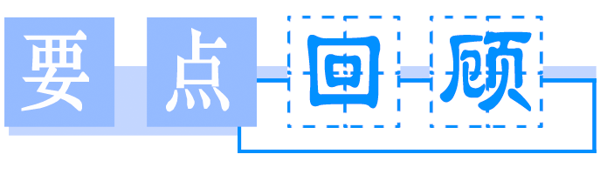
Ⅰ.立体式复习单词
A．基础单词
1．________n．航行，航海
2．________adv.实际上，事实上
3．________vt.以……为根据n.基部，基础，基地
4．________adj.较后的，后半的，后者的
5．________n．/vt.命令、指示，掌握
6．________n．/vt.请求，要求
7．________vt.辨认出，承认，公认
8．________n．口音，腔调，重音
9．________adv.直接，挺直adj.直的，笔直的，正直的
10．________adj.本国的，本地的n.本地人，本国人
11．________n．本身，本体，身份
【答案】 1.voyage 2.actually 3.base 4.latter 5.command 6.request 7.recognize 8.accent 9.straight 10.native 11.identity
B．词汇拓展
12．________adj.官方的，正式的，公务的→________n．官员
13．________adj.逐渐的，逐步的→________adv.逐渐地，逐步地
14．________n．词语，表示，表达→________vt.表示，表达
15．________adj.频繁的，常见的→________adv.常常，频繁地
16．________adj.流利的，流畅的→________adv.流利地，流畅地
【答案】 12.official；officer 13.gradual；gradually
14．expression；express 15.frequent；frequently 16.fluent；fluently
Ⅱ.递进式回顾短语
A．短语互译
1．________________因为，由于
2．________________走近，上来，提出
3．________________以……为基础
4．________________目前，现在
5．________________利用，使用
6．________________such as
7．________________play a part(in)
【答案】 1.because of 2.come up 3.be based on 4.at present 5.make use of 6.例如……，像这种的 7.扮演一个角色，参与
B．用上面短语的适当形式填空
8．The plan________________at the meeting yesterday.
9．No one knows where he is________________.
10．Sweet foods ________________chocolate can cause you to put on weight.
11．Computers________________modern society.
12．This song________________an old folk song.
13．The Internet resources should be ________________.
14．He had to retire ________________ill health.
【答案】 8.came up 9.at present 10.such as 11.play a part in 12.is based on 13.made use of 14.because of
Ⅲ.仿写式活用句型
1．Do you know that there is more_than one kind of English?
【句式仿写】 我们的飞机晚了两个多小时才起飞。
Our plane took off ________________________________________________________________________.
2．Native English speakers can understand each other even_if they don't speak the same kind of English.
【句式仿写】 即使你乘出租车也赶不上这辆火车了。
__________________，you will still miss the train.
3．Believe it or not，there is no_such_thing as standard English.
【句式仿写】 根本没有他描绘的这种UFO。
________________________________________________________________________he has described.
4．This_is_because in the early days of radio，those who reported the news were expected to speak excellent English.
【句式仿写】 那是因为他没有努力工作。
That's ________________________________________________________________________.
5．So people from the mountains in the southeastern USA speak with almost the_same dialect as people in the northwestern USA.
【句式仿写】 他和我在同一所学校上班。
He works in ________________________________________________________________________.
【答案】 1.more than two hours late 2.Even if you take a taxi 3.There is no such UFO as 4.because he didn't work hard enough 5.the same school as I do
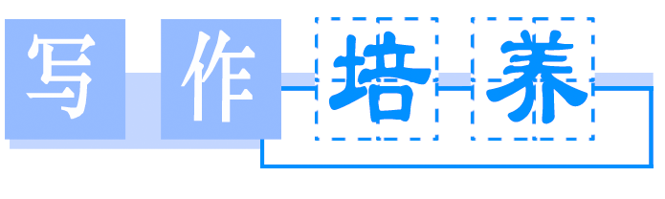
句子成分(二)
四、宾语

基本  概念 | 表示动作、行为的对象或承受者，包括单宾语、双宾语(间接宾语＋直接宾语)和复合宾语等形式。
句中  位置 | 一般在及物动词或介词后；间接宾语通常放在直接宾语前，也可在其后，但此时前面须加介词to或for，直接宾语为人称代词时，间接宾语一般后置。
表现  形式 | 名词、代词、数词、the＋形容词、不定式(短语)、动名词(短语)、从句
典型  例句 | You can leave your pet with me while travelling.(名词)  He gave me some good advice.(代词，名词)  Please take them to the waiting room.(代词)  They only bought three.(数词)  He's always helping the_poor.(the＋形容词)  He refused to_do_it.(不定式短语)  Tom likes playing_football.(动名词短语)  I don't know if_the_plane_will_arrive_on_time.(从句)
【特别提示】
①双宾语由间接宾语加直接宾语构成，间接宾语表示动作的方向或目的，常指人且须与直接宾语并存；
②复合宾语由宾语加宾语补足语构成，补足语是对宾语的补充说明，宾语与补足语间有逻辑上的主谓关系。
五、补语

基本  概念 | 补充说明宾语或主语的意义、状态等，分别叫做宾语补足语和主语补足语。
句中  位置 | 宾语补足语通常置于宾语之后，主语补足语通常置于主语和谓语之后。
表现  形式 | 名词(短语)、形容词、副词、介词短语、不定式(短语)、分词(短语)
典型  例句 | We made him our_monitor.(宾补，名词)  I found it difficult to learn maths.(宾补，形容词)  We showed him around.(宾补，副词)  The machine was found in_a_bad_state.(主补，介词短语)  The factory was ordered to_be_closed.(主补，不定式短语)  He was seen opening_the_window.(主补，现在分词短语)  He has just had his hair_cut.(宾补，过去分词)
指出下列句子画线部分的句子成分和表现形式。
1．We should help the_old_and_the_poor.
________________________________________________________________________
2．Did you write down what_he_said?
_______________________________________________________________________
3．He gave it_to_me yesterday.
________________________________________________________________________
4．Give the_poor_man_some_money.
________________________________________________________________________
5．We will make them_happy.
________________________________________________________________________
6．We found nobody in.
________________________________________________________________________
7．Please make yourself at_home.
________________________________________________________________________
8．I'll have my bike repaired.
________________________________________________________________________
9．He was elected monitor.
________________________________________________________________________
10．She was found singing_in_the_next_room.
________________________________________________________________________
【答案】 1.宾语，the＋形容词/名词化形容词 2.宾语，从句 3.双宾语，直接宾语＋间接宾语 4.双宾语，间接宾语＋直接宾语 5.复合宾语，宾语＋补足语 6.宾语补足语，副词 7.宾语补足语，介词短语 8.宾语补足语，过去分词 9.主语补足语，名词 10.主语补足语，现在分词短语

