2016安徽中考英语试卷
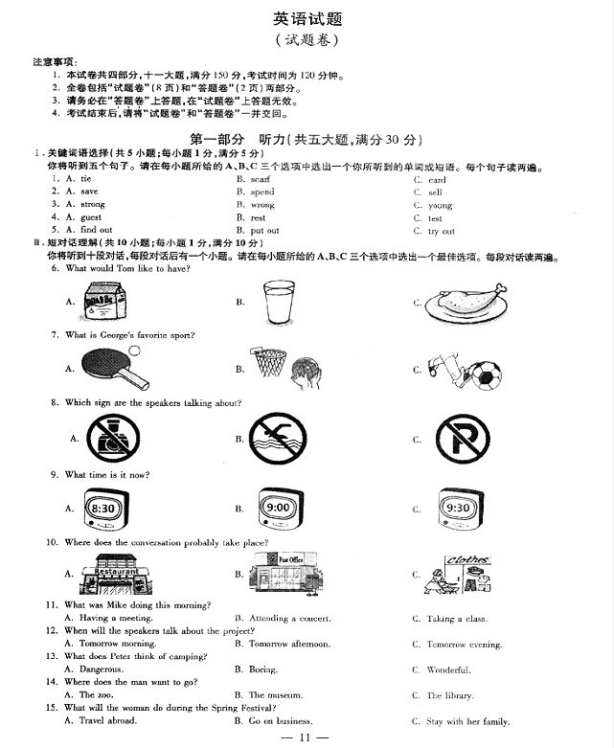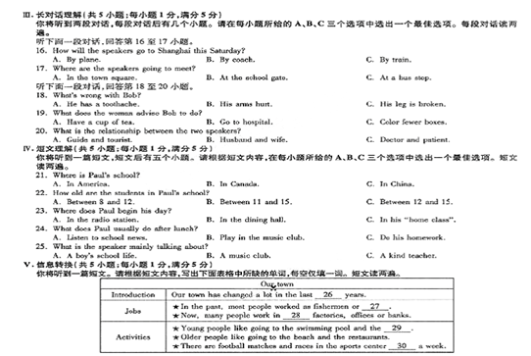

第二部分 英语知识运用（共两大题，满分45分）
VI. 单项填空（共15小题；每小题1分，满分15分）
从每小题所给的A、B、C、D四个选项中选出一个可以填入空白处的最佳选项。
31. —Nice to meet you, Mr Green. I’m Sandy and this is Brad, Ken and Emily.
— .
A. See you later B. You’re welcome
C. Pleased to meet you all D. You have a point there
32. Cathy has such a good that she won many prizes in singing competitions last year.
A. sleep B. idea C. voice D. time
33. Helen has got two brothers. of them likes chocolate, but she loves it.[来源:学科网ZXXK]
A. Neither B. None C. Each D. Any
34. When the baby dog , it was very hungry. So we gave it some food.
A. is found B. was found C. has been found D. will be found
35. Mr. Black’s memory is getting . As a result, he often leaves his keys at home.
A. older B. poorer C. greater D. better
36. Many wild animals are , and it’s time for us to do whatever we can to protect them.[来源:学科网]
A. on duty B. on show C. in order D. in danger
37. Please don’t make so much noise. I hear the speaker very well.
A. needn’t B. mustn’t C. can’t D. shouldn’t
38. —Look at the stone bridge! Do you know it was built?
A. when B. how C. where D. why
39. Don’t hurry him. You will just have to be and wait until he finishes the work.
A. active B. careful C. patient D. famous[来源:学科网ZXXK]
40. For our own safety, it’s important to the traffic rules on the way to school.
A. follow B. change C. make D. break
41. I saw Sam and David in the playground yesterday afternoon. They games with their classmates then.
A. play B. will play C. are playing D. were playing
42. Taking some exercise every day will fat and make you fit.[来源:学+科+网]
A. turn to B. sell out C. burn off D. put on
43. , Chinese people celebrate the Mid-Autumn Festival by enjoying the full moon and eating mooncakes.
A. Quickly B. Suddenly C. Secretly D. Traditionally
44. Our world will get better and better each of us lives a greener life.
A. before B. if C. though D. until
45. —I think it takes a lot of practice to play the violin well.
— . Practice makes perfect.
A. No way B. My pleasure C. I’m afraid not D. That’s true.
VII. 完形填空（共20小题：每小题1.5分，满分30分）
阅读下列短文，从每小题所给的A、B、C、D四个选项中选出一个最佳选项。
A
Let me tell you about the best day of my life! I got up early and ran to the kitchen in my pyjamas（睡衣）.It was my thirteenth birthday and I was really 46 . In fact, I wasn’t sleeping all night because I kept 47 all the presents I would get.
I walked into the kitchen with a big smile on my face, 48 nobody looked up. Mum and Dad were reading their newspapers while my two older brothers were eating breakfast. 49 said a word! “They have forgotten about my birthday!” I said to myself. I turned around and walked out of the 50 . Suddenly, I heard a noise, so I went back to 51 what it was. I couldn’t believe my eyes! There were lots of 52 on the kitchen table. “Surprise!” I heard 53 me. When I turned around, I saw Mum, Dad and my brothers! Mum was holding a huge 54 with candles and they were singing “Happy birthday” to me. We shared the cake and opened all the presents.
They didn’t 55 my birthday after all. It really was the best day of my life!
46. A. lonely B. excited C. successful D. weak
47. A. thinking about B. picking up C. taking out D. putting away
48. A. for B. so C. or D. but
49. A. Nobody B. Anybody C.Somebody D. Everybody
50. A. garden B. kitchen C. bedroom D. study
51. A. see B. taste C. explain D. choose
52. A. newspaper B. presents C. menus D. rings
53. A. of B. above C. behind D. from
54. A. picture B. bowl C. spoon D. cake
55. A. realise B. enjoy C. forget D. celebrate
B
Philip is the bravest boy I know. His friends and family are all very 56 him.
Ten-year-old Philip was born with an 57 which means that he is always breaking his bones（骨头）. Although he has such a serious illness, Philip 58 playing sports. In January last year he 59 wheelchair racing. He came second in his first 60 , and since then Philip has won every other race!
In order to look for a new challenge（挑战）， Philip 61 to take part in the London Wheelchair Marathon（马拉松）. 62 , five days before the race Philip got sick. He didn’t want to 63 . He finally made up his mind to take part. Philip was given medicine by his doctor and guess what? He not only 64 it, but he also finished in first place!
Philip is very 65 and never gives up. That’s why he has been chosen to be the Bravest Child of the Month.
56. A. proud of B. afraid of C. angry with D. strict with
57. A. ability B. effort C. illness D. interest
58. A. stops B. avoids C. minds D. loves
59. A. watched B. started C. cancelled D. held
60. A. journey B. race C. class D. interview
61. A. regretted B. hated C. failed D. decided
62. A. Instead B. Also C. However D. First
63. A. give up B. sit down C. set off D. go out
64. A. refused B. left C. completed D. invented
65. A. brave B. honest C. polite D. fair
第三部分 阅读理解（共两大题，满分45分）
VIII. 补全对话（共5小题：每小题1分，满分5分）
根据对话内容，从方框内的选项中选出能填入空白处的最佳选项，其中有两个为多余选项。
Lisa: Hey, Jane. 66
A. Me, too.
B. I hope not.
C. No problem.
D. What a shame!
E. Sounds like fun.
F. When exactly is it?
G. My friend Susan is having a party this weekend.
Jane: Really?
Lisa: Yeah, it’s a dancing party.
Jane: 67
Lisa: Do you want to go with me?
Jane: Can I? I don’t really know Susan.
Lisa: 68 She said I could invite a friend.
Jane: OK, then, I’d love to go. 69
Lisa: On Saturday night.
Jane: Wow, that’s the day after tomorrow! I need to get a new dress.
Lisa: 70 There’s a clothes shop near here. Let’s go there after work.
Jane: Sounds good!
IX. 阅读理解（共20小题：每小题2分，满分40分）
阅读下列短文，从每小题所给的A、B、C、D四个选项中选出一个最佳选项。
A
Marco Polo was from Venice, Italy. In 1271, at age 17, Marco went on a trip with his father and uncle to China. Today people often travel to different places around the world. But it was very hard for people from Europe to visit China then. After three and a half years, the Polos reached China on 1275.
While he was there, Marco Polo worked Kublai Khan, the emperor（皇帝）of China. He was able to learn and experience many things that were new to Europeans. In his diary, he wrote, “Kublai Khan’s palace is the greatest I’ve ever seen. The streets of the new capital. Daidu, are so straight and so wide.” Paper money also took him by surprise, since it was not yet in use in the West at that time. Homes were beated with “black stones... which burn like wood.” These stones were coal, and most of the Europeans knew little about it then.
After 17 years in China, Marco and his family finally returned to Venice in 1992. After he returned home, Marco completed a book about his trip, full of facts about his wonderful experiences in China.
71. How was Marco Polo’s three-and-a-half-year journey to China?
A. Expensive. B. Comfortable. C. Difficult. D. Smooth.
72. The Polos finally got to China in .
A.1271 B. 1275 C. 1288 D. 1292
73. What did Marco do when he was in China?
A. He worked for the emperor. B. He learned to build city streets.
C. He helped to dig for coal. D. He finished a book about his trip.
74. What would be the best title for the passage?
A. Magic “black stones” B. Marco Polo in China
C. Paper money on Daidu D. Kublai Khan—the greatest emperor
B
Robots seem to be getting cleverer and cleverer. Here are four examples.
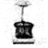  Budgee  ·He was created by Five Elements Roboties.  ·With two wheels and a little basket, he can carry things for you while you’re at the shops. | Paro  ·He was made by Takanori Shibata.  ·He is used on patients in hospitals.  ·He can learn a name and even show feelings such as surprise, happiness and sadness.
Rover  ·He was created by a team at Sydney University.  ·He is used to make cows move together from a field to a diary（牛奶场）. | Simon  ·He was developed by the Georgia Institute of Technology.  ·He can clean up offices.  ·In tests, he could tell whether someone was paying attention to him or not.
75. Which robot can help you when you are shopping?
A. Budgee. B. Simon. C. Paro. D. Rover.
76. We can learn from the passage that Paro .
A. can tell whether others pay attention to him B. was created by Five Elements Roboties
C. can help cows produce more milk D. is used on patients in hospitals
77. What can Simon do according to the passage?
A. Show feelings. B. Clean offices. C. Move cows. D. Learn names.
78. Where does the passage probably come from?
A. health report. B. A tourist map. C. A science magazine. D. A medical dictionary.
C
The olive（橄榄）tree probably first grew in southern Asia. And then it spread to Mediterranean（地中海的）countries about 6,000 years ago. Since then, it has been important in Mediterranean people’s lives.
The olive tree grows in rocky places and it doesn’t need much water. Its fruit can be made into olive oil. People have used olive oil to cook dishes for centuries. But they haven’t only used it for cooking. Some ancient cultures believed that it was useful as medicine. In modern times, people still use olive oil both for its taste and its health advantages.
Olive oil has also been an important product in the business and culture of Mediterranean countries. In ancient Greece, for example, anyone who cut down an olive tree was heavily punished. Winners at the Olympic Games wore wreaths（花环）. They were made of olive branches（树枝）. Sometimes winners were also given a prize of olive oil. People from Greece built ships so that they could use olive oil for trade. But it was the Romans who grew the olive tree in the rest of southern Europe and northern Africa.
Today, olive oil is still a very valuable product, and many different kinds of olive oil are sold in countries all over the world.
79. Where did the olive tree probably first grow?
A. In Asia. B. In Africa. C. In Europe. D. In America.
80. What can we learn about olive oil?
A. People started to cook with it recently. B. It is made from olive branches.
C. People used it to build ships in Greece. D. It can be good for health.
81. In ancient Greece, people who cut down an olive tree .
A. were wreaths B. were heavily punished
C. got a prize of olive oil D. were regarded as heroes
82. The passage is mainly about .
A. A. the method of cooking B. the trade of Greece
C. the history of the Olympic Games D. the story of olive oil
D
While many young people were enjoying the summer vacation, Zach Bonner was working his hardest. Zach started walking from Valrico, Florida, his hometown, on Christmas, 2009. He reached Los Angeles nine months later in September, 2010. He covered a total of 2,478 miles and raised $120,000 for kids in need. Along the way, Zach attended school online. His mother, brother and sister took turns to walk or drive together with him.
Although he is very young, Zach has a long history of helping others. When a terrible storm hit town in 2004, Zach, when six, pulled a wagon（小推车）through his community and collected food for people in need.
He has raised $400,000 for his Little Red Wagon Foundation since then. It gives money to projects which help homeless children. In 2007, Zach began walking to support a children’s charity（慈善组织）in Tampa, Florida. He finished his journey 23 days later, 280 miles away in Tallahassee. Then in the summer of 2009, he trekked about 670 miles from Atlanta to Washington, D.C., in just two months.
“As long as there are homeless kids, I will never stop walking for them.”Zach says.
83. What did Zach do during the summer vacation in 2010?
A. He stayed at home to look after his family.
B. He travelled to his hometown with his family.
C. He joined in a school activity with other kids.
D. He walked to collect money for kids in need.
84. We can learn from Paragraph 2 that Zach .
A. began to help people at a very early age B. made money to pay for his education
C. enjoyed playing around in his community D. worked very hard for his family
85. At what age did Zach start walking to support a Tampa children’s charity?
A. At six. B. At nine. C. At eleven. D. At twelve.
86. The underlined word “trekked” in Paragraph 3 probably means “ ”.
A. 延伸 B. 挖掘 C. 跋涉 D. 飞行
87. Which of the following best describes Zach?
A. Friendly and shy. B. Silly but lovely. C. Kind and helpful. D. Clever but lazy.
阅读短文，并用英语回答问题（请注意每小题后面的词数要求）。
E
Rock climbing is a popular hobby that many people enjoy doing. You can do it indoors on special walls or outdoors on real mountains. There are many advantages of rock climbing—it is fun and it also helps people forget worries.
The most important equipment（装备）to have is good shoes. They need to be half a size smaller than your usual size. The next thing you need is a harness（保护带）. This allows you to move freely, but will hold you up if you fall. It’s important to know how to use your equipment. If you are a beginner, it’s best to have lessons. A climber with experience can help you a lot in the beginning.
Rock climbing is very exciting for people of different ages. Climbers, however, must be careful not to pollute the environment. Sometimes rock climbers leave rubbish on the mountains where they climb. They should take it with them and throw it away. This will allow future climbers to enjoy a clean environment.
88. What advantages does rock climbing have?（不超过10个词）

89. What equipment does a climber need?（不超过10个词）

90. How can climber help protect the environment while climbing?（不超过15个词）

第四部分 写（共两大题，满分30分）
X. 单词拼写（共5小题：每小题1分，满分5分）
根据首字母及汉语提示，完成下列单词的拼写，使句意明确，语言通顺。
91. Mary has developed a new way of life by getting close to n （自然）.
92. Frank, take off your w （湿的）jacket so you don’t catch a cold.
93. This Chinese painting is the greatest work of a （艺术）I have ever seen.
94. The little girl k （亲吻）her mum good night before she goes to bed.
95. I’m s （确信的）that out dream will come true through our efforts.
XI. 书面表达（共1小题：满分25分）
假定你是李华，你的美国朋友Jack来信，说他暑假期间要来中国交流学习。他学了两年中文，但是仍然担心用中文交流时会遇到困难。请你用英语给Jack写封回信，提几点建议，要点如下：
1. 大胆自信；
2. 放慢语速；
3. 借助图画或肢体语言等表达方式。
注意：1. 词数80-100；
2. 可适当增加细节，以使行文连贯；
3. 信中不能出现与本人相关的信息；
4. 开头和结尾已为你写好，不计入总词数。
参考词汇：自信的 confident 肢体语言 body language
Dear Jack,
How is everything going? I am very glad to learn that you are coming to China this summer.

Best wishes!
Yours,
Li Hua

英语试题参考答案及评分标准
第一部分 听力
I.1-5 CACBA
II. 6-10 BCBAC 11-15 ABCBC
III. 16-20 CBBAB
IV. 21-25 ACCBA
V. 26. forty/40 27. farmers 28. car 29. cinema 30. once
评分标准：1-30题每小题1分。（26-30题中的单词拼写错误可酌情扣分）
第二部分 英语知识运用
VI.31-35 CCABB 36-40 DCACA 41-45 DCDBD

VII. 46-50BADAB 51-55 ABCDC 56-60 ACDBB 61-65 DCACA

第三部分 阅读理解
VII. 66-70 GECFA

IX. 71-75 CBABA 76-80 DBCAD 81-85 BDDAB 86-87 CC
88. It is fun and it also helps people forget worries.
89. Good shoes and a harness.[来源:Z|xx|k.Com]
90. They should take the rubbish with them and throw it away.
第四部分 写
X.91. nature 92. wet 93.art 94. kisses 95. sure
XI. One possible version:
Dear Jack,
How is everything going? I am very glad to learn that you are coming to China this summer. It’s not necessary to worry your Chinese. I’d like to share my ideas, which I think might help.
First, be brave enough to speak Chinese when you communicate with others. It’s of great important to be confident about yourself. We Chinese are very friendly so you needn’t be afraid of making any mistakes. Second, it’s better slowly and clearly. In this way you can make yourself understand more easily. What’s more, sometimes you can use drawings or pictures, and as you know, body language is also widely used across cultures and very often it really works.
Best wishes!
Yours,
Li Hua
