2016厦门市初中毕业及高中阶段各类学校招生考试
英 语
（试卷满分：150分 考试时间：120分钟）

准考证号___________ 姓名___________ 座位号___________
考生注意：
本试卷分为两大部分，第一部分（1-61小题）为选择题，请考生将答案用2B铅笔填涂在答题卡上；第二部分为非选择题，请考生将答案用0.5毫米的黑色签字笔书写在答题卡上。
第一部分 （选择题）
（一）听力测试（每小题1.5分，共30分）
I. Listen and choose the right pictures.
(听音，选择符合内容情景的图片。听两遍)
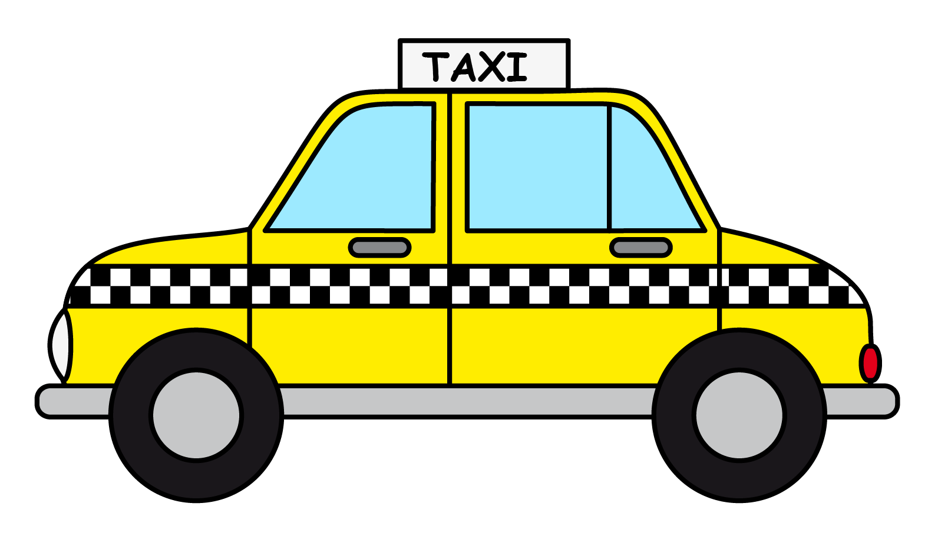
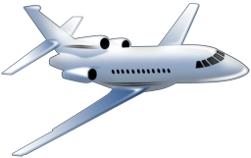
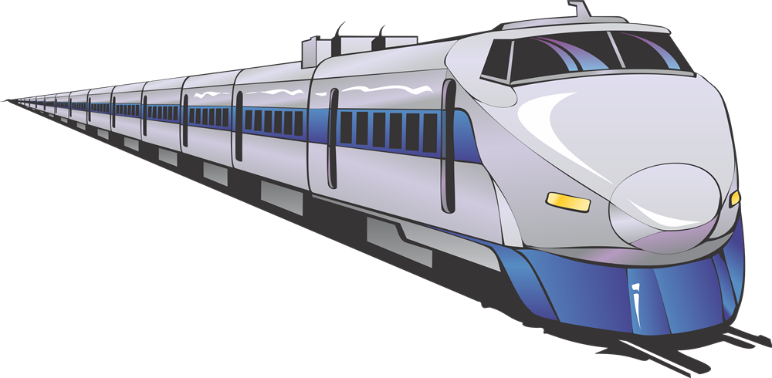

1. A B C

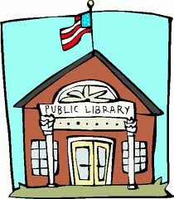


2. A B C


[来源:学科网ZXXK]
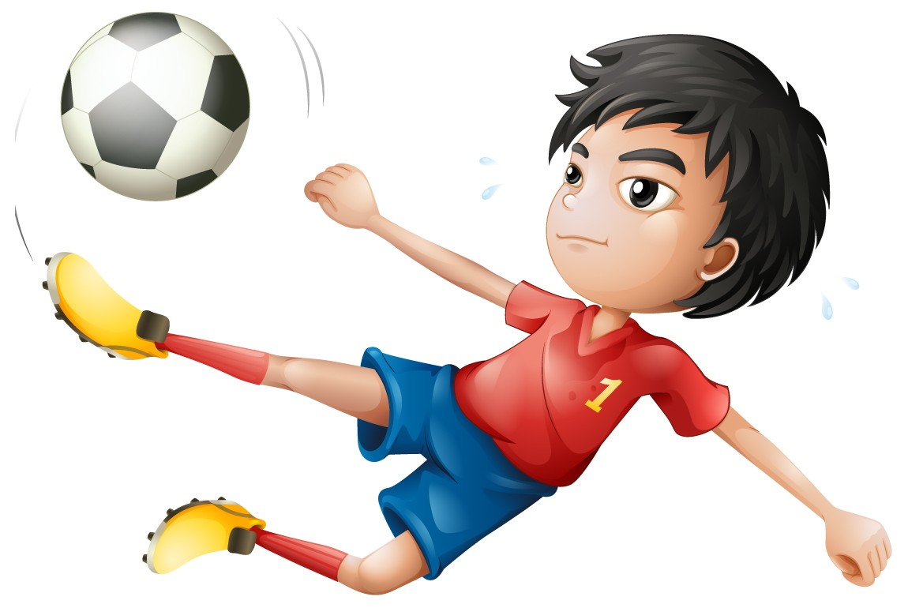

3. A B C




4. A B C
II. Listen to some short dialogues and choose the right answers to the questions you hear.
(听简短对话，然后挑选最佳答案回答所听到的问题。听两遍)
5. A. A teacher. B. A student. C. An officer.
6. A. History club. B. Art club. C. Science club.
7. A. Delicious. B. Healthy. C. Expensive.
8. A. Cool. B. Hot. C. Wet
9. A. Watch movies. B. Go to concerts. C. Do sports.
10. A. On July 6. B. On July 13. C. On July 20.
III. Listen to a long dialogue and a passage, then choose the right answers to questions 11-16.
(听一篇较长对话和一篇短文，然后选择正确答案作答11-16小题。听两遍)
Text A
11. The woman thinks she has a ________.
A. headache B. cold C. sore back
12. She has felt sick for about ________.
A. one day B. three days C. a week
13. The doctor suggests that she should ________.
A. stay in hospital for more exams
B. go home for more rest
C. go around for more exercise
Text B
14. The expression comes from something that happened in the ________.
A. zoo B. park C. market
15. A bad trader pretended a cat was a ________.
A. pig B. dog C. bird
16. When someone says “Don’t let the cat out of the bag”, he wants others to ________.
A. make a promise B. share a pet C. keep a secret

注意：请将该题的答案书写在答题卡的第二部分
IV. Listen to a passage, then fill in the blanks with the right words.
(听一篇短文，用恰当的单词填空完成62-65小题，每空一词。听三遍)
Name | 62. ________ to volunteer
Julia | Need to 63. ________ each other
Paul | Have the 64. ________ to give
Cindy | Make a 65. ________ to the city

（二）基础知识与运用（每小题1.5分，共30分）
V. 选择填空：从A、B、C中, 选出一个最佳答案完成句子。
17. — The milk shake tastes good. How do you make it?
— It’s easy, just follow the ________.
A. discussions B. instructions C. resolutions
18. — What a great thing to have a robot at home!
— Robots are really useful. One day they will help people do almost ________.
A. something B. everything C. nothing
19. — Have you seen the movie Zootopia?
— Yes, I have seen it twice. Of all the movies I’ve ever seen, it’s the ________ one.
A. interesting B. more interesting C. most interesting
20. — I think everyone should play a part in saving our environment.
— I agree. For example, there will be less air pollution ________ we drive less.
A. if B. so C. though
21. — These schools look cool. ________ are they?
— They are on sale, only $69.
A. How much B. How long C. How many
22. — Tom, let’s hang out after school.
— Sorry. I have ________ Frank to work on the biology report with him.
A. advised B. expected C. promised
23. — It’s the second time I came to Xiamen. It ________ a lot.
— Yes, it’s more and more beautiful.
A. was changing B. has changed C. will change
24. — These days, teenagers often have to do what they ________ to.
— It’s not good for their independence. They need to think on their own.
A. tell B. are telling C. are told
25. — I’ve made much progress in grammar. The ideas you ________ worked out fine.
— Glad I could help.
A. came up with B. ran out of C. looked up to
26. — I’d like to read some Chinese classics. Any suggestion?
— Journey to the West. It’s a book ________ is about Monkey King.
A. what B. who C. that
27. — Does anybody want to share ________ on Father’s Day?
— I bought a tie for my father. He loves it.
A. what you did B. where you went C. when you shopped
28. — Would you like to go to Shanghai Disneyland? It opened this June.
— ________. I’m sure I’ll have a great time there.
A. I’m afraid not B. It doesn’t matter C. That sounds like fun
VI. 完形填空：从A、B、C中，选择一个最佳答案，使短文意思完整。
At my primary school, I was one of the smartest kids there. I never 29 , but always got near perfect scores on all my tests. I was a child genius (天才), at least in my mind. I was also 30 music and sports. I was pretty sure that once I got to seventh grade, everyone including my teachers would be 31 by me.
But actually, they weren’t.
When I arrived at my new class, it seemed that there was always someone else who could do 32 than I. My grades got worse and I needed to actually be studying for my tests. I believed I wasn’t smart. I believed I wasn’t talented. I believed I 33 .
Over the next two years, I had to work very hard for everything I did. Grades were still very low but gradually 34 . I worked really hard but was still never the best at everything.
But do I really have to be the best at everything? All the pressure I was feeling, all that 35 when I did wrong, that was me! I was being too hard on myself. In fact, when I did badly on a test, my classmates would never 36 me.
No one is perfect. There will probably always be someone better than me at something. I will never be the number one at everything, and it’s really Okay.
29. A. forgot B. studied C. regretted
30. A. busy with B. tired of C. good at
31. A. amazed B. scared C. fooled
32. A. better B. easier C. slower
33. A. passed B. failed C. relaxed
34. A. improving B. fighting C. reporting
35. A. development B. excitement C. embarrassment
36. A. help with B. laugh at C. learn from
（三）阅读理解（每小题2分，共50分）
VII.阅读以下五篇短文，根据文章的内容选择最佳答案作答37-61小题。
A
An old gentleman whose eyesight (视力) was falling came to stay in a hotel room with a bottle of wine (酒) in each hand. On the wall there was a fly which he took for a nail (钉子). So as soon as he hung them on, the bottles fell broken and the wine split all over the floor.
When a waitress discovered what had happened, she felt really sorry for him and wanted to give him a hand.
So the next morning when he was out taking a walk in the garden, she put a nail on the wall exactly where the fly had stayed.
Now the old man entered his room. The smell of the split wine reminded him of the accident. When he looked up at the wall, he found the fly was there again! He walked to it carefully and hit it with all his strength.
On hearing a loud cry, the waitress rushed in. To her great surprise, the poor man was there sitting on the floor, his face was pale and a lot of blood was running on his right hand.
37. We know from this passage that ________.
A. the old man had poor eyesight
B. the old man’s hands weren’t so strong
C. the bottles of wine were too heavy
38. Picture ________ was the thing the old man saw on the wall for the first time.

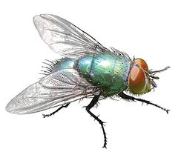
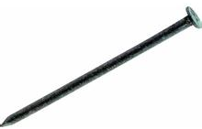
A. B. C.

39. The nail was put on the wall by ________.
A. the old man B. a gardener C. the waitress
40. The waitress must be a ________ girl.
A. careless B. kind-hearted C. dangerous
41. The old man’s hands was badly hurt because ________.
A. the hotel’s service was terrible
B. he drank too much wine
C. he mistook the nail for a fly
B
The traditional Chinese lunar calendar divides the year into 24 solar terms. Grain Rain (谷雨), as the last term in spring, starts on April 19 and ends on May 4.
Grain Rain comes from the old saying, “Rain brings up the growth of hundreds of grains”, which shows that this period of rainfall is very important for the growth of crops. Here’s something that you may not know about the Grain Rain.
1. ________  Grain Rain falls between the end of spring and the beginning of summer, and the temperature rises much higher than it does in March. With dry soil and heavy winds, sandstorms may happen more often. | 2. ________[来源:Zxxk.Com]  There is an old custom in southern China that people drink tea on the day of Grain Rain. Spring tea during Grain Rain is good for the eyes. It is also said that drinking tea on this day would prevent bad luck.
3. ________  People in northern China have the tradition to eat the vegetable toona sinensis during Grain Rain. An old Chinese saying goes “toona sinensis before the rain is as tender as silk (嫩如丝)”. The vegetable is good for the stomach and skin. | 4. ________  The Grain Rain Festival is celebrated by fishing villages in northern China. Grain Rain marks the start of the fishermen’s first voyage (航行) of the year. The custom dates back to more than 2000 years ago.
42. When Grain Rain ends, ________ starts.
A. spring B. summer C. autumn
43. The underlined word “crops” refers to ________.
A. plants in the field B. trees in the forest C. fishes in the sea
44. The people in southern China ________ on the day of Grain Rain.
A. drink tea B. eat toona sinensis C. start the first voyage
45. We can infer that “toona sinensis” must be a kind of vegetable which ________.
A. can bring good luck B. is delicious and healthy C. grows at the seaside
46. The right order of the titles from 1 to 4 should be ________.
a. Eating toona sinensis
b. Sandstorms happen
c. Grain Rain Festival
d. Drinking tea
A. b-a-d-c B. b-c-a-d C. b-d-a-c

C

Car-hailing company DiDi signed an agreement with TAL Education Group to provide free online courses for the children of taxi drivers. The courses, worth 30 million yuan, cover all subjects from primary to high school. Children can study courses at home, saving parents’ time to spend or pick up children from off-line after-school classes.
According to Zhu Jingshi, vice president of DiDi, all 153 million registered (注册) taxi drivers of DiDi can ask for the courses on the company’s mobile app. The car-hailing company will evaluate (评价) the drivers and provide courses on the basis of the time they became registered drivers with the company, the number of passengers served and evaluation from passengers.
The health and education of children have remained top priorities of Chinese parents, including taxi drivers. A survey done by DiDi and TAL showed that although the average monthly income (平均月收入) of taxi drivers is only 6000 yuan, many would like to pay 40 percent of their income for their children’s education.
The survey found that most taxi drivers were born in the 1970s and 1980s and worked seven days a week. More than 70 percent of them have children under 18 but very few have time to be with family and children. Only 8 percent of them said they had guided their children in doing homework. Because of these, 60 percent of drivers hope their children could receive the guidance from professional services.
47. The online courses would help taxi drivers ________ for their children’s education.
A. find good schools B. get better teachers C. save time and money
48. The children of taxi drivers would take the courses like Picture ________.

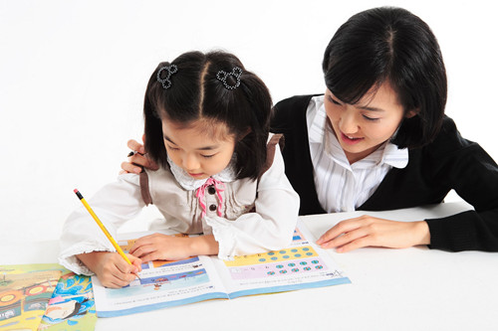

A. B. C.

49. The underlined sentence “The health and education...” means that ________.
A. most of the taxi drivers have little time to take care of their children
B. Chinese parents care about the health and education of their children most
C. lots of children of taxi drivers are in poor condition of health and education
50. According to a survey, many taxi drivers would spend about ________ yuan on their children’s education a month.
A. 2400 B. 4000 C. 6000
51. This passage mainly tells us about ________.
A. a new kind of transportation called DiDi
B. the free online courses for taxi drivers’ children
C. the taxi drivers working hard day and night
D
Everyone has a beautiful memory about school which is hard to forget. Among many things, relationships are the hardest to leave behind. Some schools try to stop students’ puppy love in different ways. Anything about “love” relationship is not allowed. For example, a middle school in Fu’an, Fujian Province forbids (禁止) boys and girls to sit together for meals and forbids boys to look at girls for a long time; a middle school in Luohe, Henan Province sets rules that boys and girls should meet in bright places with at least 5 other classmates, and if they meet in private they will be asked to go home with parents for more than a week and even advised to leave school; a middle school in Jinan, Shandong Province forbids everyone to send food and gifts to or receive them form the opposite sex (异性). It also forbids students to help the opposite sex with bags and coats and requires a “44 cm” distance between boys and girls.
Some students are not satisfied with such rules. “Why should we have strict places for different sexes to eat? It’s not using bathrooms!” Some people who care about the intelligence development of the students say that they should be more creative with fewer rules. For this, I’d like to say that middle school students are going through puberty (青春期). It’s normal for them to have some feelings for the opposite sex. Schools should provide correct guidance and education instead of giving simple and cruel rules and asking the students to follow.
52. The first paragraph mainly tells us about ________.
A. a beautiful memory of school to leave behind
B. some strict rules to stop students’ puppy love
C. some opinions to deal with students’ puppy love
53. In a middle school in Jinan, a boy can’t ________ a girl.
A. sit for meals with B. meet in private with C. send a gift to
54. We’ve learnt about ________ rules made by schools as examples in this passage.
A. 3 B. 6 C. 9
55. Which of the following statements is TRUE according to this passage?
A. Not all the students agree with the rules made to stop puppy love.
B. In a middle school in Fu’an, boys and girls can’t sit together in class.
C. Those rules can help students go through puberty without any difficulties.
56. The writer thinks ________.
A. it’s necessary to make such strict rules
B. schools needn’t do anything to stop puppy love
C. good guidance and education are better than rules only
E
Lockheed Martin, American space system company (空间系统公司) has found a really cool way to inspire the young minds of today to the research fields in Science, Technology, Engineering and Math (STEM).
It may look like a normal yellow bus, but all the magic happens once you get inside. Meet the “Mars (火星) Experience Bus,” part of Lockheed Martin’s new “Generation Beyond” national education program to get the kids joining in studying what goes on outside of our home planet. The bus offers a virtual reality (VR, 虚拟现实) experience making the teenagers feel like they are driving on Mars.
The VR experience was developed by taking advantage of software (软件) created for today’s best video games, so you can imagine the picture shown is top level. The kids do seem really excited to see the bus take a virtual trip on the red planet and search unknown places. It’s certainly a great way of leaning about the universe by virtual reality working on a common bus.
The Lockheed Martin’s bus will start a tour in the United States to allow kids from different parts of the country to take a ride in it. The Generation Beyond project also includes an iPhone app for iOS providing real-time information about weather reports for Mars, and there’s also a free deep space course for middle school teachers and students.
57. “A really cool way” in the first paragraph refers to ________.
A . A science subject B. Mars Experience Bus C. Video game software
58. “Generation Beyond” is a/an ________.
A. school bus B. educational project C. vocation trip
59. The VR experience was developed from ________.
A. video games B. space science C. diving systems
60. Which of the following statements is TRUE according to this passage?
A. It just looks like a normal school bus after you get inside.
B. Kids are sure to be more interested in all subject after the experience.
C. You can get the real-time weather reports for Mars with the iPhone.
61. The best title of this passage may be ________.
A. The common yellow bus B. The mysterious red planet C. The magic VR tour
第二部分（非选择题）
（四）情景交际运用（共15分）
VIII. 根据对话情景，填入恰当的单词。（每空一词，每词1分，共5分）
Mr. Brown: Good morning. My name is Edward Brown. I’m your new 66. ________, and I moved in yesterday.
Mrs. Smith: Good morning, Mr. Brown. May I help you?
Mr. Brown: I’m trying to do some work now. But I’m afraid your children are making too much 67. ________.
Mrs. Smith: Oh, I’m sorry, Mr. Brown. But you know it’s 68. ________ to keep little boys quiet.[来源:Z*xx*k.Com]
Mr. Brown: But I can’t stand it any more. I couldn’t work and I couldn’t 69. ________ at all last night.
Mrs. Smith: I’m very, very sorry. I’ll do my best to keep them quiet. But I’m not sure it’ll work.
Mr. Brown: Well, it seems I have to put up with it now.
Mrs. Smith: Don’t 70. ________. My husband will come back from business tonight. And the boys always listen to him.
IX. 根据情景提示，用恰当的短语或句子填空。（每句2分，共10分）
* 你想知道钥匙在哪儿,你可以这么问：
71. ________________________________________________________________________________________________?
* 你想知道对方是否有兄弟姐妹,你可以这么问：
72. ________________________________________________________________________________________ or sisters?
* 你的新同桌Tina是一位个子高高、性格外向的女孩，你可以这么介绍：
73. Tina ____________________________________________________________________________________________.
* 你想了解对方多久锻炼一次，你可以这么问：
74. ________________________________________________________________________________________________?
* 你想告诉大家“上学不能迟到”，你可以这么说：
75. Don’t ___________________________________________________________________________________________.

（五）写作（共25分）
X．段落编写（本题10分）
使用所给的词语，编写一个意义相对完整的语段。
提示词：family, decide, important, ago, because
要求：1. 使用全部提示词，并在语段中用下划波浪线“ ”标出提示词；
2. 语段具有一个相对合理的主题意义；
3. 词数为50词左右，最多不超过80词。

XI. 短文写作（本题15分）
马上要初中毕业了，假如你有机会负责组织你们班的“毕业派对”，你将会如何构思设计出一个充满创意、情感和品位的毕业庆祝活动呢？请写一篇80词以上的短文，介绍你的毕业派对计划。
内容要求：1. 简介大致的构思；
2. 分点列出活动流程；
3. 小结活动的主要特色。
注 意：短文中不允许出现与考生本人相关的真实姓名和校名等信息。

试题结束,请认真检查！
2016年厦门市初中毕业及高中阶段各类学校招生考试听力录音稿
I. Listen and choose the right pictures.
(听音，选择符合内容情景的图片。听两遍)
1. I’ll travel by train for my summer vacation.
2. My favorite place is the library. It’s very quiet and I enjoy killing time there.
3. I want to be a cook when I grow up. I love cooking and eating so much.
4. The movie was so sad that it made me cry.
II. Listen to some short dialogues and choose the right answers to the questions you hear.
(听简短对话，然后挑选最佳答案回答所听到的问题。听两遍)[来源:学科网]
5. W: Hello, my name’s Sophie. I’m a new student here.
M: Hi, Sophie. I’m Mike. Welcome to our class! That’s Mr. Lin, our math teacher.
Q: What’s Sophie?
6. W: What club do you want to join?
M: Science club.
W: Really? I thought you’d join the history club. Your house is like a museum.
Q: What club does the boy want to join?
7. M: Can you tell me where there is a good place to eat?
W: Burger King makes the most delicious hamburgers, and a new place called Subway serves really healthy sandwiches.
M: OK. I’ll try Subway. Hope it’s not too expensive.
Q: How’s the food at Subway?
8. M: Where are you going for summer vacation?
W: Yunnan. I love the cool weather there.
M: Yeah, it’s been too hot and wet in Xiamen these days.
Q: What’s the weather like in Yunnan?
9. M: The weekend is coming. Do you want to go to the movies?
W: We always watch movies on weekends. Why don’t we try something new, like doing sports or going to concerts?
M: You’re right. Let’s play tennis for a change.
W: Sounds great!
Q: What are they going to do this weekend?
10. W: Tom, grandpa is visiting us next month.
M: What a nice surprise! But I have a summer camp from July 6th to 13th.
W: Don’t worry. He’ll arrive a week after you get back.
Q: When will grandpa arrive?
III. Listen to a long dialogue and a passage, then choose the right answers to questions 11-16.
(听一篇较长对话和一篇短文，然后选择正确答案作答11-16小题。听两遍)
Text A
W: I’m feeling a bit run down, doctor.
M: What’s wrong?
W: I have a bit of fever and a cold an d a sore throat.
M: How long have you been like this?
W: For a few days, hum... exactly from the day before yesterday. But it got very bad last night. I feel very weak.
M: I will take your temperature, and then a blood test. I suggest you stay overnight here for more examinations. It seems
like the flu.
W: May I go home for some clothes first?
M: You’d better call your parents so that someone can be with you and look after you.
W: OK, thank you.
Text B
There are lots of colorful expressions about animals in English, and many of them might sound strange or funny to English learners. Here’s a great expression that means “make the secret known to the public”, usually by mistake. People often say “Don’t let the car out of the bag” When they are sharing a secret.
The expression “let the cat out of the bag” probably comes from the days when people used to buy animals at markets. Sometimes a market trader would put a cat in his bag and pretend it was a pig to fool the customer! So if someone lets the cat out of the bag, the secret would be open to us.
IV. Listen to a passage, then fill in the blanks with the right words.
(听一篇短文，用恰当的单词填空完成62-65小题，每空一词。听三遍)
Yes, volunteering makes you feel good. Yes, you learn from other people, But there are many other reasons people volunteer, too. And here are three of them.
I’m Julia. I volunteer because in helping others, I feel that we are all in this together and we need to support each other. Life has so much to offer if we can look beyond ourselves.
I’m Paul, I volunteer because I have the time, I recognize that time is something I can give, if not money. I enjoy meeting different people from different places and cultures while volunteering. It is a lot of fun.
I’m Cindy, I volunteer because I love my city and I need to give back something and make a difference to it. I have been given so much in life. I believe it’s important to give as well.

2016厦门市初中毕业及高中阶段各类学校招生考试英语参考答案
第一部分 （选择题）
（一）听力测试（每小题1.5分，共30分）
I – III
1-5 BBAAB 6-10 CBACC 11-15 BBACA 16 C
IV.
62. reasons 63. support 64. time 65. difference
V. 选择填空：从A、B、C中，选出一个最佳答案完成句子。
17-20 BBCA 21-25 ACBCA 26-28 CAC
VI. 完形填空：从A、B、C中，选择一个最佳答案，使短文意思完整。
29-32 BCAA 33-36 BACB
VII. 阅读下面五篇短文，根据文章的内容选择最佳答案作答37-61小题。
37-41 ABCBC 42-46 BAABC 47-51 CABAB 52-56 BCBAC 57-61 BBACC
第二部分（非选择题）
（四）情景交际运用（共15分）
VIII. 根据对话情景，填入恰当的单词。（每空一词，每词1分，共5分）[来源:Z&xx&k.Com]
66. neighbor 67. noise 68. hard/difficult 69. sleep 70. worry
IX. 根据情景提示，用恰当的短语或句子填空。（每空2分，共10分）
71. Where is the key
72. Do you have any brothers
73. is a tall and outgoing girl
74. How often do you exercise
75. be late for school
（五）写作（共25分）
X. 段落编写
【段落编写评分参考标准】
5+2 分：包含5个单词的句子基本正确得5分，
所使用的句式比较好加2分，
但所有句子的意义完全不相关的则酌情扣分 ；
2 分：段落有一个较清晰的中心大意；
1 分：语段有良好的过度和衔接。
XI. 短文写作
One possible version
I have a plan for the party that divides into three parts. They’re Picture show, Talent show and Senior high message.
Part 1. Picture show
We bring some photos taken with our teachers or classmates and describe the photos with a good story about our school lives.
Part 2. Talent show
We can share our hobbies with our classmates. We can show what we can do in music, art or sport. We can also show other special abilities like playing magic and so on.
Part 3. Senior high message
Each of us prepares a big card, and then writes down a message for senior high on the card for each other. So every one can exchange the best wishes with his or her classmates.
In this party, all of us can share our wonderful experience in the past three years. We can present what they’ve learnt and how much progress we’ve made, too. And finally we may look forward to the future with lots of encouragement or advice.
【短文写作评分参考标准】
第一档 (13-15分)：能清楚地表达自己的观点和想法；语言准确、丰富、流畅，富有个性和说服力；基本无语 法错误;
第二档 (9-12分)：能清楚地表达自己的观点和想法；行文比较自然，但语言表达较平淡，个性化和说服力一般,， 且存在少量语法错误;
第三档 (5-8分)：观点表述不够鲜明，比较缺乏说服力；同时各种语言用法错误较多。
第四档 (1-4分)：内容比较空洞或不切题，词汇和句式用法错误很多。

