2016年河南省普通高中招生考试试卷
英语
注意事项：
1．本试卷共10页，七个大题，满分120分，考试时间100分钟。请用蓝、黑色水笔或圆珠笔直接答在试卷上。
2．答卷前请将密封线内的项目填写清楚。
一、听力理解(20小题，每小题1分，共20分)
第一节
听下面5段对话。每段对话后有一个小题，从题中所给的A、B、C三个选项中选出最佳答案，并将其标号填入题前括号内。每段对话读两遍。
( ) 1. Who is going to Canada?
A. Jack. B. Chris. C. Julie.
( ) 2. When can Linda probably come to the party'?
A. At 6:30. B. At 7:00. C. At 7:30.
( ) 3. What did Eric do last weekend?
A. He read a book. B. He stayed at home. C. He went swimming.
( ) 4. Why does Peter look unhappy?
A. Because he has a math problem.
B. Because he failed in the math test.
C. Because he's lost his math textbook.
( ) 5. How many people are there inthe boy's family?
A. Two. B. Three. C. Four.
第二节
听下面几段对话或独白。每段对话或独白后有几个小题，从题中所给的A、B、C 三个选项中选出最佳答案，并将其标号填入题前括号内。每段对话或独自读两遍。
听下面一段对话，回答第6至第7两个小题。
( ) 6. How doesthe womanlike dogs?
A. They are noisy. B. They are peaceful. C. They are easy to train.
( ) 7. What will the woman have as a pet?
A. A cat. B. A dog. C. A bird.
听下面一段对话，回答第8至第9两个小题。

( ) 8. Where is the woman going?
A. To the bus station. B. To the train station. C. To the airport.
( ) 9. How much does the woman pay?
A. $40. B. $45. C. $50.

听下面一段独白，回答第10至第]2三个小题。

( ) 10. How oRen does Dennis buy a new story book?
A. Every day. B. Every week. C. Every month.
( ) 11. What does Dennis think of reading?
A. Fantastic. B. Boring. C. Relaxing.
( ) 12. What does Dennis want to be when he grows up?
A. A teacher. B. A writer. C. A reporter.

听下面一段对话，回答第13至第15三个小题。

( ) 13. Who does the woman buy a birthday present for?
A. Her sister. B. Her mother. C. Her daughter.
( ) 14. What size swimming suit does the woman want?
A. Small. B. Large. C. Medium.
( ) 15. Where can the woman buy a cheaper swimming suit?
A. On the first floor. B. On the second floor. C. On the third floor.

第三节
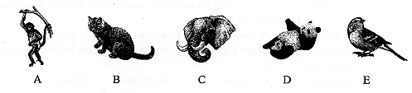
听下面一篇短文。根据短文内容，按照所听内容的先后顺序将下列图片排序，并将其标号填写在题号后的横线上。短文读两遍o

16．_________ 17．__________ 18．_________ 19．_________ 20．_________

二、选择填空。（15小题，每小题1分，共15分）
从ABCD 四个选项中选出一个最佳答案，并将序号填在题前的括号内。
( ) 21.---Kate, are you only child in your family?
---Yes, but new baby is on the way.
A. a; the B. an; the C. the; a D. the; the
( ) 22.--Are you going out with Jade tonight?
--That's my . Mind your own!
A. offer B. business C. question D. chance
( ) 23.--- What a bad day!
--- Everyone has one of those days When goes right.
A. nothing B. anything C. everything D. something
( ) 24. My parents said they would come to visit me. I couldn't to see them after several months away from home.
A. wait B. help C. expect D. afford
( ) 25. I have been to quite a few restaurants, but I can. say this one is .
A. good B. better C. the better D. the best
( ) 26. It's so cold outside. Remember to close the door you when you leave.
A. beside B. before C. with D. behind
( ) 27. ---You look very pretty, if I say so.
---Thanks a lot for saying that.
A. must B. may C. will D. have to
( ) 28. ---There is someone knocking at the door.
---It must be the computer repairman. I him to come to fix my computer.
A. call B. have called C. called D. will call
( ) 29. The boss asked Tim to go and out if there was anyoneelse absent.
A. find B. finding C. to find D. found
( ) 30. A stupid man tells a woman to shut up, while a wise man tells her that her mouth is quite beautiful it is closed.
A. unless B. since C. when D. though
( ) 31. We are going to take the high-speed train to Xi'an tomorrow, so an early arrival at the station____________ .
A. advises B. is advised C. is advising D. was advised
( ) 32. Theaters may have a brighter future if they can provide a movie experience
people cannot get at home.
A. that B. who C. whom D. what
( ) 33. Everyone wants to reach the top of the mountain, but all the happiness happens while you it.
A. climb B. climbed C. are climbing D. have climbed
( ) 34. Almost every university now has a website which allows us to ________ the information about it.
A. look at B. look after C. look around D. look through
( ) 35.--What did Tom say to you just now, John?
--He asked _____________ .
A. why I am so happy today
B. what will I do for the weekend
C. Who did I play football with after school[来源:学_科_网]
D. if I could go to the movie with him tonight

三、完形填空(10小题，每小题1分，共10分)
先通读短文，掌握其大意，然后从A、B、C、D四个选项中选出一个可以填入相应空白处的最佳答案，并将其标号填入题前括号内。

A man feared his wife wasn't hearing as well as she used to and he thought she might need some hearing aid (助听). Not quite sure how to 36 her, he called the family doctor to discuss the problem. The doctor toldhim there was a simple test the husband could do to give the doctor a better 37 of her hearing loss.
"Here's what you do," said the doctor. "Stand about 40 feet away from her, and in a 38 conversational speaking tone (音调) see if she hears you. If not, go to 30 feet, then 20 feet, and so on 39 you get a reply."
That evening, the wife was in the 40 , and he was in the yard. He said to
himself,"I'm about 40 feet away, and let me see what will happen." Then in a usual tone he asked,"Honey, what's for dinner?"
No 41 .
So the husband moved closer to the kitchen, about 30 feet from his wife and
asked,"Honey, what's for dinner?"
42 no reply.
Next he moved into the dining room where he was about 20 feet from his wife and 43 , "Honey, what's for dinner?"
Again he got no reply. He walked up to the kitchen door, about 10 feet away. "Honey,what's for dinner?" Again there was no reply.
So he 44 right up behind her. "Honey, what's for dinner?"
"Chicken! James, for the 45 time I've said that."
( ) 36. A. save B. help C. face D. guide
( ) 37. A. choice B. excuse C. idea D. suggestion
( ) 38. A. loud B. strange C. special D. usual
( ) 39. A. until B. before C. when D. as
( ) 40. A. toilet B. garden C. kitchen D. dining room
( ) 41. A. dinner B. way C. move D. reply
( ) 42. A. Still B. Even C. Just D. Almost
( ) 43. A. laughed B. repeated C. thought D. added
( ) 44. A. ran B. stood C. walked D. jumped
( ) 45. A. second B. third C. fourth D. fifth

四、阅读理解(20小题，每小题2分，．共40分)
阅读下面四篇语言材料，然后按文后要求做题.。

A
A doctor entered the hospital hurriedly after being called in for an important surgery (外科手术).
He found the boy's father in the hall waiting worriedly.
On seeing him, the father cried out, "Why did you take all this time to come? Don't you know that my son is in danger? Don't you have any sense of duty?"
The doctor smiled and said, "I am sorry. I wasn't in the hospital and I came as fast as I could after receiving the call and now, I wish you'd calm down so that I can do my work."
"Calm down?! What if your son was in this room right now? Would you calm down? If your own son dies while waiting for a doctor, then what will you do?" said the father angrily.The doctor smiled again and replied, "We will do our best and you should also pray (祈祷)for your son's healthy life."
The surgery took some hours after which the doctor went out happy, "Thank goodness!Your son is saved!" And without waiting for the father's reply he carried on his way running by saying, "If you have any questions, ask the nurse."
"Couldn't he wait some minutes so that I can ask about my son's state?" shouted the father when seeing the nurse minutes after the doctor left.
The nurse answered, tears coming down her face. "His son died yesterday in a road accident. He was at the burial (葬礼) when we called him for your son's surgery. And now that he saved your son's life, he left running to finish his son's burial."

根据材料内容选择最佳答案，并将其标号填入题前括号内。

( ) 46. What did the doctor do afterhe received the call for the surgery?
A. He asked another doctor to do his duty.
B. He went to the hospital as soon as possible.
C. He discussed the boy's state with the father.
D. He waited until his son's burial was finished.
( ) 47. The father shouted at the doctor because he thought
A. he had waited too long B. no one cared for his son
C. the doctor was cold to him D. the surgery took a long time
( ) 48. Who told the truth to the father in the end?
A. The doctor. B. The nurse. C. His son. D. A patient.
( ) 49. How might the father feel after he knew the troth?
A. Angry. B. Excited. C. Sorry. D. Doubtful.
( ) 50. What is the best title for the text?
A. Seeing is believing B. Time waits for no man
C. Practice makes perfect D. Think before you decide
B
Have you ever had trouble sleeping in a new place?
Lots of people do. And now researchers from Brown University in Rhode Island think they know why. They found that one-half of the brain "remains more awake" than the otherhalf when people are trying to sleep in a new place.
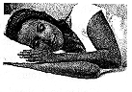
The sleep findings were reported in Current Biology by Brown University. In their report, the researchers said many people report they have a harder time sleeping the first night at a hotel or other places outside their home. They call it "first-night influence". "In Japan they say, 'If you change your bed, you can't sleep,'" said Yuka Sasaki, one of the report's writers. "You don't sleep very well in a new place. We all know about it."
The researchers measured brain waves (测量脑波) for 35 volunteers over two nights in a laboratory. The two nights were a week apart (间隔). They found during the first night the left half of the brain was more active than the right half. This was during the first deep-sleep period, the researchers said.
Sasaki said a lot of questions remain.
Researchers did not keep measuring brain waves all night long. So, they don't know if the left half keeps "watch" all night, or whether it "works in shifts (轮换) with the right half later in the night". They also do not know why the brain activity, at least during the first period of deep sleep, is always on the left half.
For some, this research may be calming. It is good to know that our brain is "looking out for us" in a new place. But it may not help with sleep. That brain activity, at least according to this new research, makes it harder to get the sleep people need to wake up well rested in the morning.

根据材料内容选择最佳答案，并将其标号填入题前括号内。

( ) 51. How many times did the researchers measure brain waves for 35 volunteers?
A. Once. B. Twice. C. Three times. D. Four times.
( ) 52. The researchers found during the first deep-sleep period.
A. the brain waves remained the same
B. the brain activity helped with sleep
C. the right half of the brain kept "watch"
D. the left half of the brain was more active
( ) 53. Which of the following is one of the questions that remain?
A. Whether the new bed keeps you from sleeping.
B. How you have trouble sleeping in a new place.
C. Why the brain activity is always on the left half.
D. What people can do when they can't sleep well.
( ) 54. The underlined word "calming" has the closest meaning to" ".
A. pleasing B. different C. serious D. strange
( ) 55. What is the text mainly about?
A. What we will have to do to sleep well.
B. How researchers measure brain waves.
C. Who doesn't sleep well in a new place.
D. Why it's harder to sleep in a new place.

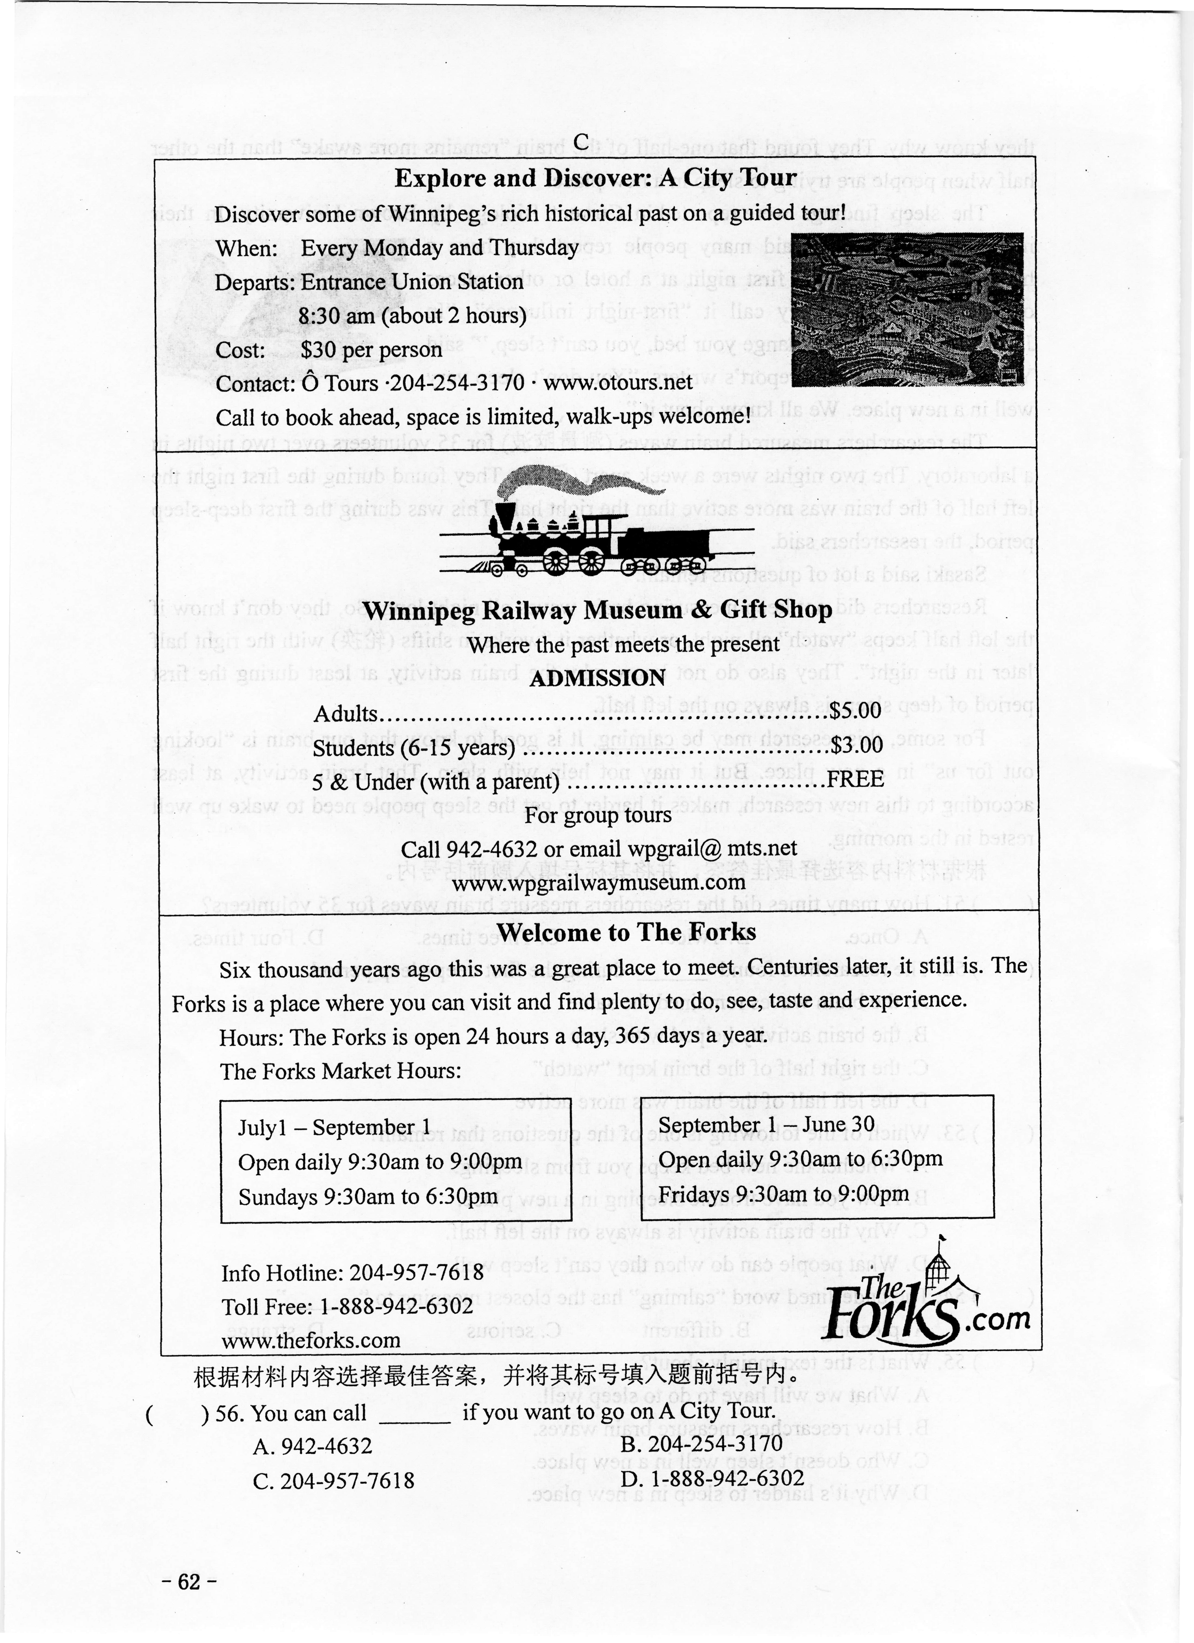
C

根据材料内容选择最佳答案，并将其标号填入题前括号内

( ) 56. You can call if you want to go on A City Tour.
A. 942-4632 B. 204-254-3170
C. 204-957-7618 D. 1-888-942-6302
( ) 57. Martin will visit Winnipeg Railway Museum with his 4-year-old daughter. How much should he pay?
A. $3.00. B. $5.00. C. $8.00. D. $30.00.
( ) 58. Which is the proper time to visit The Forks Market?
A. 8:30am on Sundays in July.
B. 8:30am on Saturdays in June.
C. 7:30pm on Fridays in August.
D. 7:30pm on Mondays in October.
( ) 59. What is mentioned in each part of the text?
A. Open hours. B. Group tours. C. Limited space. D. Historical past.
( ) 60. Where is the text probably taken from?
A. A guidebook. B. A movie poster.
C. A sports magazine. D. A science report.
[来源:学科网ZXXK]
D

There are so many expressions in American English that sound pleasant (令人愉快的)but are not. 61 When someone says they have to "face the music", it does not mean they are going to a concert. "Facing the music" means to accept and deal with the punishment of an action.
62 For example, "I can't face another night of camping! It's cold and rainy." Or "In life, you must face your fears." Face used in this way is very common.But now, let's go back to facing the music. Imagine a friend asks you to take care of her beautiful red sports car. She gives you the keys and says, "Thanks so much for watching my car while I'm away. But please, do not drive it. It is an extremely (极其) fast car." 63 You want to show off to some friends. So, you drive it around town one night. As bad luck would have it, you lose control of the car and drive it into a stop sign. Bang!
When your friend returns you must tell her what you have done and "face the music". 64 It could be losing her friendship or paying for repairs to her sports car or both. Whatever the music is, you must face it.
65 To "take your medicine" means to accept the results from something bad you have done. And if someone says, "You made your bed. Now lie in it." they mean you created a bad situation and now you will experience the results!

根据材料内容，从下面五个选项中选出能填入文中空缺处的最佳选项，使短文意思通顺、内容完整，并将其标号填写在下面题号后的横线上。
A. But you do not listen.
B. "Face the music" is a good example.
C. The "music" here is the result of your actions.
D. Americans often use the word "face" in this way.
E. There are other American expressions that mean the same thing as "face the music".

61.__________ 62._________ 63.________ 64.__________ 65.__________

五、词语运用(10小题，每小题1分，共10分)
阅读短文，从方框中选择适当的词并用其正确形式填空，使短文通顺、意思完整。请将答案写在下面题号后的横线上。每空限填一词，每词限用一次。方框中有两个词是多余的。

always talk count I below friend or people send free around and

Next time you're in a public place, take a look around you. And 66 how many people are using their phones. I can tell you now that it is probably more than half, whether you're on a bus, in a caf6 67 simply walking down the street.
I'm not saying that I am not an example of this, but it . 68 mazes (使惊愕) me how people can spend so much time on their phones without 69 to others. Has it gone too far?
Recently, my smart phone broke and had to be 70 off for repair for a week or so. I had to use a really old, basic phone just to keep me in touch with my family and 71 . All I could do on this phone was to send text messages, make calls and play one game. And I loved it. I loved being 72 from the Intemet, and I really didn't mind not having updates (更新) about what my friends were doing. It allowed 73 to spend more time enjoying my time in London and watching the people 74 me and really see what was going on.
However, I knew that as soon as I got my smart phone back I would be one of those 75 once again. Perhaps I should just go back to using the basic phone and forget I ever got my smart phone back.

66. 67. 68. 69. 70.
71. 72. 73. 74. 75.

六、补全对话(5小题，每小题2分，共10分)
根据下面的对话情景，在每个空白处填上一个适当的句子，使对话的意思连贯、完整。

A: What terrible weather! I'd love to go out, but I think it will just continue raining.
B: Well, I listened to the weather report. 76.______________________________ .
A: I hope so. Listen, I'm going to have a party this Saturday. Would you like to come?
B: Oh,I'd love to. Thank you for inviting me. 77. ___________________________?
A: Well, only my friends. Just a chance to get together and have fun. Peter and Mark are going to help out with the cooking!
B: Hey, I'll help, too! 78.________________________________________________ .
A: Would you? That sounds delicious! My Russian cousins are going to be there. I'm sure they'll love it.
B:79.____________________________________?
A: Yes, Russians! They love making friends. The more I think about my party, the more I get excited.
B: So do I. 80.___________________________________________ .
A: That's what I'm expecting!

[来源:学+科+网Z+X+X+K]
七、书面表达(15分)
我们的每一次变化都见证着我们的成长。请以“The biggest personal change I've ever made”为题，并根据要点和要求，用英语写一篇短文。
1．要点：1)变化是什么；
2)变化是如何发生的；
3)变化后有何感受。
2．要求：1)文中不得出现真实姓名和学校名称；
2)词数80左右。

The biggest personal change I've ever made
___________________________________________________________________________________________________________________________________________________________________________________________________________________________________________________________________________________________________________________________________________________________________________________________________________________________________________________________________________________________________________________________________________________

2016年河南省普通高中招生考试
英语试题参考答案及评分标准
一、听力理解(20小题，每小题1分，共20分)
1 | 2 | 3 | 4 | 5 | 6 | 7 | 8 | 9 | 10
B | C | B | A | C | C | A | B | B | C

11 | 12 | 13 | 14 | 15 | 16 | 17 | 18 | 19 | 20
A | B | A | C | A | B | E | D | C | A
二、单项选择(亚5小题，每小题1分，共15分
21 | 22 | 23 | 24 | 25 | 26 | 27 | 28 | 29 | 30 | 31 | 32 | 33 | 34 | 35
C | B | A | A[来源:学科网] | D | D | B | C | A | C | B | A | C | D | D
三、完形填空(10小题，每小题矍分，共10分)
36 | 37 | 38 | 39 | 40 | 41 | 42 | 43 | 44 | 45
B | C | D | A | C | D | A | B | C | D
四、阅读理解(20小题，每小题2分，共40分)
46 | 47 | 48 | 49 | 50 | 51 | 52 | 53 | 54 | 55 | 56 | 57 | 58 | 59 | 60
B | A | B | C | D | B | D | C | A | D | B[来源:学科网] | B | C | D | A

61 | 62 | 63 | 64 | 65
B | D | A | C | E
五、词语运用(10小题，每小题1分，共10分)
66. count 67. or 68. always 69. talking 70. sent
71. friends 72. free 73. me 74. around 75. people
六、补全对话(5小题，每小题2分，共10分)
76.The sun will come out (soon/later/this afternoon/tomorrow/...)
It will stop raining/clear up (soon/later/this afternoon/tomorrow/...)
The rain will stop (soon/later/this afternoon/tomorrow/...)
It will be sunny/fine (soon/later/this afternoon/tomorrow/...)
It said (that) it would be sunny/...
…
77. Who (else) is going/will go (to the party)
Who (else) is going to attend/attending (the party)
Who (else) is going to come/coming (to the party)
Who (else) will come to/attend the party
Who (else) have you invited/has been invited (to the party)

78. I'll/I can make Chinese/French/... food
I'llfl can make fruit salad/...

79. (Are they) Russian/Russians
Your Russian cousins

80. I'm sure/I think/hope/expect/believe (that) everyone will have a good time/enjoy themselves/...
I'm sure/I think/hope/expect/believe we will have run. ave a good time/enjoy
ourselves/...
I believe we will have a good/wonderful/great/.., time
七、书面表达(15分)
One possible version:
The biggest personal change I've ever mad
The biggest personal change I've ever made is that I have fallen in love with
reading.
When I was a child, I didn't enjoy books at all. Later, my mother always read stories for me and bought me books. Gradually I began to love reading. While reading,I feel like talking with a wise man. Reading is also a fantastic way to pass my
free time.
Books are my friends. And they have and will benefit me a lot.
评分标准：
1．第1-45题，每小题1分。凡与答案不符的均不给分。
2．第46-65题，每小题2分。凡与答案不符的均不给分。
3．第66-75题，每小题1分。凡与答案不符的均不给分。
4．第76-80题，每小题2分。句中大小写错误，每两个扣0．5分。单词拼写错误，每两个扣1分。答案不唯一。如果考生写出的句子符合英语表达习惯，且上下文意思连贯，无错误，应当给分。
5．书面表达，15分。考生应根据题目要求，采用适当的时态、语态、句式和词语，完整、准确地表达所要求的内容。分四档评分：
第一档：符合题目要求，内容完整，层次结构清晰，表达清楚，语言无误o 13-15分。
第二档：基本符合题目要求，内容较完整，层次结构较清晰，表达较清楚，语言有少量错误。9-12分。
第三档：部分内容符合题目要求，内容不够完整，层次结构不够清晰，表达不够清楚，语言有较多错误。4-8分。
第四档：不符合题目要求，整篇表达不清楚，或照抄、拼凑几个词语。 0-3分。

