**小学一年级英语期末考试模拟练习题**

一、将单词和图片连线

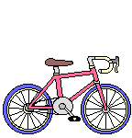 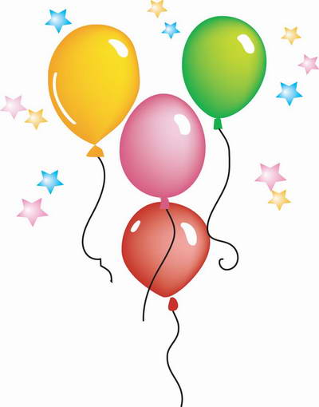  [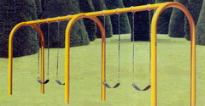](http://www.wxjstn.com/prodcts/images/qqxl/QQXL10.jpg) [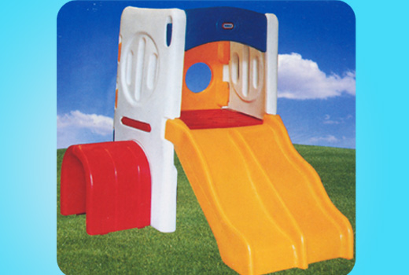](http://www.abc100.com/product_detail.asp?id=229) [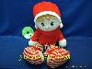](http://china.alibaba.com/offer/view_pics.htm?offer_subject=%B9%A9%D3%A6%B6%F9%CD%AF%CD%E6%BE%DF%A3%AC%D1%F3%CD%DE%CD%DE%A3%AC%B2%BC%B9%AB%D7%D0%A3%AC%C9%FA%C8%D5%C0%F1%C6%B7%A3%AC%C7%E9%C8%CB%BD%DA%C0%F1%CE%EF&view_url=p1Src%3Dhttp%3A%2F%2Fimg.china.alibaba.com%2Fimg%2Foffer%2F35%2F01%2F43%2F77%2F35014377-1%26p2Src%3Dhttp%3A%2F%2Fimg.china.alibaba.com%2Fimg%2Foffer%2F35%2F01%2F43%2F77%2F35014377%26p3Src%3Dhttp%3A%2F%2Fimg.china.alibaba.com%2Fimg%2Foffer%2F35%2F01%2F43%2F77%2F35014377-2&tracelog=jy_picbar_from_sale_detail_img)

doll bicycle swing ball balloon slide

二、选词填空

( )1、How are you?

A、old B、big C、am

( )2、I seven.

A、’m B、am C、are

( )3、You nine.

A、are B、’re C、am

( )4、A book you.

A、to B、is C、for

( )5、Happy birthday you.

A、to B、for C、is

三、看一看选一选

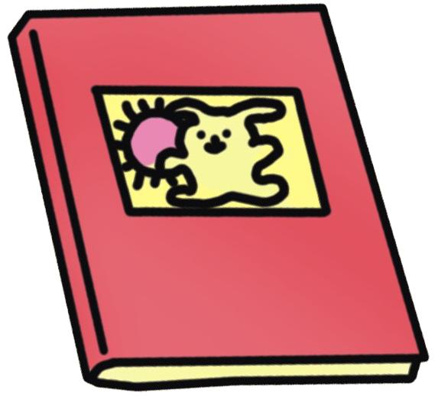1. Is this a pencil? 2. Is this a rubber?

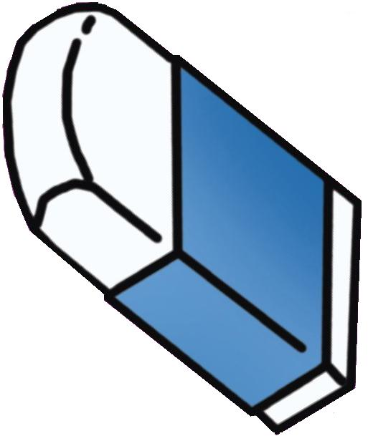( )　Yes, it is. ( )　Yes, it is.

( ) No, it isn’t. ( ) No, it isn’t.

3. Is this a ruler? 4. Is this a book?

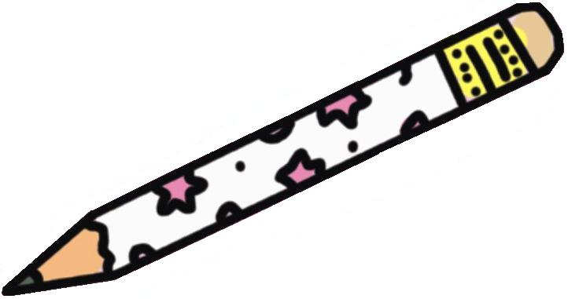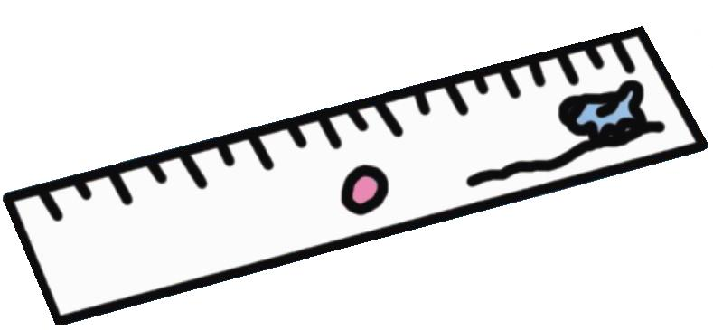( )　Yes, it is. ( )　Yes, it is.

( ) No, it isn’t. ( ) No, it isn’t.

5. Is this a bag? 6. Is this a pen?

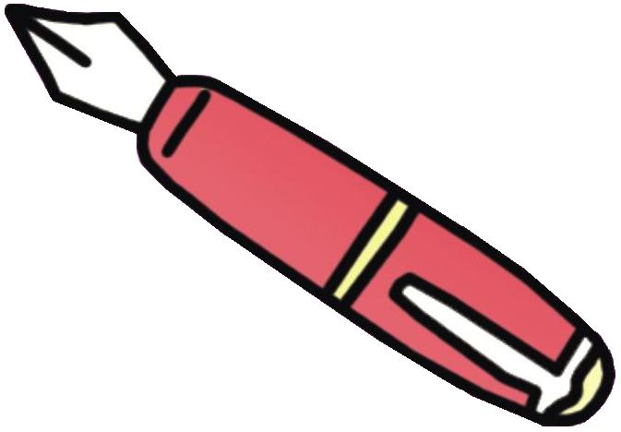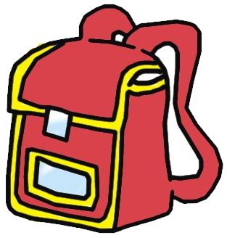( )　Yes, it is. ( )　Yes, it is.

( ) No, it isn’t. ( ) No, it isn’t.

**四．找出同类单词，并将同类单词用线连起来。**

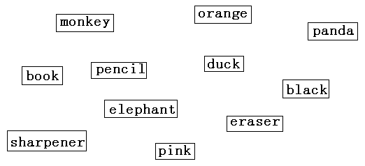

1. 用is , am 和are 填空：

1. She ______ a teacher . 2. They ________ cows.

3. What _______ these ? 4. I ______ a pupil ,too.

5. It _______ under the tree. 6. My father ________ a doctor .

7. This ________ our classroom . 8. These ________ eggs .

9. My name ______ Amy . 10. His hat ________ on the bed .

六、按要求填单词：

A. his B. my C. her D. our E. their F. your.

1. This is ________ (她的)dress . 2. That is ________（我们的）classroom.

3. What’s ______（你的）name ? 4. Look! ______ （他们的）school bags .

5. ______（我的） name is Amy . 6. It is ________（他的） hat .

七 、比较大小；

1．Seven nine 2. ten twelve 3. three two

4. eight – one five+four 5. four + nine eleven – five

八．词汇连线：

school pencil ice class how

box bag old cream room

九、将句子与小熊相应的位置连起来。

This is my face.

This is my nose.

This is my eye.

This is my mouth.

This is my ear.

十、根据所给情景选择正确语句，看谁做的最认真！

1、与人问好时 A. Good afternoon

2、询问别人的名字时 B. How many girls?

3、你想知道“有多少个女孩?”时 C. What’s your name?

4、下午遇见好朋友怎样打招呼 D. Hello.

5、告别时 F. Goodbye.