绝密★启封前
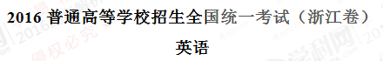
选择题部分（共80分）
第一部分：英语知识运用（共两节，满分30分）
第一节：单项填空（共20小题；每小题0.5分，满分10分）
从A、B、C和D四个选项中，选出可以填入空白处的最佳选项，并在答题纸上将该选项标号涂黑。
1. --Are you sure you're ready for the best?
--_________. I'm well prepared for it.
A. I'm afraid not B. No problem C. Hard to say D. Not really
【答案】B
【解析】
试题分析：句意：—你确定你准备好考试了吗？—没问题。我已经做好准备了。A.恐怕不；B.没问题；C.很难说；D.不是真的。根据语境，故选B。
考点：考查交际用语。
2.______prize for the winner of the competition is ______two-week holiday in Paris.
A. The ; 不填 B. A ; 不填 C. A ; the D. The ; a
【答案】D
【解析】学科&网
试题分析：句意：这个比赛获胜者的奖品是一个巴黎的两个星期的假期。第一空填the，是特指“获胜者的奖品”，用定冠词，第二空是泛指“一个两周的假期”，用不定冠词a。故选A。
考点：考查冠词。
3. In many ways , the education system in the US is not very different from ____in the UK.
A. that B. this C. one D. it
【答案】A
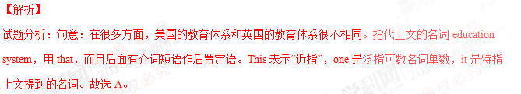考点：考查代词。
4. It is important to pay your electricity bill on time , as late payments may affect your ______.
A. condition B. income C. credit D. status
【答案】C
【解析】
试题分析：句意：准时付电费很重要，因为付晚了会影响你的信用。Condition条件；income收入；credit学分，信用（卡）。根据句意故选C。
考点：考查名词辨析。
5._______online shopping has changed our life , not all of its effects have been positive.
A. Since B. After C. While D. Unless
【答案】C
【解析】
试题分析：句意：尽管网上购物已经改变了我们的生活，单数不是所有的影响都是积极的。While引导让步状语从句，意为“尽管，虽然”；since既然，自从；after在……之后；unless除非。故选C。
考点：考查连词。
6.That young man is honest , cooperative , always there when you need his help .______, he's reliable.
A. Or else B. In short C. By the way D. For one thing
【答案】B
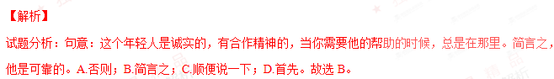考点：考查介词短语。
7. The study suggests that the cultures we grow up _______influence the basic processes by which we see world around us.
A. on B. in C. at D. about
【答案】B
【解析】
试题分析：句意：研究表明我们成长的文化影响我们看周围世界的基本过程。The cultures后面是定语从句，省略that，定语从句中cultures作宾语，那么还缺少一个介词，和cultures搭配用介词in，故选B。
考点：考查介词。
8. We can achieve a lot when we learn to let our differences unite , rather than _______ us.
A. divide B. reject C. control D. abandon
【答案】A
【解析】
试题分析：句意：当我们学会让我们的差异联合起来而不是将我们分离的时候，我们就获得很多。A.将……分开；B.拒绝，拒收；C.控制；D.放弃。根据语境，故选A。
考点：考查动词辨析。
9. Silk ______ one of the primary goods traded along the Silk Road by about 100 BC.
A. had become B. reject C. control D. abandon
【答案】A
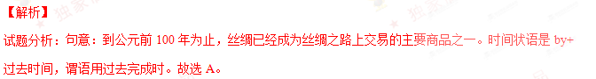考点：考查动词时态。
10.To return to the problem of water pollution , I'd like you to look at a study _______ in Australia in 2012.
A. having conducted B. to be conducted C. conducting D. conducted
【答案】D
【解析】
试题分析：句意：为了回到水污染的问题，我想要你研究一下2012年澳大利亚进行的研究。使用非谓语动词作定语，study和conduct是动宾关系，用过去分词作定语。B项也表示被动，但是不定式的被动，表示将要发生的事情。故选D。学科.网
考点：考查非谓语动词。
11. Scientists have advanced many theories about why human beings cry tears , none of ______ has been proved.
A. whom B. which C. what D. that
【答案】B
【解析】
试题分析：句意：关于人类为什么哭的时候会流泪，科学家已经提出了很多理论，没有一个被证明了。使用定语从句，先行词是theories，指物，定语从句中用代词+介词+关系代词which引导。故选B。
考点：考查定语从句。
12.When their children lived far away from them , these old people felt ______from the world.
A. carried away B. broken down C. cut off D. brought up
【答案】C
【解析】
试题分析：句意：当孩子远离他们生活的时候，这些老人感觉和世界隔绝了。Carry away带走，夺走；break down崩溃，破坏，抛锚，分解；cut off切断；bring up养育，培养。故选C。
考点：考查动词短语。
13. A sudden stop can be a very frightening experience , ______ if you are travelling at high speed.
A. eventually B. strangely C. merely D. especially
【答案】D
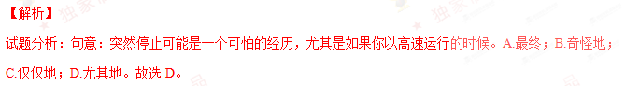考点：考查副词辨析。
14. When the time came to make the final decision for a course , I decided to apply for the one that ______my interest.
A. limited B. reserved C. reflected D. spoiled
【答案】C
【解析】
试题分析：句意：当最后决定课程的时候到了，我决定申请能反映我兴趣的课程。A.限制；B.保留；C.反映，反射；D.宠坏。故选C。
考点：考查动词辨析。
15. Had the governments and scientists not worked together , AIDS-related deaths _______ since their highest in 2005.
A. had not fallen B. would not fall C. did not fall D. would not have fallen
【答案】D
【解析】
试题分析：句意：如果政府和科学家不共同努力，艾滋病相关的死亡就不会从2005年的最高点下降。使用虚拟语气， if条件句用的had done，而且省略it，将had提前，主句用would have done表示对过去情况的虚拟。故选D。
考点：考查虚拟语气。
16. In this article , you need to back up general statements with ________ examples.
A. specific B. permanent C. abstract D. universal
【答案】A
【解析】
试题分析：句意：在文章中，你需要用具体的例子来支持总的观点。A.具体，明确的；B.永久的；C.抽象的；D.全球的，共通的。故选A。
考点：考查形容词辨析。
17. George _________ too far . His coffee is still warm .学.科网
A. must have gone B. might have gone C. can't have gone D. needn't have gone
【答案】C
【解析】
试题分析：乔治不可能走得太远了。他的咖啡仍然是温的。can’t have done是对过去的否定推测；must have done过去一定做了某事；might have done过去可能做了某事；needn’t have done过去本不必做某事。故选C。
考点：考查情态动词+have done。
18. I have always enjoyed all the events you organized and I hope to attend in the coming years
A. little more B. no more C.much more D.many more
【答案】D
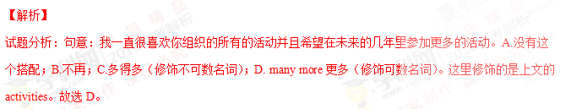考点：考查短语辨析。
19. I had as much fun sailing the seas as I now dowith students.
A. wotking B. work C. to work D. worked
【答案】A
【解析】
试题分析：句意：我在海上航行和现在和学生一起一样快乐。使用非谓语动词作状语，I和work是主谓关系，用现在分词作时间状语。故选A。
考点：考查非谓语动词。
20.—The movie starta at 8:30,and wo can have a quick bite before wo go
--.See you at 8:10
A. So long B. Sounds great C. Good luck D.Have a good time
【答案】B
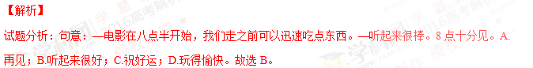考点：考查交际用语。
第二节：完形填空（共20小题；每小题1分，满分20分0）
阅读下面短文，掌握其大意，然后从21—40各题所给的四个选项（A、B、C和D）中，选出最佳选项，并在答题纸上将该选项标号涂黑。学.科网
During the war,my husband was stationed at an army camp in a desert in California.I went to live there in order to be 21 him. I hated the place .I had never 22 been so unhappy . My husband was ordered out on a long-term duty,and I was left in a tiny shack(棚屋) alone. The heat was 23 -almost 125 ⁰F even in the shade of a cactus(仙人掌)。 24 a soul to talk to . The wind blew non-stop ,and all the food I ate ,and the evry air I breathed,were 25 with sand , sand , sand !
I was so sorry for myself that I wrote to my parents. I told them I was 26 and coming back home.I said I couldn’t stand it one minute longer. I 27 be in prison! My father answered my 28 with just two lines-two lines that will always sing in my 29 - two lines that completely changed my life :
Two men looked out from prison bars
One saw the mud ,the other saw the stars
I read those two lines 30 I was ashamed of myself. I made up my mind I would find out what was good in my present 31 ; I would look for the stars.
I made friends with the natives,and their 32 amazed me. They gave me presents of their favorite artworks which they had 33 to sell to toueists . I studied the delightful forms of the cactus .I watched for the desert sunsets,and 34 for seashells that had been left there millions of years ago when the desert had been an ocean 35
What brought about this 36 change in me ? The desert hadn’t changed , 37 I had .I had changed my 38 And by doing so ,I changed an unhappy experience into the most amazing 39 of my life . I was excited by this new world that I had dicovered I had looked out of my self-creatded prison and 40 the stars
21. A. off B. behind C. near D. beyond
22. A. before B. already C. then D. still
23. A. inflexible B. incomprehensible C. uncontrollable D.unbearable
24. A. Only B. Not C. Many D.Such
25. A. covered B. filled C. buried D. charhed
26. A. catching up B. keeping up C. giving up D.getting up
27. A. ought to B. might well C. would rather D.had better
28. A.request B. call C. question D.letter
29. A. comparison B. imagination C. consideration D. memory
30. A. over and over B. by and by C. up and down D.noe and then
31. A. company B. occupation C. situation D.relationship
32. A. movement B. reaction C. guidance D.purpose
33. A. refused B. failed C. managed D.happened
34. A. asked B. hunted C. waited D.headed
35. A. floor B. surface C. rock D.level
36. A. shocking B. challenging C. puzzling D.astonishing
37. A. as B. but C. for D.or
38. A. attitude B. principle C. identity D.standard
39. A. vacation B. operation C. affair D. adventure
40. A. sought B. counted C. found D.reached
【语篇解读】这是一篇记叙文。作者讲述自己为了离丈夫近一些，住在他所在的沙漠的军营里，寂寞的生活和艰苦的生活条件让作者难以忍受，她写信告诉父母要回家。父亲给他的信中就两行字，就是这两行字使作者改变了自己对人生的态度。
21.【答案】C
【解析】
试题分析：根据上文的I went to live there，可知，作者去住在丈夫的军营为了靠近丈夫。A.远离；B.在……后面；C.靠近；D.超过。故选C。
考点：考查介词辨析。
22.【答案】A
【解析】
试题分析：根据下文I was left in a tiny shack(棚屋) alone.可知，作者以前从没有感觉这么不开心。A.以前；B.已经；C.然后；D.仍然。故选A。
考点：考查副词辨析。
23.【答案】D学科&网
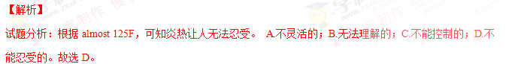考点：考查形容词辨析。
24.【答案】B
【解析】
试题分析：根据上文a desert和alone，可知，没有一个人可以交谈。A.仅仅；B. 没有；C.很多；D.这样。故选B。
考点：考查副词辨析。
25.【答案】B
【解析】
试题分析：根据上文a desert可知，作者吃的食物，呼吸的空气都充满了沙子。A.覆盖；B.填满；C.埋葬；D.负责，要价。故选B。
考点：考查动词辨析。
26.【答案】C
【解析】
试题分析：根据下文coming back home，可知，作者写信给父母，告诉他们她要放弃。A.赶上； B. 维持； C. 放弃；D.起床。故选C。
考点：考查动词短语辨析。
27.【答案】C
【解析】
试题分析：根据上文I said I couldn’t stand it one minute longer，可知，我宁愿在监狱里。A.应该；B.不妨，最好；C.宁愿；D.最好。故选C。
考点：考查短语辨析。
28.【答案】D
【解析】
试题分析：根据上文I wrote to my parents，可知，作者的爸爸回复了作者的信，只有两行字。A.请求；B.电话；C.问题；D.信。故选D。
考点：考查形容词辨析。
29.【答案】D
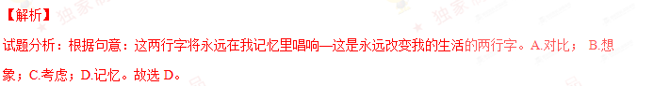考点：考查名词辨析。学科.网
30.【答案】A
【解析】
试题分析：根据下文I was ashamed of myself.可知，作者一遍又一遍地读这两行字。A.一遍又一遍；B.不久；C. 上上下下； D. 不时。故选A。
考点：考查短语辨析。
31.【答案】C
【解析】
试题分析：根据上文I would look for the stars，可知，作者决定要发现在现在的环境中好的东西。A.公司，陪伴；B.占据，职业；C.环境； D. 关系。故选C。
考点：考查名词辨析。
32.【答案】B
【解析】
试题分析：根据下文They gave me presents of their favorite artworks which they had 33 to sell to toueists .可知，作者和当地人交朋友，他们的反应让作者很惊讶。A.运动；B.反应；C.指导； D.目的。故选B。
考点：考查名词辨析。
33.【答案】A
【解析】
试题分析：根据句意：他们给我最喜欢的艺术作品的礼物，这些作品是他们拒绝卖给游客的。A.拒绝；B.失败；C.设法完成；D.碰巧。故选A。
考点：考查动词辨析。
34.【答案】B
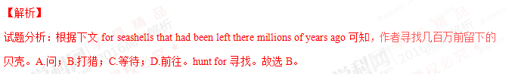考点：考查动词辨析和短语搭配。
35.【答案】A
【解析】
试题分析：根据上文millions of years ago可知，几百万年前，沙漠曾经是海床。A.地板；B.表面；C.岩石；D.水平。故选A。
考点：考查名词辨析。
36.【答案】D
【解析】
试题分析：根据上文two lines that completely changed my life :，可知，这里是：什么造成我这样令人惊讶的改变？A.令人震惊的；B.有挑战的；C.令人困惑的；D.令人惊讶的。故选D。
考点：考查形容词辨析。
37.【答案】B
【解析】
试题分析：根据句意：沙漠没有改变，但是我变了。表示转折关系。A.正如，因为，随着；B.但是；C.因为；D.或者。故选B。
考点：考查连词辨析。
38.【答案】A
【解析】
试题分析：根据下文I changed an unhappy experience into the most amazing可知，虽作者改变了自己的态度。A.态度；B.原则；C.身份；D.标准。故选A。
考点：考查名词辨析。
39.【答案】D
【解析】
试题分析：根据上一段内容可知，作者将不愉快的经历变成最令人惊叹的人生冒险。A.假期；B.手术；C.事务；D.冒险。故选D。
考点：考查名词辨析。
40.【答案】C
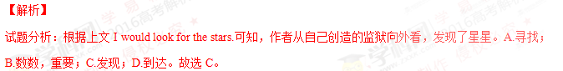考点：考查动词辨析。

第二部分：阅读理解（第一节20小题，第二节5小题；每小题2分，满分50分）
第一节：阅读下列材料，从每题所给的四个选项（A、B、C、D）中，选出最佳选项，并在答题纸上将该选项标号涂黑。学.科网
A
“Did you hear what happened to Adam Last Friday?”Lindsey whipers to Tori.
With her eyes shining,tori brags，“You bet I did,Sean told me two days ago.”
Who are Lindsey and Tori talking about?It just happened to be yours truly,Adam Freedmam,I can tell you that what that what they are saying is (a) not nice and (b) not even true.Still,Lindsey and Tori aren’t very different from most students here at Linton Higt School,including me.Many of our conversations are gossip(闲话)。I have noticed three effects of gossip:it can hurt people,it can give gossipers a strange kind of satisfaction,and it can cause social pressures in a group.
An important negative effect of gossip is that it can hurt the person being talked about.Usually,gossip spreads information about a topic-breakups,trouble at home,even dropping out-that a person would rather keep secret.The more embarrassing or shameful the secret is,the juicier the gossip it makes.Probably the worst type of gossip is the absolute lie.People ofen think of gossipers as harmless,but cruel lies can cause pain.
If we know that gossip can be harmful,then why do so many of us do it?Tht answer lies in another effect of gossip:the satisfaction it gives us.Sharing the latest rumor(传言)can make a person feel important because he or she knows something that others don’t.Similarly,hearing the latest rumor can make a person feel like part of the “in group.”In other words,gossip is satisfying because it gives people a sense of belonging or even superiority(优越感).
Gossip also can have a third effect:it strengthens unwritten,unspoken rules about how people should act.Professor David Wilson explains that gossip is important in policing behaviors in a group.Translated into high school terms, this means that if everybody you hang around with is laughing at what John wore or what Jane said,then you can bet that wearing or saying something similar will get you the same kind of negative attention.The do’s and don’ts conveyed through gossip will never show up in any student handbook.
The effects of gossip vary depending on the situation.The next time you feel the urge to spread the latest news,thing about why you want to gossip and what effects your “juicy story”might have.
41.The author uses a conversation at the beginning of the passahe to .
A.introduce a topic
B.present an argument
C.describe the characters
D.clarify his writing purpose
42.An important negative effects of gossip is that it.
A.breaks up relationships
B.embarrasses the listener
C.spreads information around
D.causes unpleasant experiences
43.In the auther’s opinion,many people like to gossip because it.
A.gives them a feeling of pleasure
B.helpl them to make more friends
C.makes them better at telling stories
D.enables them to meet important people
44.Professor David Wilson think that gossip can .
A.provide students with written rules
B.help people watch their own behaviors
C.force school to impove student handbooks
D.attract the police’s attention to group behaviors
45.What advice does the author give in the passage?
A.Never become a gossiper
B.Stay away from gossipers
C.Don’t let gossip turn into lies
D.Think twice before you gossip.
【语篇解读】本文是一篇议论文。文章讨论了传言的危害和人们为什么喜欢传闲话。
41. 【答案】A
【解析】
试题分析：根据文章第三段的Many of our conversations are gossip. （我们的话题很多都是闲话），可知开头的对话是为了介绍本文的主题，故选A。
考点：考查推理判断。
42. 【答案】D
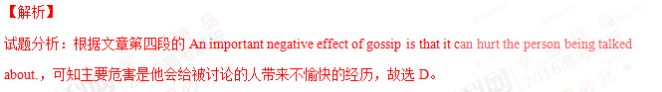考点：考查细节理解。
43. 【答案】A
【解析】学科&网
试题分析：根据文章第五段的The answer lies in another effect of gossip: the satisfaction it gives us,可知人们散播传言是因为它会带来满足感，故选A。
考点：考查细节理解。
44. 【答案】B
【解析】
试题分析：根据文章第六段的Professor David Wilson explains that gossip is important in policing behaviours in a group.可知他认为传言能帮助人们观察自身的行为，故选B。
考点：考查细节理解。
45. 【答案】D
【解析】
试题分析：根据文章最后一段的The next time you feel the urge to spread the latest news, think about why you want to gossip and what effects your “juicy story” might have. 可知作者的建议是让人们在传言之前三思而后行。故选D。
考点：考查细节理解。
B
Below are search record from a university library’s database
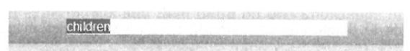
Quick Search l Category l Full Text l Advanced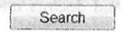
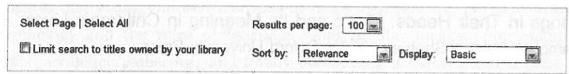
Refine Your Search
Remove all them
Year Published
2016( 9 )
2015( 90 )
2014( 290 )
2013( 118 )
2012(62 )
Show more……
Language
English(637 )
German(2)
Category
Education(639)
Social Science(27)
Medicine (15)
Psychology(11)
Language/Linguistics
(10)
Show more…..

Search full text books for children
Displaying 1 to 100 of 639 titles for children where Category is Education
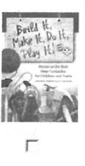
Build it ,Make it ,Play it ! Guides for Children and Teens Bomhold Catharine ;Elder Terri,2004 l ABC-CLIO
Series: Children’s and Young Adult Literature Reference
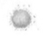Available
For busy librarians and educators ,finding instructions for projects ,activities ,sports ,and games that children and teens will find interesting is a constant challenge, This guide is a time-saving,one-stop….
Read this book l View details l Add to Collection
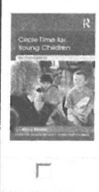
Circle Time for Young Children
Mosley Jenny,2014 l Taylor and Francis
Series: Essential Guides for Early Years Practitioners
Available
Jenny Mosley’s quality circle time model involves setting up an on-going, timetable process
Of circle-meeting for adults and children ,As a basis for teaching relationship skills, building up self-esteem…..
Read this book l View details l Add to Collection
Connecting Animals and children in Early Childhood
Selly Patty Born,2014 l Redleaf Press
Available
Understand the value of connecting animals and children .From familys pets and wild animals to toys ,stuffed animal ,and media images ,animals are a central part of every child’s world .This book examines….
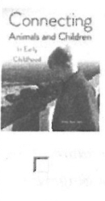
Read this book l View details l Add to Collection

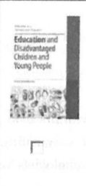
Education and Disadvantaged Children and Young People
Matsumoto Mitsuko; Brool Colin,2013 l Bloomsbury Publishiing
Series: Education as a Humanitarian Response
Available
Do street children go ti school ,and if not ,why not? What kind of education can be ‘meaningful’ to young people affected by conflict? The contributors explore groups of children and young people who have….
Read this book l View details l Add to Collection

Children with School problme:A Physkian’s Manual

The children paediatric Society; Andrews Debra;Mahoney WilliamJ,2012 I wiley
Available
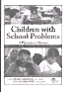
The physician’s guide to diagnosing and treating learning disabilities in children.1 to 10 Canadians have a learning disability,and doctors must be able to idcntify,diagnose,trear,and manage children…
Read this book I view details I Add to Collection
Songs in Their Heads:Music and Its Meaning In Children’s Lives
Campbell Patricia Shehan,1989 I Oxford University Press
Available
This book explores the intrest and needs of children in their expressed thounts and actual “musicking”behaviours, This text examines the songs they sing,the ryhthms…
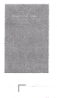
Read this book I view details I Add to Collection
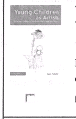
Young Children as Artists:Art and Design in the Earty Years and Kay Stage 1
Tutchell Suzy 2014 I Taylor Francis
Available
From the monment a child is bom,they intctract with the world,looking at colours,feeding texrures;constructing mental and physical images of what they see and experience.Within all early years…
Read this book I view details I Add to Collection
Big Ideas for Littles Kids:TEAching Philosophy Through Children’s Liferature
Wartnberg Thomas E.2014 I Rowman&Littlefield Publishers
Available
Big Ideas for Little Kids includes everything a teacher,or a college student needs to teach philosophy to elementary school children from picture books.Written in a clear and accessible style…
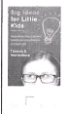
Read this book I view details I Add to Collection
46.Suppose you are doing research on children’s relationship skills,you may want to read.
A.Circle Time for Young Children
B. Children with School Problems:A Phsysician’s Manual
C.Education and Disaddvantaged Children and Young People
D.Build It,Make It,Do It,Play It!Guides for Children and Teens
47.Which book would you recommend to someone interesten inchildren’s mental imanges?
A.Connecting Animals and Children in Early Childhood.
B.Songs in Their Heads:Music and Its Meaning in children’sLives.
C.Big Ideas for Little Kids: Teaching Philosophy Through children’s Literature.
D.Young Children as Artists:Art and Design in the Early Years and Key Stage 1.
48.How many books published in 2015 are found in this search?
A. 9. B.90. C.118. D.290.
49. Children with School Problems:A Phsysician’s Manua lis most likely intended for.
A. educators B. librarians C. doctors D.artists
【语篇解读】本文是一篇应用文，文章提供了图书馆网页上一些书本的信息。
46. 【答案】A
【解析】
试题分析：根据Circle Time for Young Children部分的句子As a basis for teaching relationship skills，可知这本书和孩子的社交技巧有关，故选A。
考点：考查细节理解。
47. 【答案】D
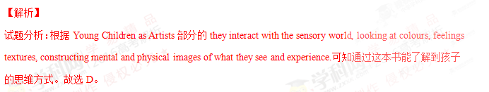考点：考查推理判断。
48. 【答案】B
【解析】
试题分析：根据侧边栏的Year Published下的2015（90），可知有90本书是2015年出版的。故选B。
考点：考查细节理解。学科&网
49. 【答案】C
【解析】
试题分析：根据Children with School Problems部分的The physician’s guide to diagnosing and treating learning disabilities in children.可知这本书介绍了如何诊断治疗孩子的病症，是给医生读的资料，故选C。
考点：考查细节理解。
【名师点睛】这是一篇广告布告类阅读理解，这种题目一般是比较简单的，考查细节题为主。可以使用信息筛选法做题。为了节省时间，可以用先看题目，带着题目在文中寻读的方法找到信息句，理解并找出正确答案。

C
A scientist working at her lab bench and a six-old baby playing with his food might seem to have little in common.After all,the scientist is engaged in serious research to uncover the very nature of the physical world,and the baby is,well, just playing…right?Perhaps,but some developmental psychologists()have argued that this“play”is more like a scientific investigation than one might think.
Take a closer look at the baby playing at the table.Each time the bowl of rice is pushed over the table edge,it
falls in the ground---and, in the process, it belongs out important evidence about how physical objects interact ; bowls of rice do not flood in mid-sit, but require support to remain stable. It is likely that babies are not born knowing the basic fact of the universe; nor are they ever clearly taught it. Instead, babies may form an understanding of object support through repeated experiments and then build on this knowledge to learn even more about how objects interact. Though their ranges and tools differ, the baby’s investigation and the scientist’s experiment appear to share the same aim(to learn about the natural world ), overall approach (gathering direct evidence from the world), and logic (are my observations what I expected?).
Some psychologists suggest that young children learn about more than just the physical world in this way---that they investigate human psychology and the rules of language using similar means. For example, it may only be through repeated experiments, evidence gathering, and finally overturning a theory, that a baby will come to accept the idea that other people can have different views and desires from what he or she has, for example, unlike the child , Mommy actually doesn’t like Dove chocolate.
Viewing childhood development as a scientific investigation throws on how children learn ,but it also offers an inspiring look at science and scientists. Why do young children and scientists seem to be so much alike? Psychologists have suggested that science as an effort ---the desire to explore, explain, and understand our world---is simply something that comes from our babyhood. Perhaps evolution provided human babies with curiosity and a natural drive to explain their worlds, and adult scientists simply make use of the same drive that served them as children. The same cognitive systems that make young children feel good about feel good about figuring something out may have been adopted by adult scientists. As some psychologists put it, ”It is not that children are little scientists but that scientists are big children.”
50. According to some developmental psychologists,
A. a baby’s play is nothing more than a game.
B. scientific research into babies; games is possible
C. the nature of babies’ play has been thoroughly investigated
D. a baby’s play is somehow similar to a scientist’s experiment
51.We learn from Paragraph 2 that
A. scientists and babies seem to observe the world differently
B. scientists and babies often interact with each other
C. babies are born with the knowledge of object support
D. babies seem to collect evidence just as scientists do
52. Children may learn the rules of language by
A. exploring the physical world B. investigating human psychology
C. repeating their own experiments D. observing their parents’ behaviors
53. What is themain idea of the last paragraph?
A. The world may be more clearly explained through children’s play.
B. Studying babies’ play may lead to a better understanding of science.
C. Children may have greater ability to figure out things than scientists.
D. One’s drive for scientific research may become stronger as he grows.
54. What is the author’s tone when he discusses the connection between scientists’ research and babies’ play?
A. Convincing. B. Confused. C. Confidence. D. Cautious.
【语篇解读】本文是一篇说明文。文章主要介绍了孩子的玩耍和科学家的研究有共同之处。学.科网
50. 【答案】D
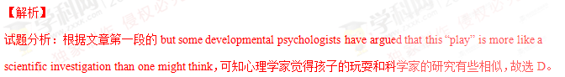考点：考查细节理解。
51. 【答案】D
【解析】
试题分析：根据文章第二段的句子overall approach (gathering direct evidence from the world)可知孩子也会像科学家一样收集证据，故选D。
考点：考查细节理解。
52. 【答案】C
【解析】
试题分析：根据文章第三段的句子For example, it may only be through repeated experiments, evidence gathering and finally overturning a theory可知孩子可以通过重复自己的实验来学习语言的规律，故选C。
考点：考查细节理解。
53. 【答案】B
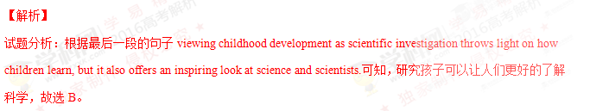考点：考查细节理解。
54. 【答案】D学科.网
【解析】
试题分析：根据作者在文中的用词appear to和may来弱化绝对性的表达，和通过引用其他人的观点some psychologist suggest/argue that 可知，作者的语气是谨慎的。故选D。
考点：考查推理判断。

D
Two things changed my life: my mother and a white plastic bike basket. I have thought long and hard about it and it’s true. I would be a different person if my mom hadn’t turned a silly bicycle accessory into a life lesson I carry with me today.
My mother and father were united in their way of raising children, but it mostly fell to my mother to actually carry it out. Looking back, I honestly don’t know how she did it. Managing the family budget must have been a very hard task., but she made it look effortless. If we complained about not having what another kid did, we’d hear something like, “I don’t care what so –and –so got for his birthday, you are not getting a TV in your room a car for your birthday a lsvish sweet 16 party.” We had to earn our allowance by doing chores around the house. I can stil l remember how long it took to polish the legs of our coffee table.My brothers can no doubt remember hours spent cleaning the house .Like the two little girls growing up at the White House,we made our own beds (no one left the house unitil that was done)and picked up after ourselves.We had to keep track of our belongings ,and if something was lost ,it was not replaced.
It was summer and ,one day ,my mother drove me to the bike shop to get a tire fixed---and there it was in the window, White, shiny, plastic and decorated with flowers ,the basket winked at me and I knew ----I knew---I had to have it.
“It’s beautiful,” my mother said when I pointed it out to her,”What a neat basket.”
I tried to hold off at first ,I played it cool for a short while. But then I guess I couldn’t at and it any longer:“Mom, please can I please ,please get it? I ‘ll do extra chores for as long as you say, I’ll do anything ,but I need that basket,I love that basket.Please ,Mom .Please?”
I was desperate.
“You know,” she said ,gently rubbing my back while we both stared at what I believes was the coolest thing ever,” If you save up you could buy this yourself.”
“By the time I make enough it’ll bu gone!”
“Maybe Roger here could hold it for you,” she smiled at Roger ,the bike guy.
“He can’t hold it for that long ,Mom .Someone else will buy it .Please, Mom,Please?”
“There might be another way,” she said.
And so our paying plan unfolded. My mother bought the beautiful basket and put it safely in some hiding place I couldn’t find. Each week I eagerly counted my growing saving increased by extra work here and there (washing the car ,helping my mother make dinner, delivering or collecting things on my bike that already looked naked without the basket in front).And then ,weeks later ,I counted ,re-counted and jumped for joy. Oh ,happy day ! I made it! I finally had the exact amount we’d agreed upon….
Days later the unthinkable happened. A neighborhood girl I’d played with millions of times appeared with the exact same basket fixed to her shiny ,new bike that already had all the bells and whistles. I rode hard and fast home to tell my mother about this disaster. This horrible turn of events.
And then came the lesson . I’ve taken with me through my life:”Honey, Your basket is extra-special,” Mom said, gently wiping away my hot tears.”Your basket is special because you paid for it yourself.”
55.What can we learn from the first two paragraphs?
A. The children enjoyed doing housework.
B.The author came from s well-off family
C. The mother raised her children in an unusual way
D.The children were fond of the US president’s daughters.
56.When the author saw the basket in the window,she .
A. fell in love with it B. stared at her mother
C. recognized it at once D.went up to the bike guy
57.Why did the author say many “please” to her mother?
A. She longed to do extra work. B. She was eager to have the basket.
C.She felt tired after standing too long. D.She wanted to be polite to her mother.
58.By using“naked” (Paragraph 12),the author seems to stress that the basket was
A..something she could afford B.something important to her
C.something impossible to get D.something she could do without
59.To the author, it seemed to be a horrible turn of events that
A. something spoiled her paying plan
B. the basket cost more than she had saved
C.a neighborhood girl had bought a new bike
D.someone else had got a basket of the same kind
60.What is the life lesson the author learned from her mother?
A. Save money for a rainy day B. Good advice is beyond all price.
C. Earn your bread with your sweat D. God helps those who help themselves
【语篇解读】本文为一篇记叙文。作者回忆自己母亲对孩子不寻常的教育方法。通过一个自行车篮子的事情，母亲教会作者什么事情都要自力更生，通过自己努力得到的东西才是珍贵的。学科&网
55. 【答案】C
【解析】
试题分析：根据第二段的句子We had to earn our allowance by doing chores around the house…. we made our own beds (no one left the house unitil that was done)and picked up after ourselves.We had to keep track of nd if something was lost ,it was not replaced.可知，作者的母亲用不寻常的方法教育孩子。故选C。
考点：考查推理判断
56. 【答案】A
【解析】
试题分析：根据第三段的句子and there it was in the window, White, shiny, plastic and decorated with flowers ,the basket winked at me and I knew ----I knew---I had to have it.可知，当作者在橱窗里面看见这个篮子就喜欢上了它。故选A。
考点：考查细节理解
57. 【答案】B
【解析】
试题分析：根据第五段的句子I tried to hold off at first ,I played it cool for a short while. But then I guess I couldn’t at and it any longer:可知，作者说了很多“pleases”，因为她渴望拥有这个篮子。故选B。
考点：考查推理判断
58. 【答案】B
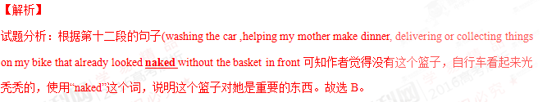考点：考查推理判断
59. 【答案】D
【解析】
试题分析：根据第十三段的句子A neighborhood girl I’d played with millions of times appeared with the exact same basket fixed to her shiny ,new bike that already had all the bells and whistles.可知作者认为其他人有和她相同的篮子是一个灾难。故选D。
考点：考查推理判断
60. 【答案】C
【解析】
试题分析：根据文章内容可知，作者的妈妈教育作者要通过自己的努力获得想要的东西，也就是Earn your bread with your sweat。故选C。
考点：考查主旨大意
第二节：下面文章中有5处（第61-65题）需要添加小标题。请从以下选项（ABCDE和F）中选出符合各段意思的小题，并在答题纸上将相应选项的标号涂黑。选项中有一项是多余选项。
A. Get involved in student activities
B. Your voice is actually super important
C. There is a significant increase of opportunities
D. Stay in active communication with your friends
E. Get smart about the people who you spend your time with
F. Your major does not matter as much in your first of college
Five Things Nobody Told Me about College
As I type this , I am in my university dorm room. A year ago, when I was awaiting to hear the results of my college applications, I often went to websites for some type of insider look on what college would be like. However, there’s only so much that prep books, websites, and older friends can teach. Here are the top 5things nobody told me about college:
61
Nobody entering a university knows exactly what they want to study. If they tell you otherwise, they’re lying and will probably change what they want to purse within the first quarter of attendance . During my first quarter at University of California, Riverside (UCR),I thought that I wanted to study Political Science with its focus on International Affairs, so that’s what I applied for. However, once I worked with statewide and local government, I realized that a better fit for me would be Public Policy, and now I am in the process of changing my area.
62
In college, there are so many good chances for you to meet your expectations. However, there is a very important difference between wanting to do something and applying for something. In order for you to take advantage of the conferences, research, internships ,and fellowships that your university offers, apply! Step into your academic advisor’s office, introduce yourself, and begin making the valuable connections that are necessary to help during the rest of your college career. Great things happen when you step out of your comfort zone, and you would be surprised on how many chances exist if you just ask.
63
College is where you meet your birdesmaids, neighbors, and potential bosses. The relationships you develop now will probably be linked to the ones you value later, so be wise about the people who you invest yourself in . You are only one person, and you do not have time to waste on people who would rather cause drama or mess up with your purpose. Surround yourself with uplifting individuals who challenge you to be better while loving you for who you are, and be patient to the people who are the complete opposite of that description.
64
As a first-year, I was afraid to make any noise towards campus issues that I noticed. It was not until I became involved in student government that I gained the confidence to handle projects that I created with the help of ASUCR Office of the President. During my first quarter, I spoke directly to the Chancellor, asking him for support towards my initiavives, met with the Vive Chancellors, and coorerated with my teaching assistances to begin my undergraduate research protect. Nothing good will happen when you are silent.
65
At my high school, there were about only four active club and organizations that students could be a part of. Imagine my surprise when I stepped foot onto UCR’s campus, where over 400 organizations exist, ranging from political organizations to karate club. You are not paying all or your tuition(学费)to merely go to class, study,pass tests and graduate. Make something worthy out of your experience. Create that you will want to tell your grandchildren one day. It all begins here, by signing up to join an organization.
61. 【答案】F
【解析】
试题分析：根据本段的句子Nobody entering a university knows exactly what they want to study. If they tell you otherwise, they’re lying and will probably change what they want to purse within the first quarter of attendance .可知，这段主要介绍了：你的专业在大学一年级不重要。故选F。
考点：考查段落大意
62. 【答案】C
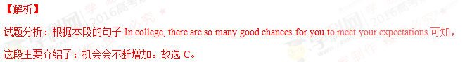考点：考查段落大意
63. 【答案】E
【解析】
试题分析：根据本段的句子The relationships you develop now will probably be linked to the ones you value later, so be wise about the people who you invest yourself in .可知，这段主要介绍了：对于在一起的人要理性一些。故选E。
考点：考查段落大意
64. 【答案】B
【解析】
试题分析：根据本段的句子Nothing good will happen when you are silent.可知，这段主要介绍了：你说的话实际上非常重要。故选B。
考点：考查段落大意
65. 【答案】A
【解析】
试题分析：根据本段的句子It all begins here, by signing up to join an organization.可知，这段主要介绍了：参与一些学生的活动。故选A。
考点：考查段落大意

非选择题部分（共40分）
第三部分：写作（共两节，满分40分）
第一节：短文改错（共10小题；每小题1分，满分10分）
下面短文中有10处语言错误。请在有错误的地方增加、删减或修改某个单词。
增加：在缺词处加一个漏字符号（∧），并在其下面写上该加的词。
删除：把多余的词用斜线（/）划掉。
修改：在错的词下划一横线，并在该词下面写上修改后的词。
注意：1.每处错误及其修改均仅限一词；
2.只允许修改10处，多着（从第11处起）不计分。
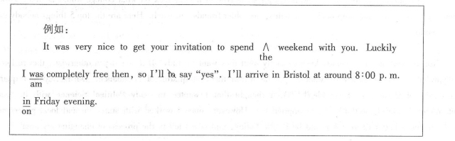
When I was a very young children, my father created a regular practice I remember well years late. Every time he arrived home at end of the day ,we’d greet het at the door. He would ask who we was and pretend not to knowing us, Then he and my mother would have had a drink while she prepared dinner and they would talk about his day and hers. While they chat, my father would lift my sister and me up to sit in the top of the fridge. It was both excited and frightening to be up there！
My sister and I thought he was so cool for putting us there.
When I was a very young children,my father created a regular practice I r
child
emember well years late.Every time he arrived home at ∧end of the day ,
later the
we’d greet herat the door.He would ask who we was and pretend not to knowing
him were know
us,Then he and my mother would have had a drink while she prepared dinner and they would talk about his day and hers.While they chat,my father would lift my sister and
chatted
me up to sit in the top of the fridge.It was both excited and frightening to be up there！
on exciting
66.【答案】children改成child
【解析】
试题分析：因为前面有不定冠词a，所以这里用单数。故children改成child。
考点：考查名词单复数
67.【答案】late改成later
【解析】
试题分析： late是形容词“迟的”，或副词“迟地”，但是“一段时间后面应该接later”，表示“……时间以后”。故late改成later。
考点：考查副词.学.科.网
68.【答案】at后面加the

考点：考查冠词
69.【答案】her改成him
【解析】
试题分析：根据上文可知我们每天在门口迎接爸爸。用him指代my father，作greet的宾语。故her改成him。
考点：考查代词
70.【答案】was改成were
【解析】
试题分析：这句话的主语是we，谓语用复数，而且这篇文章是作者回忆小时候的事情，用一般过去时。故was改成were。
考点：考查主谓一致
71.【答案】knowing改成know
【解析】
试题分析：pretend后面接不定式作宾语，这里是否定式pretend not to do。故knowing改成know。
考点：考查动词不定式
72.【答案】去掉had
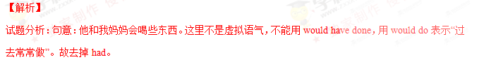考点：考查动词形式
73.【答案】chat改成chatted
【解析】
试题分析：根据主句内容my father would lift my sister 可知while引导的时间状语从句用一般过去时。故chat改成chatted。
考点：考查动词时态
74.【答案】in改成on
【解析】
试题分析：on the top of…为固定搭配，意为“在……顶部”。故in改成on。
考点：考查介词
75.【答案】excited改成exciting
【解析】
试题分析：这句话的主语是形式主语it，真正的主语是to be up there，主语是物的时候，表语应该用现在分词形式的形容词。故excited改成exciting。
考点：考查形容词

第二节：书面表达（满分30分）
“Planning is good ,but doing is better”是一句英国名言。请以此为题目用英语写一篇100-120词的短文。
要求如下：
1.简述你对这句名言的理解；
2.用一个具体事例加以说明；
3.给出恰当的结尾。
注意：1.文章的标题已给出（不计词数）：
2.文中不得以任何形式透露地区、学校、老师或同学姓名等真实信息，否则按作弊行为认定。学科网
Planning Is Good ,But Doing Is Better
【答案】One possible student version

Planning Is Good ,But Doing Is Better
Planning is good as it decides in detail how we do.However,a plan can bear no fruit without being actually carried out.
My experience in the English speech contest last October is a case in point.A month before the event,I Spent hours working out a schedule outlining my goals and practical steps.After that,I set out to read widely for an inspiring topic,wrote a speech,and practiced its delivery in beautiful prounnciation with good public speech skills.I finally came out of the contest as the first prize winner.
I know how I achieved my success. It came from good planning and better doing combined.
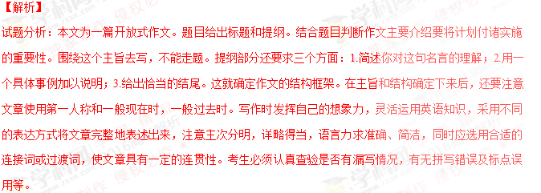考点：考查开放式作文

