Unit 7 Will people have robots ? 教案（附学案）
Teaching goals:
- Words& phrases: robot, paper, less, fewer, simple, unpleasant, factory, seem, etc.
- will 构成的一般将来时态的陈述句、否定句、疑问句及回答.
- There be 句型的一般将来时.
- 学习一般将来时态的相关知识，学会对未来进行预测.
- 对two years ago ,now ,two years later 简洁回顾与展望的方式，贴近实际符合学生心理，激发学习兴趣.
- 通过时间对比复习一般过去时态、一般现在时态，巩固一般将来时.
Important points:
- will构成一般将来时态的句式。
- There be 句型的一般将来时态。
Difficult points: How to make predictions.
Process & methods: Task-based language teaching, 3p
Attitudes and values:通过引导学生展望未来，及对未来生活的设计，来达到前景教育的目的，同时也通过对前景的设想，让学生在潜移默化中反省自己的现状，使之对目前的学习、生活习惯作适当的调整，并不断的改善自己的现状，使学生的理想观和价值观更为科学，更具发展价值。

Period1 section A(1a-1c)
Teaching procedures:
Step 1 Warming up
- Greetings: Good morning!
- Show the pictures and ask questions
What’s this?
Do you want to have a robot in your home?
Can you guess what will happen in the future?
Collect the Ss’ answers and say something about their predictions.
Step 2 Presentation
Page 49, 1a.
1. 引导学生们看大屏幕上的图片，根据图示来理解will来表达一般将来时态。
用一句话来让学生们明白一般将来时态：
I’m thirteen years old now. And I will be fifteen years old in two years.
现在我十三岁，两年后我将是十五岁。
2. 让学生们看大屏幕上图片，并让学生学习will + 动词原形及won’t + 动词原形的用法。通过例句让学生们理解。
3.Let’s predict the future一百年后，世界环境会有什么变化？人们的家居生活会是什么样的？发挥你的想象力，把它们用图画描绘出来。
（1） How will your future be like in 100 years? Can you see anything about it?
（2） Ss discuss and think about their future. Then say some sentences.
e.g. People will have robots at their home.
There will be only one country.
People won’t use money in the future.
…
(同学们如果自己想象不出来，可以根据大屏幕的图片提示来说句子。)
（3）1a, Group work:全班共同讨论1a对未来的预测，发表自己的观点。
How will the world be different 100 years from now? Read the predictions in 1a. Check A for agree or D for disagree.
Ask Ss to read the sentences then discuss them and check A or D.

Step 3 Practice
Page 49,1b .Listening practice (listen to the recording and circle the predictions you hear in 1a. )
- Pre-listening
Preview these words & phrases:
in 100 years 一百年后 clean the kitchen 打扫厨房 be free 免费的 probably 可能
there will be 将有 only one 只有一个 world peace 世界和平 I hope so 我希望如此
on computers 用电脑 disagree 不同意 You do? 真的吗？there always be 总是有
There be 结构的将来时
肯定式 | There + will be + 主语+其他
否定式 | There + won’t be +主语+其他
疑问式 | （1）一般疑问句：will + there be + 主语+其他？  肯定回答：Yes, there will.  否定回答：No, there won’t.  (2)特殊疑问句：特殊疑问词+ there will的一般疑问句？

- While-listening
The teacher will play the tape two times, please try your best to catch the words!
The first time, try to find the main idea.( “4W” and “1H”.)
The second time, listen sentence by sentence.
- Post-listening
(1).Finish the task in 1b.
(2).Role-play the conversation on page101.
(3).Make conversations. (1c) Pair work:对于一百年后的预测，哪些可能发生？哪些不可能发生？结合1a内容，两人一组自由讨论。讨论时可借助如下对话形式：
(1)A：Will people use money in 100 years? (2)A: Will there be one country?
B: Yes, they will /No, they won’t。 B: Yes, there will./ No, there won’t.
(4)观察与思考：观察以上听力训练中所填词汇，结合1a中预测未来的句子，请你来总结：
① 表示将来发生的动作或情况应该用___ +____________来表达。其否定形式为___________+____________。你能写出它的疑问句式吗？_______________________
② There be 句型的一般将来时结构为______________________。

Step4 Production
Page 2, 1c. Pair work
Ask Ss to make conversations.
Step 5 Homework
第一课时学案
学习目标：学会用将来时态预言
一、课前准备：要求学生复习be going to 结构表将来的计划和打算。
翻译下列句子。
1、我打算下周举办生日聚会。
2、他的弟弟计划明天去北京。
3、当我长大了，我打算当一名运动员。
二、新课预习检测: （小组合作完成）
1、Complete the following words we’ve learned in this unit. 根据本单元所学单词，补全下列单词。
r_bo_ p_p_r m_n_y p_ll_tion
2、Look at the following pictures and complete the dialogue. 看图，完成下列对话。
1．A: Will people have ________ in their homes?
B: Yes, ________ ________. I think every home will have one. 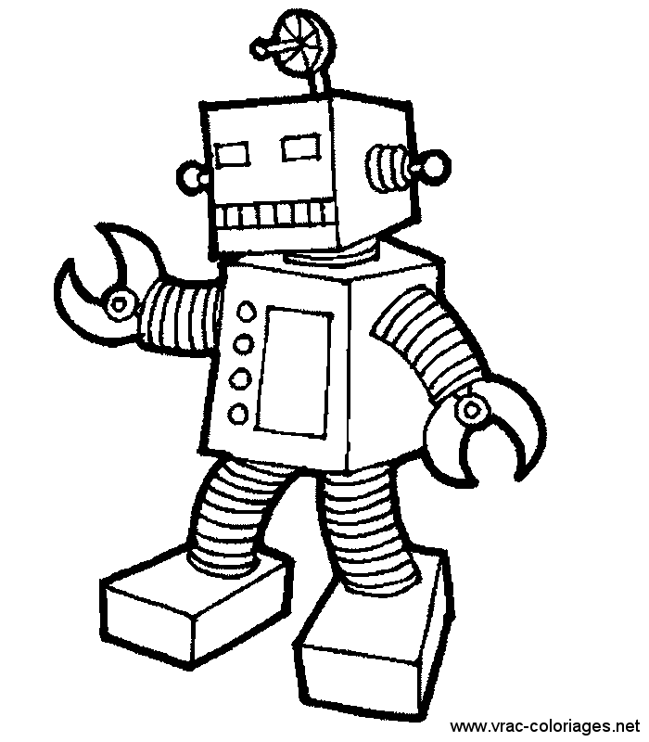

3.练习：将下列句子译成英文。
① 一百年后人们将会拥有机器人。People __________ ________robots in 100 years.
② 每样东西都将会免费吗？__________everything __________ __________?

三、教师导学
Explain :一般将来时态
构成: will / be going to +动词原形
1、用be going to do表示将来：主要意义，一是表示“意图”，即打算在最近的将来或将来进行某事。
Are you going to post that letter?
How long is he going to stay here?
I am going to book a ticket.
另一意义是表示“预见”，即现在已有迹象表明将要发生或即将发生某种情况。
It’s going to rain.
2、用will/ shall do表示将来：
You will feel better after taking this medicine
I will not lend the book to you.
She will come to have class tomorrow.
Will she come to have class tomorrow?
Yes,she will/ No.she won’t
She won’t come to have class tomorrow.
提醒学生注意划线部分的特点。由此总结出一般将来时的结构为:
1、助动词will+动词原形 ,
2、变一般疑问句，直接把will提到句首。
3、变否定句直接在will后加not
四、练习巩固：
Form sentences. 组句(请注意大小写和标点符号)。
1．on paper, books, on computers, not, be, only, will
________________________________________________________________
2．will, 200 years old, to be, live, will, people
_______________________________________________________________
3．in 100 years, won’t, any, be, paper money, there
________________________________________________________________
五、学习体会:

