2013年高考江苏卷试题及答案解析
英 语
第一部分：听力（共两节，满分30分）
该部分分为第一、第二两节。注意：回答听力部分时，请先将答案标在试卷上。听力部分结束时，你将有两分钟的时间将你的答案转涂到客观题答题卡上。
第一节（共5小题；每小题1.5分，满分7.5分）
听下面5段对话。每段对话后有一个小题，从题中所给的A、B、C三个选项中选出最佳选项，并标在试卷的相应位置。听完每段对话后，你都有10秒钟的时间来回答有关小题和阅读下一小题。每段对话仅读一遍。
例：How much is the shirt?
A. ￡19.15 B. ￡ 9.18 C. ￡9.15
答案是C。
1. What does the man want to do?
A. Take photos.
B. Buy a camera.
C. Help the woman.

【答案】A

2. What are the speakers talking about?
A. A noisy night
B. Their life in town.
C. A place of living.

【答案】C

3. Where is the man now?
A. On his way.
B. In a restaurant.
C. At home.

【答案】A

4. What will Celia do?
A. Find a player.
B. Watch a game.
C. Play basketball.

【答案】C

5. What day is it when the conversation takes place?
A. Saturday.
B. Sunday.
C. Monday.

【答案】B

第二节（共15小题；每小题1.5分，满分22.5分）
听下面5段对话或独白。每段对话或独白后有几个小题，从题中所给的A、B、C三个选项中选出最佳选项，并标在试卷的相应位置。听每段对话或独白前，你将有时间阅读各个小题，每小题5秒钟；听完后，各小题将给出5秒钟的作答时间。每段对话或独白读两遍。
听下面一段对话，回答第6至7两个小题。
6. What is Sara going to do?
A. Buy John a gift
B. Invite John to France
C. Give John a surprise

【答案】B

7. What does the man think of Sara’s plan?
A. Funny.
B. Exciting.
C. Strange.

【答案】B

听下面一段圣诞，回答第8和第9两个小题
8. Why does Diana say sorry to Peter?
A. She has to give up her travel plan.
B. She wants to visit another city.
C. She needs to put off her test.

【答案】A

9. What does Diana want Peter to do?
A. Help her with her study.
B. Take a book to her friend.
C. Teach a geography lesson.

【答案】B

听下面一段对话，回答第10至第12三个小题。
10. Why does the man call the woman?
A. To tell her about her new job.
B. To ask about her job program
C. To plan a meeting with her.

【答案】A

11. Who needs a new flat?
A. Alex.
B. Andrea.
C. Miranda.

【答案】B

12. Where is the woman now?
A. In Baltimore.
B. In New York.
C. In Avon.

【答案】A

听下面一段对话，回答第13至16四个小题。
13. What does Jan consider most important when he judges a restaurant?
A. Where the restaurant is.
B. Whether the prices are low.
C. How well the food is prepared.

【答案】C

14. When did Jan begin to write for a magazine?
A. After he came back to Sweden.
B. Before he went to the United States.
C. As soon as he got his first job in 1982.

【答案】A

15. What may Jan do to find a good restaurant?
A. Talk to people in the street.
B. Speak to taxi drivers.
C. Ask hotel clerks.

【答案】A

16. What do we know about Jan?
A. He cooks for a restaurant.
B. He travels a lot for his work.
C. He prefers American food.

【答案】B

听下面一段独白，回答第17至20四个小题。
17. What do we know about the Plaza Leon?
A. It’s a new building.
B. It’s a small town.
C. It’s a public place.

【答案】C

18. When do parents and children like going to the Plaza Leon?
A. Saturday nights.
B. Sunday afternoon.
C. Fridays and Saturdays.

【答案】B

19. Which street is known for its food shops and markets?
A. Via Del Mar Street.
B. Fernando Street.
C. Hernandes Street.

【答案】C
20. Why does the speaker like Horatio Street best?
A. It has an old stone surface.
B. It is named after a writer.
C. It has a famous university.

【答案】C

第二部分: 英语知识运用(共两节, 满分35 分)
第一节: 单项填空 (共15小题; 每小题1分,满分15分)
请认真阅读下面各题, 从题中所给的A、B、C、D 四个选项中, 选出最佳选项, 并在答题卡上将该项涂黑。
例: It is generally considered unwise to give a child _______ he or she wants.
A. however B. whatever C. whichever D. whenever
答案是B。
21. Gnerally, students’ inner motivation with high expectations from others _____ essential to their development.
A. is B. are C. was D. were

【答案】

【解析】
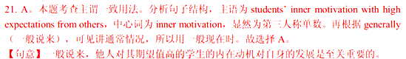

22. —The T-shirt I received is not the same as is shown online.
—_____? But I promise you we’ll look into it right away.
A. Who says B. How come C. What for D. Why worry

【答案】

【解析】
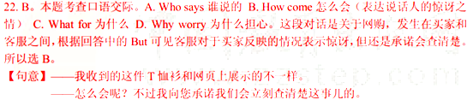
23. —The town is so beautiful! I just love it.
—Me too. The character of the town is well _____.
A. qualitfied B. preserved C. decorated D. simplified

【答案】

【解析】


24. Lionel Messi, _____ the record for the most goals in a calendar year, is considered the most talented football player in Europe.
A. set B. setting C. to set D. having set

【答案】

【解析】
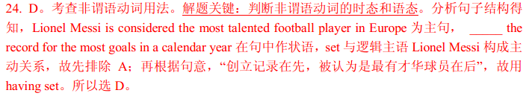

25. —Could I use your car tomorrow morning?
—Sure, I _____ a report at home.
A. will be writing B. will have written C. have written D. have been writing

【答案】

【解析】
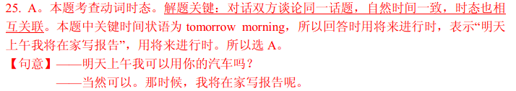

26. I am always delighted when I recieve an e-mail from you. _____ the party on July 1st, I shall be pleased to attend.
A. On account of B. In response to C. In view of D. With regard to

【答案】

【解析】
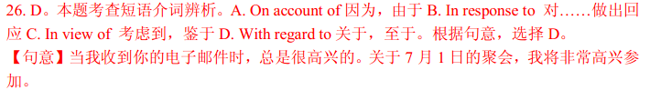

27. “Never for a second,” the boy says, “_____ that my father would come to my rescue.”
A. I doubted B. do I doubt C. I have doubted D. did I doubt

【答案】

【解析】
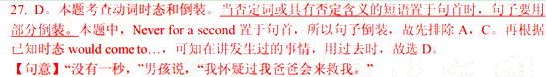

28. In the global economy, a new drug for cancer, _____ it is discovered, will create many economic possibilities around the world.
A. whatever B. whoever C. wherever D. whichever

【答案】

【解析】
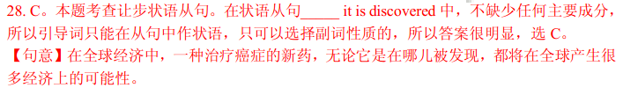

29. Team leaders must ensure that all members _____ their natural desire to avoid the embarrasment associated with making mistakes.
A. get over B. look over C. take over D. come over

【答案】

【解析】
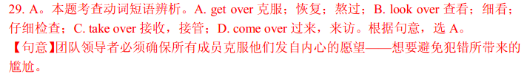

30. I should not have laughed if I _____ you were serious.
A. thought B. would think C. had thought D. have thought

【答案】

【解析】
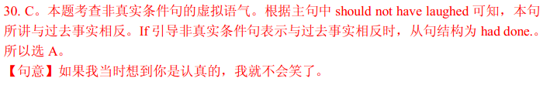

31. Shortly after suffering from a massive earthquake and _____ to ruins, the city took on a new look.
A. reducing B. reduced C. being reduced D. having reduced

【答案】

【解析】
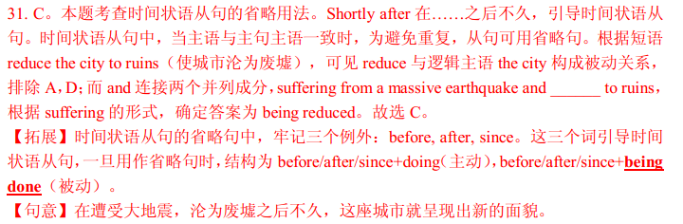

32. The president of teh World Bank says he has a pssion for China, _____ he remembers starting as early as his childhood.
A. where B. which C. what D. when

【答案】

【解析】
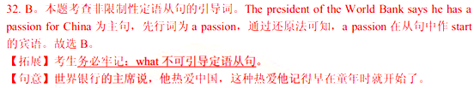

33. With inspiration from other food cultures, American food culture can take a _____ for the better.
A. share B. chance C. turn D. when

【答案】

【解析】
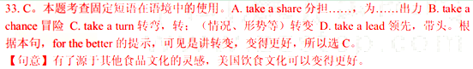

34. —What about your self-drive trip yesterday?
—Tiring! The road is being widened, and we _____ a round ride.
A. had B. have C. would have D. have had

【答案】

【解析】
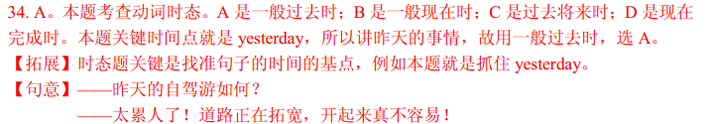

35. —Thank you for the flowers.
—_____. I thought they might cheer you up.
A. That’s right B. All right C. I’m all right D. It’s all right

【答案】

【解析】
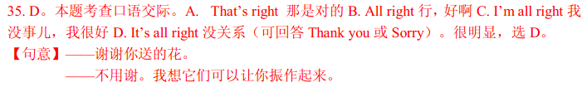

第二节: 完形填空(共20小题; 每小题1 分, 满分20 分)
请认真阅读下面短文, 从短文后各题所给的A、B、C、D 四个选项中, 选出最佳选项, 并在答题卡上将该项涂黑。
I used to believe in the American Dream, which meant a job, a mortgage (按揭), credit cards, success. I wanted it and worked toward it like everyone else, all of us 36 chasing the same thing.
One year, through a series of unhappy events, it all fell 37 . I found myself homeless and alone. I had my truck and $56. I 38 teh countryside for some place I could rent for the 39 possible amount. I came upon a shabby house four miles up a winding mountain road 40 the Potomac River in West Virginia. It was 41 , full of broken glass and rubbish. I found the owner, rented it, and 42 a corner to camp in.
The locals knew nothing about me, 43 slowly, they started teaching me the 44 of being a neighbor. They dropped off blankets, candles, and tools, and began 45 around to chat. They started to teach me a belief in a 46 American Dream—not the one of individual achievement but of 47 .
What I have believed in, all those things I thought were 48 for a civilized life, were nonexistent in this place. 49 on teh mountain, my most valuable possessions were my 50 with my neighbors.
Four years later, I moved back into 51 . I saw many people were having a really hard time, 52 their jobs and homes. I managed to reant a big enough house to 53 a handful of people. There are four of us now in the house, but over time I’ve had nine people come in and move on to other places. We’d all be in 54 if we hadn’t banded together.
The American Dream I believe in now is a shared one. It’s not so much about what I can get for mysefl; it’s about 55 we can all get by together.
36. A. separately B. equally C. violently D. naturally

【答案】

【解析】

37. A. off B. apart C. over D. out

【答案】

【解析】

38. A. crossed B. left C. toured D. searched

【答案】

【解析】

39. A. fullest B. largest C. fairest D. cheapest

【答案】

【解析】

40. A. at B. through C. over D. round

【答案】

【解析】

41. A. occupied B. abandoned C. emptied D. robbed

【答案】

【解析】

42. A. turned B. approached C. cleared D. cut

【答案】

【解析】

43. A. but B. although C. otherwise D. for

【答案】

【解析】

44. A. benefit B. lesson C. nature D. art

【答案】

【解析】

45. A. sticking B. looking C. swingting D. turning

【答案】

【解析】
46. A. wild B. real C. different D. remote

【答案】

【解析】

47. A. neighborliness B. happiness C. friendliness D. kindness

【答案】

【解析】

48. A. unique B. expensive C. rare D. necessary

【答案】

【解析】

49. A. Up B. Down C. Deep D. Along

【答案】

【解析】

50. A. cooperation B. relationship C. satisfaction D. appointments

【答案】

【解析】

51. A. reality B. society C. town D. life

【答案】

【解析】

52. A. creating B. losing C. quitting D. offering

【答案】

【解析】
53. A. put in B. turn in C. take in D. get in

【答案】

【解析】

54. A. yards B. shelters C. camps D. cottages

【答案】

【解析】

55. A. when B. what C. whehter D. how

【答案】

【解析】
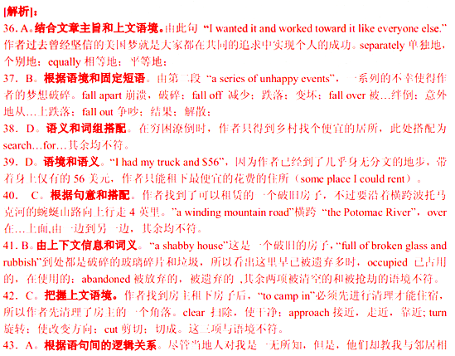

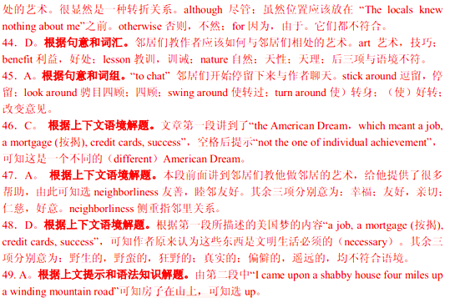

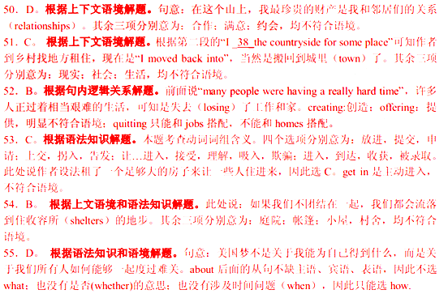

第三部分: 阅读理解(共15 小题; 每小题2 分, 满分30 分)
请认真阅读下列短文, 从短文后各题所给的A、B、C、D 四个选项中, 选出最佳选项, 并在答题卡上将该项涂黑。
A


Guest Services  Front Gate Guest Services can help you with anything from finding out what time your favourite show starts to purchasing tickets. The Guest Services location inside Front Gate also serves as a message center, lost children’s area and lost and found. Canada’s Wonderland does not offer personalized public paging (传呼). | Food & Drink Options  Shops are located throughout Canada’s Wonderland. Pinic baskets and coolers are welcome at the shelter located outside Wonderland on the north side of our Front Gate. Outside food and drinks are not allowed in the Park. Bottled water may be brought into the Park.
ATMs  ATMs are located just inside the Park beside Stroller, Locker and Wheelchair Rentals at the Front Gate, as well as KidZville (beside Guest Services), Splash Works (two locations), and outside Thunder Run. | Pet Care  A pet care facility is located outside our Front Gate on the south side for a daily fee. Water and air-conditioned shelters are provided. Guests are asked to provide food and exercise.
First Aid  If you need medical assistance, tell any park emloyee who will call First Aid and have them come to your location. | Stroller, Locker and Wheelchair Rentals  Stroller, locker and wheelchair rentals are available inside the Park at the Front Gate, beside Thrills Are Wonderland.
Smoking Policy  Smoking is not permitted while riding or standing in line for rides or in any of the chidren’s areas or the Water Park. Smoking is permitted in designated (指定的) areas only. | Failure to observe all Park rules could result in being driven out of the Park without refund.
56. The leaflet is to inform visitors of the Park’s _____.
A. advanced management B. thrill performances
C. entertainment facilities D. thoughtful services

【答案】

【解析】

57. A visitor to the Park can _____.
A. rent a stroller outside Front Gate B. ask for first aid by Thunder Run
C. smoke in the Water Park D. leave his pet at KidZville

【答案】

【解析】
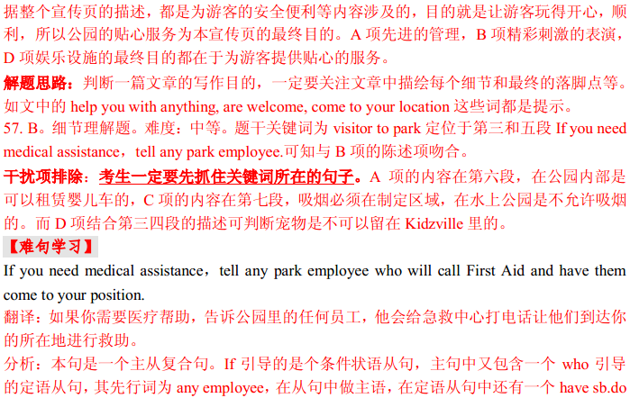

B
We’ve considered several ways of paying to cut in line: hiring line standers, buying tickets fromscalpers (票贩子), or purchasing line-cutting privileges directly from, say, an airline or anamusement park. Each of these deals replaces the morals of the queue (waiting your turn) with the morals of the market (paying a price for faster service).
Markets and queues—paying and waiting—are two different ways of allocating things, and each is appropriate to different activities. The morals of the queue, “First come, first served,” have an egalitarian (平等主义的) appeal. They tell us to ignore privilege, power, and deep pockets.
The principle seems right on playgrounds and at bus stops. But the morals of thequeue do not govern all occasions. If I put my house up for sale, I have no duty toaccept the first offer that comes along, simply because it’s the first. Selling myhouse and waiting for a bus are different activities, properly governed by different standards.
Sometimes standards change, and it is unclear which principle should apply. Think of the recorded message you hear, played over and over, as you wait on hold when calling your bank: “Your call will be answered in the order in which it was received.” This is essential for the moralsof the queue. It’s as if the company is trying to ease our impatience with fairness.
But don’t take the recorded message too seriously. Today, some people’s calls are answered faster than others. Call center technology enables companies to “score” incoming calls and to give faster service to those that come from rich places. You might call this telephonic queue jumping.
Of course, markets and queues are not the only ways of allocating things. Some goods we distribute by merit, others by need, still others by chance. However, the tendency of markets to replace queues, and other non-market ways of allocating goods is so common in modern life that we scarcely notice it anymore. It is striking that most of the paid queue-jumping schemes we’ve considered — at airports and amusement parks, in call centers, doctors’ offices, and national parks — are recent developments, scarcely imaginable three decades ago. The disappearance of the queues in these places may seem an unusual concern, but these are not the only places that markets have entered.
58. According to the author, which of the following seems governed by the principle “First come,first served”?
A. Taking buses. B. Buying houses.
C. Flying with an airline. D. Visiting amusement parks.

【答案】

【解析】

59. The example of the recorded message in Paragraphs 4 and 5 illustrates _____.
A. the necessity of patience in queuing B. the advantage of modern technology
C. the uncertainty of allocation principle D. the fairness of telephonic services

【答案】

【解析】
60. The passage is meant to _____.
A. justify paying for faster services B. discuss the morals of allocating things
C. analyze the reason for standing in line D. criticize the behavior of queue jumping

【答案】

【解析】




C
If a diver surfaces too quickly, he may suffer the bends. Nitrogen (氮) dissolved (溶解) in his blood is suddenly liberated bythe reduction of pressure. The consequence, if the bubbles (气泡) accumulate in a joint, is sharp pain and a bent body—thus the name. If the bubbles form in his lungs or his brain, the consequence can bedeath.
Other air-breathing animals also suffer this decompression (减压) sickness if they surface too fast: whales, for example. And so, long ago, did ichthyosaurs. That these ancient sea animals got the bends can beseen from their bones. If bubbles of nitrogen form inside the bone they can cut off its blood supply. This kills the cells in the bone, and consequently weakens it, sometimes to the point of collapse. Fossil (化石) bones that have caved in on themselves are thus a sign that the animal once had the bends.
Bruce Rothschild of the University of Kansas knew all this when he began a study of ichthyosaur bones to find out how widespread the problem was in the past. What he particularly wanted to investigate was how ichthyosaurs adapted to the problem of decompression over the 150 million years. To this end, he and his colleagues traveled the world’s natural-history museums, looking at hundreds of ichthyosaurs from the Triassic period and from the later Jurassic and Cretaceous periods.
When he started, he assumed that signs of the bends would be rarer in younger fossils, reflecting their gradual evolution of measures to deal with decompression. Instead, he was astonished to discover the opposite. More than 15% of Jurassic and Cretaceous ichthyosaurs had suffered the bends before they died, but not a single Triassic specimen (标本) showed evidence of that sort of injury.
If ichthyosaurs did evolve an anti-decompression means, they clearly did so quickly—and, most strangely, they lost it afterwards. But that is not what Dr Rothschild thinks happened. He suspects it was evolution in other animals that caused the change.
Whales that suffer the bends often do so because they have surfaced to escape apredator (捕食动物) such as a large shark. One of the features of Jurassic oceans was an abundance of large sharks and crocodiles, both of which were fond of ichthyosaur lunches. Triassic oceans, by contrast, were mercifully shark- and crocodile-free. In the Triassic, then, ichthyosaurs were top of the food chain. In the Jurassic and Cretaceous, they were prey (猎物) as well as predator—and often had to make a speedy exit as a result.
61. Which of the following is a typical symptom of the bends?
A. A twisted body.
B. A gradual decrease in blood supply.
C. A sudden release of nitrogen in blood.
D. A drop in blood pressure.

【答案】

【解析】

62. The purpose of Rothschild’s study is to see _____.
A. how often ichthyosaurs caught the bends
B. how ichthyosaurs adapted to decompression
C. why ichthyosaurs bent their bodies
D. when ichthyosaurs broke their bones

【答案】

【解析】

63. Rothschild’s finding stated in Paragraph 4 _____.
A. confirmed his assumption B. speeded up his research process
C. disagreed with his assumption D. changed his research objectives

【答案】

【解析】

64. Rothschild might have concluded that ichthyosaurs ______.
A. failed to evolve an anti-decompression means
B. gradually developed measures against the bends
C. died out because of large sharks and crocodiles
D. evolved an anti-decompression means but soon lost it

【答案】

【解析】
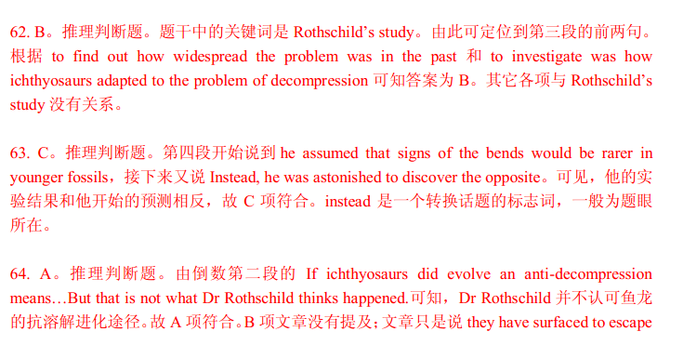

D
Mark Twain has been called the inventor of the American novel. And he surely deserves additional praise: the man who popularized the clever literary attack on racism.
I say clever because anti-slavery fiction had been the important part of theliterature in the years before the Civil War. H. B. Stowe’s Uncle Tom’s Cabin is only the most famous example. These early stories dealt directly with slavery. With minor exceptions, Twain planted his attacks on slavery and prejudice into tales that were on the surface about something else entirely. He drew his readers into the argument by drawing them into the story.
Again and again, in the postwar years, Twain seemed forced to deal with the challenge of race. Consider the most controversial, at least today, of Twain’s novels, Adventures of Huckleberry Finn. Only a few books have been kicked off the shelves as often as Huckleberry Finn, Twains most widely read tale. Once upon a time, people hated the book because it struck them as rude. Twain himself wrote that those who banned the book considered the novel “trash and suitable only for the slums (贫民窟).” More recently the book has been attacked because of the character Jim, the escaped slave, and many occurences of the word nigger. (The term Nigger Jim, for which the novel is often severely criticized, never appears in it.)
But the attacks were and are silly—and miss the point. The novel is strongly anti-slavery. Jim’s search through the slave states for the family from whom he has been forcibly parted is heroic. As J. Chadwick has pointed out, the character of Jim was a first in American fiction—a recognition that the slave had two personalities, “the voice of survival within a white slave culture and the voice of the individual: Jim, the father and the man.”
There is much more. Twain’s mystery novel Pudd’nhead Wilson stood as a challenge to the racial beliefs of even many of the liberals of his day. Written at a time when the accepted wisdom held Negroes to be inferior (低等的) to whites, especially in intelligence, Twain’s tale centered in part around two babies switched at birth. A slave gave birth to her master’s baby and, for fear that the child should be sold South, switched him for the master’s baby by his wife. The slave’s light-skinned child was taken to be white and grew up with both the attitudes and the education of the slave-holding class. The master’s wife’s baby was taken for black and grew up with the attitudes and intonations of the slave.
The point was difficult to miss: nurture (养育), not nature, was the key to social status. The features of the black man that provided the stuff of prejudice—manner of speech, for example—were, to Twain, indicative of nothing other than the conditioning that slavery forced on its victims.
Twain’s racial tone was not perfect. One is left uneasy, for example, by the lengthy passage in his autobiography (自传) about how much he loved what were called “nigger shows” in his youth—mostly with white men performing in black-face—and his delight in getting his mother to laugh at them. Yet there is no reason to think Twain saw the shows as representing reality. His frequent attacks on slavery and prejudice suggest his keen awareness that they did not.
Was Twain a racist? Asking the question in the 21st century is as wise as asking the same of Lincoln. If we read the words and attitudes of the past through the “wisdom” of the considered moral judgments of the present, we will find nothing but error. Lincoln, who believed the black manthe inferior of the white, fought and won a war to free him. And Twain, raised in a slave state, briefly a soldier, and inventor of Jim, may have done more to anger the nation over racial injustice and awaken its collective conscience than any other novelist in the past century.
65. How do Twain’s novels on slavery differ from Stowe’s?
A. Twain was more willing to deal with racism.
B. Twain’s attack on racism was much less open.
C. Twain’s themes seemed to agree with plots.
D. Twain was openly concerned with racism.

【答案】

【解析】

66. Recent criticism of Adventures of Huckleberry Finn arose partly from its _____.
A. target readers at the bottom
B. anti-slavery attitude
C. rather impolite language
D. frequent use of “nigger”

【答案】

【解析】

67. What best proves Twain’s anti-slavery stand according to the author?
A. Jim’s search for his family was described in detail.
B. The slave’s voice was first heard in American novels.
C. Jim grew up into a man and a father in the white culture.
D. Twain suspected that the slaves were less intelligent.

【答案】

【解析】
68. The story of two babies switched mainly indicates that _____.
A. slaves were forced to give up their babies to their masters
B. slaves’ babies could pick up slave-holders’ way of speaking
C. blacks’ social position was shaped by how they were brought up
D. blacks were born with certain features of prejudice

【答案】

【解析】

69. What does the underlined word “they” in Paragraph 7 refer to?
A. The attacks.
B. Slavery and prejudice.
C. White men.
D. The shows.

【答案】

【解析】

70. What does the author mainly argue for?
A. Twain had done more than his contemporary writers to attack racism.
B. Twain was an admirable figure comparable to Abraham Lincoln.
C. Twain’s works had been banned on unreasonable grounds.
D. Twain’s works should be read from a historical point of view.

【答案】

【解析】
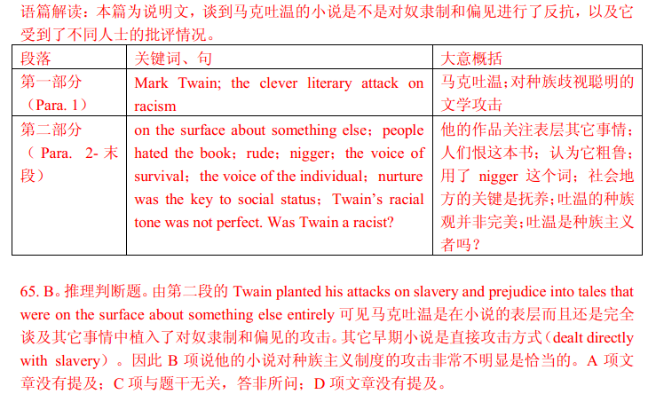

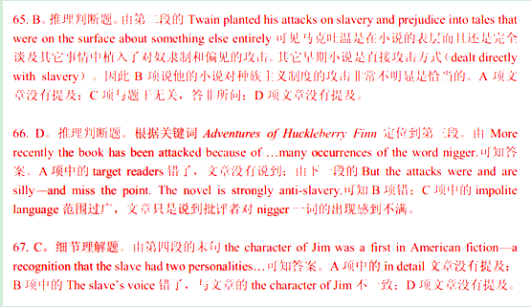

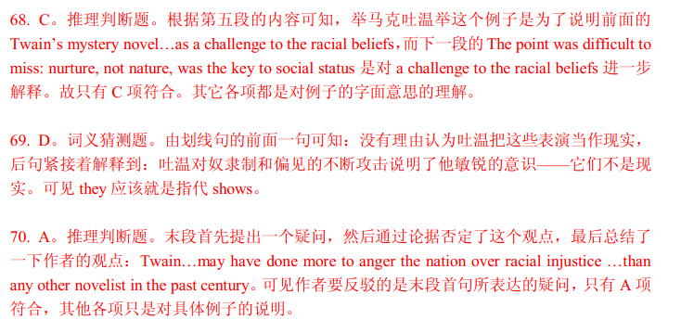

第四部分: 任务型阅读(共10 小题;每小题1 分,满分10 分)
请认真阅读下列短文,并根据所读内容在文章后表格中的空格里填入一个最恰当的单词。
注意: 请将答案写在答题卡上相应题号的横线上。每个空格只填一个单词。
Quiet Virtue: The Conscientious
The everyday signs of conscientiousness (认真尽责)—being punctual, careful in doing work, self-disciplined, and scrupulous (一丝不苟的) in attending to responsibilities—are typical characteristics of the model organizational citizen, the people who keep things running as they should. They follow the rules, help out, and are concerned about the people they work with. It’s teh conscientious worker who helps newcomers or updates people who return after an absence, who gets to work on time and never abuses sick leaves, who always gets things done on deadline.
Conscientiousness is a key to success in any field.. In studies of job performance, outstanding effectivenss for almost all jobs, from semi-skilled labor to sales and management, depends on conscientiousness. It is particularly important for outstanding performance in jobs at the lower levels of an organization: the secretary whose message taking is perfect, teh delivery truck driver who is always on time.
Among sales representatives for a large American car manufactures, those who were most conscientious had the largest volume of sales. Conscientiousness also offers a buffer (缓冲) against the threat of job loss in today’s constantly chaning market, because employees with this quality are among the most valued. For the sales representatives, their level of conscientiousness mattered almost as much as their sales in determining who stayed on.
But conscientiousness in the absence of social skills can lead to problems. Since conscientious people demand so much of themselves, they can hold other people to their own standards, and so be overly judgement when others don’t show the same high levels of model behavior. Factory workers in Great Britain and the United States who were extremely conscientious, for example, tended to criticize co-workers even about failures that seemed unimportant to those they citicized, which demanded their relationships.
When conscientiousness takes the form of living up to expectations, it can discourage creativity. In creative professions like art or advertising, openness to wild ideas and spontaneity (自发性) are scarce and in demand. Success in such occupations calls for a balance, however; without enough conscientiousness to follow through, people become mere dreamers, with nothing to show for their imaginativeness.
Quiet Virtue: The Conscientious

Conscientious people are very (71) ▲ with themselves.
Features of
conscientiousness
Conscientious people are very (72) ▲ to others.

Conscientiousness keeps an organization (74) ▲
smoothly.

Conscientious employees at the lower levels give outstanding (75) ▲ .
(73) ▲ of
conscientiousness

The most conscientious salespersons usually have the largest volume of sales

Conscientious employees are less likely to be (76) ▲ .

Employers’ evaluations of the work of conscientious people
can be (78) ▲ .

Conscientious peopel without social skills tend to have
(79) ▲ relationships with their fellow workers.
Possilbe (77) ▲ with
conscientiousness

Conscientiousness can (80) ▲ creativity, expeically in
professions calling for imagination.

【答案】

【解析】
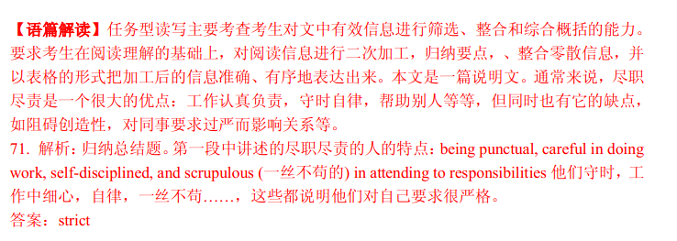

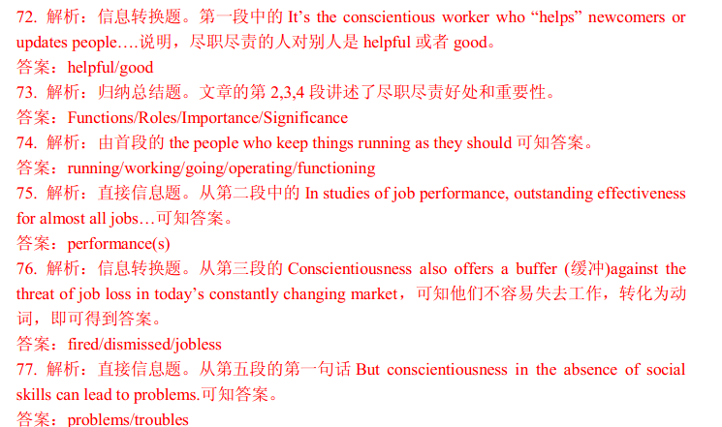

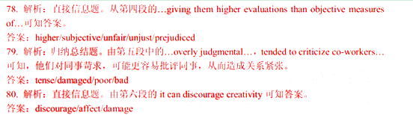

第五部分: 书面表达(满分25 分)
81. 请根据你对以下两幅图的理解，以 “Actions Speak Louder than Words”为题，用英语写一篇作文。
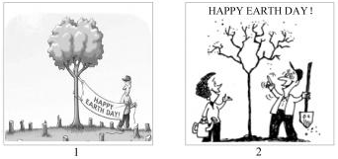

参考词汇：
banner (横幅)
stump (树桩)
你的作文应包括以下内容：
1. 简要描述两幅图的内容；
2. 概述你对两幅图中不同做法的理解；
3. 举例说明两幅图对你的启示。
注意：
1. 可参照图片适当发挥；
2. 作文词数 150 左右；
3. 作文中不得提及有关考生个人身份的任何信息,如校名、人名等。
Actions Speak Louder than Words
_____________________________________________________________________________________________________________________________________________________________________________________________________________________________________________

【答案】

【解析】


