黑龙江省龙东地区2014年初中毕业学业统一考试
英 语 试 题
本考场试卷序号
（ 由监考填写）
考生注意：
1、考试时间120分钟
2、全卷共五道大题，总分120分
题号 | I | II | III | IV | V | 总分 | 核分人
得分

得分 | 评卷人
第一部分 语言知识运用(共计65分)
Ⅰ.Multiple choice (本题共30分,每小题1分，)
Choose the best answer from A, B or C according to the meaning of the sentence.
( ) 1.－Your handwriting looks so good. －Really? ________
A. Thank you. B. Don’t mention it. C. No, not good.
( ) 2. Mum, it’s so hot. Could I have some ________?
A. hamburgers B. bread C. ice-cream
( ) 3.－Is this ________iPhone5?
－No, it isn’t ________. It belongs to Alex.
A. yours; mine B. your; mine C. your; my
( ) 4. Write_______ and try not to make any mistakes.
A. as carefully as you can B. as careful as possible C. more careful
( ) 5.－Will you get there by ________bike?
－No, I will take ________bus.
A. the; a B. a; the C. /; a
( ) 6.－________will Eric’s aunt be back?
－In half an hour.
A. How soon B. How often C. How long
( ) 7.－Of the three TV programs, which one do you think is ________?
－I think A Bite of China is.
A. interesting B. more interesting C. the most interesting
( ) 8.－Excuse me, Mr Li, where is the Fishing Island?
－Let me show you on the map. It’s ________the east of China.
A. in B. on C. to
( ) 9. How time flies! Three years ________since I ________ you last time.
A. have passed; met B. has passed; met C. passed; have met
( ) 10.－It’s our duty ________our city clean and beautiful.
－Yes. We should do something for it.
A. to keep B. keep C. keeping
( ) 11.－I have read the book Sense and Sensibility. －________.
A. So have I B. Neither have I C. So I have
( ) 12. Tom, a ________ boy, can speak English quite well.
He wants to learn________ language next term.
A. twelve-years-old; second B. twelve year old; the second
C. twelve-year-old; a second
( ) 13.－Does your son ________an hour________ his homework after school?
－No, shorter than that now, about half an hour.
A. spend; do B. spend; doing C. spends; to do
( ) 14.－Must I get up at 6 o’clock?
－No, you ________.You can get up at 7 o’clock.
A. mustn’t B. needn’t C. can’t
( ) 15. Miss Black is a friend of ________, she always looks after my sister.
A. Mary’s mother’s B. Mary’s mother’ C. Mary mother’s
( ) 16. Shirley is the girl ________ taught me how to use Wechat(微信).
A. whom B. which C. who
( ) 17.－Excuse me .Could you please tell me ________ my car?
－Sure. Park it right here. I’ll help you.
A. how to stop B. where to park C. when to park
( ) 18. Wang Yaping and Liu Yang are our ________ in China. We’re proud____ them.
A. women astronauts; of B. woman astronauts; of C. women astronauts; in
( ) 19. To make our dreams come true, we should have aims ________ then try our best to
achieve it.
A. and B. but C. or
( ) 20.－You look too tired. Why not ________ a rest ?
－Sounds good.
A. stop having B. to stop having C. stop to have
( ) 21.－Tom, why are you in such a hurry?
－Oh, my bike is broken, I’m going to have it ________.
A. repairing B. repaired C. to repair
( ) 22. Mr Bridges, my primary school teacher, used to tell us that practice _______ perfect.
A. make B. made C. makes
( ) 23. Don’t throw away the waste paper. It needs ________.
A. to recycle B. recycling C. recycle
( ) 24.－What can you see in the garden?
－Flowers. ________ beautiful they are!
A. What B. How C. How a
( ) 25.－Jack, your room is dirty. It should ________ right away.
－Sorry, I’ll do it right now.
A. be cleaned B. be cleaning C. cleaned
( ) 26.－Henry, please call us as soon as you________ Hawaii.
－OK. I’ll do that, Mom.
A. arrive in B. are arriving in C. will arrive at
( ) 27.－Alice, what kind of food would you like for lunch, beef noodles or fried rice?
－ ________ is OK. I don’t mind.
A. Either B. Both C. Neither
( ) 28. ________fans would like to go to Brazil to watch the World Cup.
A. Million of B. Millions of C. Millions
( ) 29. I don’t think they can make everything good enough, ________?
A. do I B. can they C. can’t they
( ) 30. Mike is looking for ________ in the cinema. He has drunk too much water.
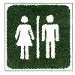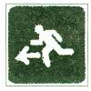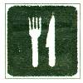
A. B. C.

得分 | 评卷人
Ⅱ.Close test (本题共15分,每小题1分，请将正确选项前的字母填在题前的括号中)
Choose the best answer to complete the passage.
Everyone likes gifts. Some little kids think they 31 enough gifts. Some old people think they get too many gifts. Different people like different 32 gifts. Some presents are never too small. A little child may give his mother 33 from a tree. It is enough 34 her happy.
Gift giving is 35 in different countries. In Japan, people sometimes give special gifts. But they 36 . Later, the same gift may be given away to 37 .Many people have enough things and don’t want more gifts 38 .In Canada, many people 39 big gifts to other people. They will 40 a park bench or a tree to help remember a person.
In the USA, some people ask their families and friends 41 money to charity rather than 42 them gifts. In Sweden, doing 43 for someone is the best gift. People don’t need to spend 44 money. Instead, 45 is enough.

( ) 31.A. don’t get
( ) 32.A. kind of
( ) 33.A. a leaf
( ) 34.A. made
( ) 35.A. the same
( ) 36.A.aren’t opened [来源:学科网]
( ) 37.A. someone else
( ) 38.A. himself
( ) 39.A.will give
( ) 40.A.cost
( ) 41.A. to donate
( ) 42.A. buy
( ) 43.A. everything
( ) 44.A. too much
( ) 45.A. making meal
B. don’t give
B. kinds of
B. a card
B. make
B. different
B. are opened
B. else someone
B. themselves
B. haven’t given
B. pay for
B. donate
B. to buy
B. nothing
B. much too
B. make a meal
C. don’t like
C. kind
C. a toy
C. to make
C. difficult
C. didn’t open
C. everyone else
C. yourselves
C. will not give
C. take
C. donating
C. bought
C. something
C. too many
C. making a meal

得分 | 评卷人
Ⅲ. Communication (本题共20分, 每小题2分)
(A) Choose the best choice from A to F to finish the dialogue. You have one more answer. Each choice should be used only once.
A: Hi, Peter. I see you wearing a pair of glasses. But you didn’t wear it before, did you?
B: (46) But I’m afraid I have to wear it now.
A: (47)
B: Because I get screen sightedness（近视症）and (48)
A: (49) What happened?
B: My doctor said that I watched movies or played games on my iPad quite a lot.
I suggest you not to do that like me.
A: (50) Peter.
B: You’re welcome.
A. Why ? B. I’m sorry to hear that.
C. No, I didn’t. D. Thank you for your advice.
E. Yes, I did. F. I can’t see things clearly.

46 47 48 49 50
(B) Complete the dialogue with proper words or sentences.
A: Hi, Frank. Where did you go this morning?
B: (51) .
A: Why did you go to the railway station?
B: You know National Day is coming. I went there to buy a train ticket.
A: But you look upset now. (52) ?
B: I got up very early this morning in order to buy a train ticket.
(53) .
A: What a pity!
B: Have you bought the train ticket to go home?
A: Yes, (54) .
B: Online?
A: Yes, it’s more convenient. (55) .
B: OK. I will have a try. Thank you a lot.
A: You’re welcome.
第二部分 阅读理解(共计40分)[来源:Zxxk.Com]
得分 | 评卷人[来源:Z*xx*k.Com]
Ⅳ. Reading comprehension (本题共40分, A, D每小题1分, B, C, E每小题2分)
( A )
Nestwatch is a program to monitor nests（观察鸟巢).It was developed by the Smithsonian Migratory Bird Center.

( )56. Environmental problems are one of the things that cause the decline(减少) in the number of the kinds of birds. Nestwatch can help us to better understand the causes of the decline of the kinds of birds and give possible solutions to it. It aims to provide a nest-monitoring plan to follow the breeding patterns(繁殖模式) of all North American birds.
( )57. Nestwatch teaches people about the breeding of birds and encourages them to collect information on nests. The information includes where nests are, the kinds of nests and the number of eggs in them.
( )58. Anyone can check information on Nestwatch freely. Nestwatch makes it easy for people both to deal with their information on nests and to see other people’s information on nests.
( )59. We invite people of all ages who are interested in the natural world. Anyone is welcome to help monitor the success of the breeding of birds and better understand the danger they face.
( )60. The information from lots of people will be put together for people to learn more about the breeding of birds and the things that influence their populations across different places.
Choose the best topic from A to F according to the meaning of the passage.

A. People to take part in Nestwatch B. Nestwatch is important.
C. Ways of using the information. D. Things involved (包括)in Nestwatch
E. Nestwatch is amazing. F. Aim to put the information together.
( B )
Want to say “hello” from Disneyland? Send a post card！
Beautiful scenes of paradise(乐园), wild animals, silly pictures—you can find them all in one place. Where? On a post card! Have people always sent post cards? No. Before post cards, people liked sealed(密封的) letters.
The idea for the first decorated(装饰) post card came to John P. Charlton in 1861.He thought a simple card with decorations would be a great way to send a note. Then in the late 1800s, post cards with pictures appeared. By law, people had to write their note on the front—on the picture! The back was only for the address. Several years later, England allowed a divided-back post card. Then people could write their note on the back left side and put the address on the right. During the early 1900s, the golden age of post cards, picture post cards became a craze of the world. In 1908, Americans alone mailed over 677 million post cards. Today, post cards are the third most popular collection in the world after stamps and coins.
Judge the following sentences true (T) or false (F) according to the passage.
( ) 61. We can see some silly pictures on the post cards.
( ) 62. Post cards were produced before sealed letters.
( ) 63. In 1861, the first decorated post card appeared.
( ) 64. Post cards were the most popular during the early 1900s.
( ) 65. Stamps, coins and post cards are the most popular collections in the world.
( C )
Choose the best choice from A, B or C according to what you read.
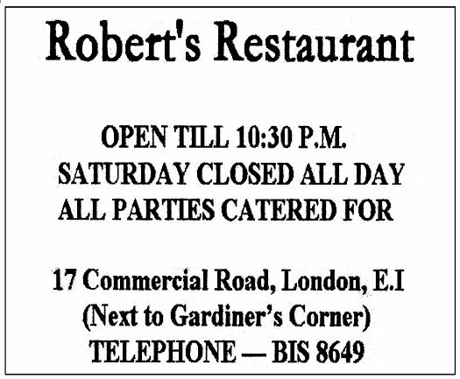

( )66. If the Jacksons want to have dinner together this week, they can go to _______.
A. Anchor on Tuesday B. Robert’s Restaurant at 10:30 pm
C. Anchor on Saturday
( )67. You can go to Robert’s Restaurant when you are in _______.
A. Australia B. Britain C. France
( )68. Which of the following information can NOT be found in the two pictures?
A. Which day Anchor is closed? B. Anchor ’s phone number.
C. Robert’s Restaurant’s opening time.
( )69. Anchor is known for _______.
A. its homemade meals B. its service for parties
C. the Gardiner’s Corner
( ) 70. What are these two pictures?
A. Tickets B. Menus C. Advertisements[来源:学科网]
( D )
Once a wicked wizard(邪恶的巫师)was on a visit to a city and stole the tongues(舌头)from the sleeping people and cast a spell(施一个咒语)on them. The spell meant that these tongues could only say bad things about people. Then the wizard returned these tongues to their owners. In very little time, that city was filled with the sound of people saying bad things about each other.
On seeing all this, the good wizard decided to do something. She cast a spell on the ears of the city people. Under this spell, no matter when the ears heard people saying bad things, they would close up so that nothing could be heard. Later, the tongues started to feel completely useless. When they realized this, they began to change by saying good things to each other.
Until today, the wicked wizard goes on casting the spell on tongues all over the world. But thanks to the good wizard, now people all realize that the best way to end something bad is to pay no attention to it.
Fill in the blanks according to the passage .Only one word for each blank.
Long ago, a wicked wizard (71) a city and stole the tongues from the sleeping people and cast a spell on them. The spell meant that these tongues could only say bad things about people. Then the wizard returned these tongues to their owners. In very little time that city was (72) of the sound of people saying bad things about each other. A good wizard knew this and she cast a spell on the ears of the city people. Under this spell, (73) the ears heard people saying bad things, they would close up and nothing could be heard.
Until today, the wicked wizard (74) casting the spell on tongues throughout the world. But because of the good wizard, now (75) realizes that the best way to end something bad is to pay no attention to it.
71 72 73 74 75
( E )
A TV program has become popular in China recently. It has made people all over China become interested in writing Chinese characters(汉字).
The increasing use of computers and smart phones has left most young people hardly able to write by hand. Many of them are even unable to remember the 10,000 characters used in daily life without electronic help.
CCTV started the Chinese Character Dictation Competition to improve the population’s handwriting skills. Contestants（参与者）on the show were school pupils, but it was found that 70 % of adults in the audience（观众）were unable to remember how to write the word “chan chu”.
Because computers allow people to type characters simply by entering pinyin, they don’t
need to remember how to write them. “The keyboard age has had a big influence on the handwriting of Chinese characters.”Guan Zhengwen, who designed and directed the show said.
He added that he hoped to encourage people to keep it alive as an art form.
Hao Mingjian, an editor of a magazine, putting his heart into Chinese characters, said,“Learning Chinese characters goes on throughout your life. If you stop using them for a long time, it is very likely that you will forget them.”
Answer the questions according to the passage.
76. Are Chinese people interested in writing Chinese characters now?

77. What has left most young people hardly able to write by hand?

78. Why did CCTV start the Chinese Character Dictation Competition?

79. How do computers allow people to type characters simply?

80. What can you learn from the passage?
得分 | 评卷人
第三部分 书面表达 (共计15分)
Ⅴ.Writing ( 本题共15分，其中81题5分，82题10分)
（注意：文中不能出现考生真实姓名、校名和师名，否则不得分）
81.假如你叫Bill,昨天游泳后患了感冒，今天早上觉得头疼。妈妈给你量了体温后，发现你发烧，便带你去看医生。医生说你需要卧床休息两天，特向老师请假。请给老师写一张请假条。
June 12 th, 2014
Dear Mrs. White,
I’m sorry to tell you that I can’t go to school today.

With best wishes.
Your student,
Bill
82. (A). 话题作文：即将到来的假期，你打算怎样度过呢？是去旅游，去放松玩乐还是去做一些其它有意义的事情？请以“Doing Something _________ in Summer Holiday”为题写一篇英语短文，谈谈你的想法。（提示：先将题目补充完整，可用meaningful，relaxing, interesting等。）
(B). 图示作文：仔细观察下列三幅图片，展开合理想象，写一篇短文。
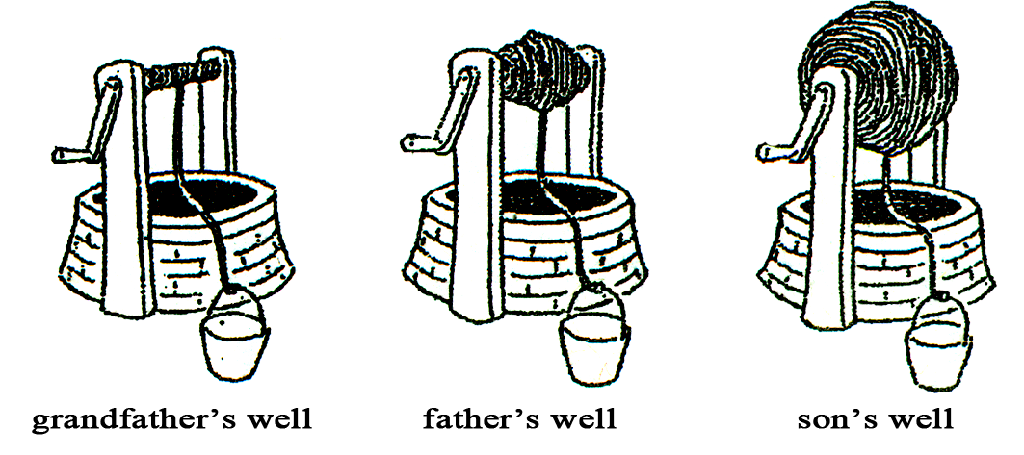
grandfather’s well father’s well son’s well
提示词：rope 绳子 broadcast 宣传 call on 号召 make contributions to 为…做出贡献
要求：1. 话题作文或图示作文任选其一。2. 词数在80～100词之间。
3. 要求字迹工整，语法正确，意思连贯，合乎逻辑，可适当发挥。

[来源:学。科。网]
黑龙江省龙东地区2014年初中毕业学业统一考试
英语试题参考答案及评分标准
说明：
- 阅卷教师首先要认真研读《试题》及《参考答案》，并严格依照本评分标准评卷。
- 主观性试题如考生所答与本答案不符，但符合逻辑和语境，语法正确，赋分。
- 阅读理解（E）答语符合题意要求，赋分；补全对话（B）及书面表达题，阅卷教师要根据题目要求，从逻辑上，语意上，语法上进行评分，对紧扣主题，并且适当发挥的，根据评分标准酌情赋分；若出现大小写错误，一次性扣0.5分，不重复性扣分。
- 试卷总分逢0.5进1分。
第一部分 语言知识运用(共计65分)
Ⅰ.Multiple choice (本题共30分,每小题1分)
1—5 ACBAC 6—10 ACABA 11—15 ACBBA
16—20 CBAAC 21—25 BCBBA 26—30 AABBC
Ⅱ.Close test (本题共15分,每小题1分)
31—35 ABACB 36—40 AABCB 41—45 AACAC
Ⅲ. Communication (本题共20分, 每小题2分)
(A)46—50 CAFBD
(B) 51. I went to the railway station.
52. What’s the matter (with you)?/What’s wrong/up/your trouble?
53. But I was told that the tickets were sold out when I got there/I didn’t buy one
But it has /they have been sold out./ But they had been sold out when I got there.
54. I’ve bought the train ticket /it/one online.
55. I think you can try to buy the ticket online, too.
/ You should have a try. /You’d better have a try.
/You are supposed to buy one online.
注：只要学生答案符合语境，教师即可酌情赋分。
第二部分 阅读理解(共计40分)
Ⅳ. Reading comprehension (本题共40分, A, D每小题1分, B, C, E每小题2分)
(A)56—60 BDCAF (B)61—65 TFFTT (C)66—70 CBCAC
(D) 71. visited 72. full 73. whenever 74. continues / keeps 75. everyone
(E) 76. Yes, they are.
77. The increasing use of computers and smart phones.
78. Because it/they wanted to improve the population’s handwriting skills.
/ To improve the population’s handwriting skills.
79. By entering pinyin.
80. It’s important/necessary to have/make/let young Chinese know the importance of writing Chinese words.
/Computers have a big influence on the handwriting of Chinese characters.
/We /Young people must learn to write Chinese characters.
注：只要学生答案符合文章原意，教师即可酌情赋分。
第三部分 书面表达 (共计15分)
Ⅴ.Writing ( 本题共15分，其中81题5分，82题10分)
评分要求：根据学生所写的内容和语言表达，初步确定其所属的档次，然后赋分。不足70词的，从本题
总分中扣1分；书写较差，格式、标点符号错误较多，以致影响阅卷的，降低一个档次。
每档次赋分范围和要求：
第一档（12～15分）:完成了试题的内容，覆盖所有的内容要求；应用了较多的语法结构和词汇，使用
了复合句，基本没有语法和词汇错误；具有较强的语言表达能力；格式和标点规范，符合英语的表达习
惯；行文连贯，表达清晰明了，可读性强，完全达到了预期的写作目的。
第二档（8～11分）：符合题意要求；应用的语法结构和词汇基本正确，并能满足题目要求，虽有一
语法和词汇错误，但不影响理解；达到了预期写作目的，可读性较好。
第三档（4～7分）：基本完成了试题规定的内容，虽漏掉一些内容，但覆盖所有主要内容；语法结构较
简单，词汇有限；但就整体而言，初步达到了预期写作的目的。
第四档（1～3分）：未恰当或未完成试题规定的内容，漏掉了或未描述清楚主要内容，写了一些无关
内容；有较多的语法和词汇错误，影响了对写作内容的理解，信息未能清楚地表达出来。
第五档（0分）：未能传达任何有关写作信息，写的内容均与所要求的内容无关或写的内容无法辨认。
81．范文：（仅供参考） June 12 th, 2014
Dear Mrs. White,
I’m sorry to tell you that I can’t go to school today. I’ve caught a cold because I swam yesterday.
This morning I had a headache. After taking my temperature, my mother found that I had a high fever. Immediately she took me to see a doctor, who advised me to stay in bed for 2 days. Now I am writing to you to ask for 2 days’ sick leave.
With best wishes.
Your student,
Bill
82. 范文：（仅供参考） A
Doing Something Meaningful in Summer Holiday
It’s important to do something meaningful in summer holiday.
I can do many things to help others as well as to improve myself. Maybe I can work as a volunteer to help more people. For example I can go to see old people in old people’s home. It will be a wonderful thing if I talk with them and bring laugher to them. Of course, I will meet many new people and make friends with them during my meaningful holidays. Besides, I can read some books to open my mind and learn some new things at the same time. All the good and meaningful things I’ve done in the holiday can make me a better person.
Make a good plan for your summer holiday and do something meaningful.
B
Saving Water
By watching the three pictures above, we can see that there is less and less underground water as the rope of the well becomes longer and longer.
We all know that water is important for us. We can’t live without it. But we are short of drinking water now. As middle school students, what should we do to save water?
First, we are supposed to volunteer to broadcast the importance of saving water to the public. It’s necessary for us to call on people to save water.
Second, we should do everything we can in our daily life. For example, we must turn off the tap as soon as we finish using it. After washing vegetables, we can use it to water the flowers. After washing faces, it’s better to use it to clean the floor.
In a word, everyone should make contributions to saving water so that we won’t see that the last drop of water is our tears.
Let’s work together to save water!

