2013学年第二学期初三模拟考试
英语试卷
（满分150分，考试时间100分钟） 2014年4月
考生注意：本卷有七大题，共99小题。试题均采用连续编号，所有答案务必按照规定在答题纸上完成，做在试卷上不给分。
Part 1 Listening (第一部分 听力)
I. Listening Comprehension ( 听力理解 ): (共30分)
A. Listen and choose the right picture. ( 根据你听到的内容，选出相应的图片。) ( 6分)
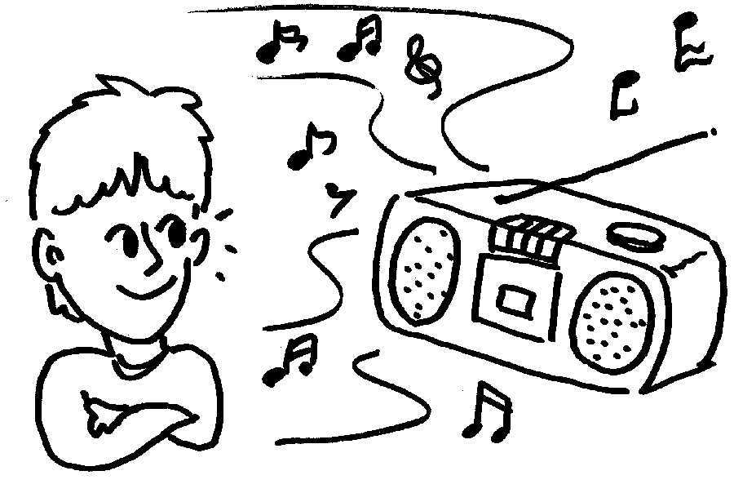
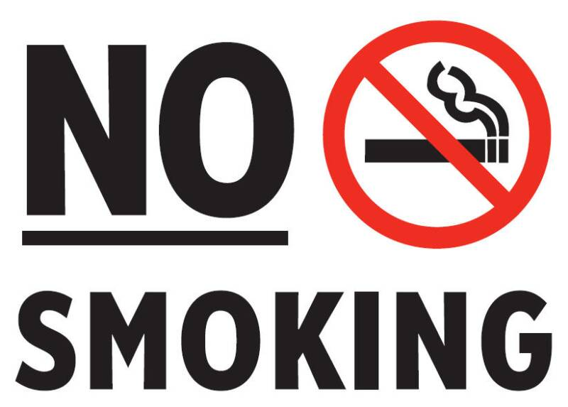
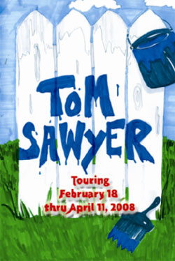

A B C
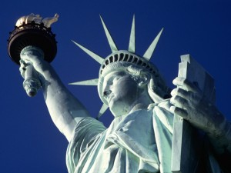

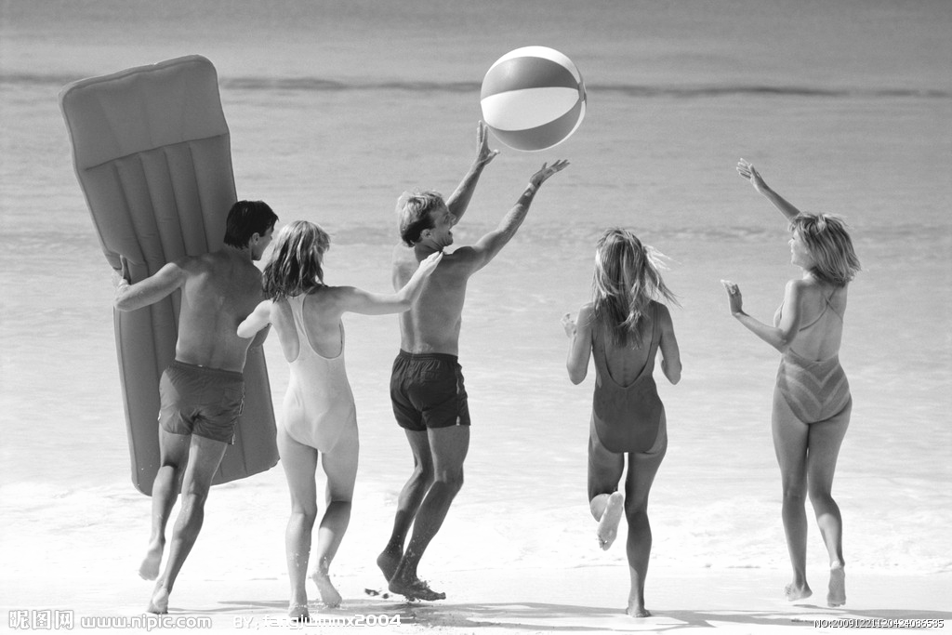
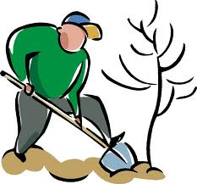

D E F G
1. ______ 2. ______ 3. ______ 4. ______ 5. ______ 6. ______
B. Listen to the dialogue and choose the best answer to the question you hear. ( 根据你听到的对话和问题，选出最恰当的答案。) (10分)
7. A) Her sister. B) Her cousin. C) Her brother. D) Her friend.
8. A) A director. B) A guide. C) A waitress. D) A shop assistant.
9. A) Taiwan. B) Shanghai. C) America. D) Australia.
10. A) To go to the City Beach. B) To stay at home.
C) To watch the concert on TV. D) To watch a film on TV.
11. A) Rainy. B) Cloudy. C) Terrible. D) Wonderful.
12. A) 9:00. B) 9:05. C) 9:25. D) 9:30.
13. A) Black. B) Brown. C) Green. D) Red.
14. A) Because he got up too late. B) Because the traffic was heavier.
C) Because he ate too much. D) Because he didn’t take the girl’s advice.
15. A) The girl shouldn’t watch TV last night. B) The girl can watch it on the Internet.
C) He didn’t like the singing contest. D) He missed the singing contest, too.
16. A) The lecture was famous. B) The girl enjoyed the lecture very much.
C) The lecture was boring. D) The boy didn’t like the lecture at all.
C. Listen to the passage and tell whether the following statements are true or false. ( 判断下列句子是否符合你听到的短文内容，符合的用“T”表示，不符合的用“F”表示。)
( 7分 )
17. Jim had great friends and was good at all his subjects.
18. One Saturday afternoon, Jim and Chris played volleyball.[来源:学_科_网Z_X_X_K]
19. When they waited at a traffic light, they talked about volleyball.
20. On their way back home, they had a car accident.
21. When Jim woke up, he was with his family and Chris.
22. Jim’s mother looked at Jim with tears on her face.
23. According to the doctor, Jim could run and walk soon.
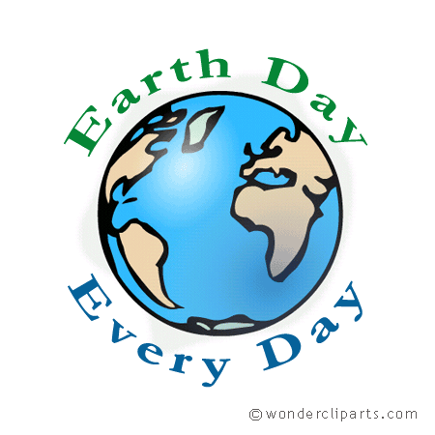
D. Listen to the passage and complete the following sentences.（听短文，完成下列内容。每空格限填一词。） （7分）
24. Earth Day is on 22nd every year.
25. We need to keep trash cleaned up our world will be beautiful.
26. “Reduce” means use .
27. We can reduce our use of resources like water or .
28. If we take these materials to a recycling center, they can be used again in a way.
29. On Earth Day, we remind and everyone on the earth that we must do these things.
30. We must do these things every day, not on Earth Day.
Part 2 Vocabulary and Grammar (第二部分 词汇和语法)
II. Choose the best answer. (选择最恰当的答案。) (共20分)
31. I have pity on you, but I really cannot help you this time.
A) / B) a C) an D) the
32. Mike, I can’t find my pen. Will you please lend me __________?
A) you B) yours C) your D) yourself[来源:Zxxk.Com]
33. The shirts are both expensive and out of fashion. I’ll take ____________ of them.
A) neither B) either C) all D) both
34. Xi Jinping, president of China, arrived at Moscow ________ March 22, 2013 and paid a two-day visit to Russia with his wife Peng Liyuan.
A) in B) at C) to D) on
35. --- Here is the ________, please.
--- Oh, I’d like meat with some green peppers, an egg soup and a tin of Coke.
A) bill B) list C) menu D) book
36. David Beckham says he feels ___________ by his new role as part-time global ambassador
(大使) for Chinese football.
A) excited B) excitedly C) angry D) angrily
37. We decided not to have a picnic last Sunday afternoon because it was raining _________.
A) serious B) seriously C) heavy D) heavily
38. My mother knows little English, __________ she can understand the instructions (说明) with the help of the pictures.
A) so B) or C) but D) and
39. I had a great time at the party last night __________ I didn’t know anybody there.
A) if B) when C) as soon as D) though
40. We’ve invited some of our friends to dinner tonight, but we’ll have to ________ the plan because our son is badly ill now.
A) give up B) pick up C) put up D) take up
41. --- __________ is it from your home to the nearest shopping mall?
--- About ten minutes’ bus ride.
A) How many B) How soon C) How much D) How far[来源:学科网ZXXK]
42. He’s given an important talk on science to us, _________?
A) is he B) isn’t he C) has he D) hasn’t he
43. When the parents arrived, the students __________ their classrooms.
A) have cleaned B) had cleaned C) cleaned D) are cleaning
44. Chiang Mai (清迈) __________ one of the hottest tourist destinations for Chinese since the movie Lost in Thailand (《人再囧途之泰囧》) was shown.
A) becomes B) became C) has been D) was
45. Xi Jinping __________ president of the People's Republic of China (PRC) in March, 2013.
A) elect B) is elected C) elected D) was elected
46. The air in some of the cities in China is not very good. All of us _________ try our best to keep the environment clean. [来源:Z§xx§k.Com]
A) can B) may C) should D) ought
47. The Beijing-Guangzhou high-speed rail line has opened. It enables us _________ from Beijing to Guangzhou in eight hours.
A) travels B) travel C) to travel D) travelling
48. Not long ago, the workers were busy __________ a large number of dead pigs from the Huangpu River.
A) collect B) collecting C) to collect D) collected
49. --- I got up very early this morning, but I still missed the early bus. --- __________
A) Well done! B) What a shame! C) Congratulations! D) Be careful!
50. --- Sally, your handwriting looks so beautiful. I really love it． --- __________
A) I practice every day. B) No，I don’t think so.
C) Thank you very much. D) Well，it’s not good enough.
III. Complete the following passage with the words or phrases in the box. Each word can only be used once.（将下列单词或词组的序号填入空格。每空格限填一词/词组，每词/词组只能填一次。） （共8分）
A. Instead B. complained about C. something D. continued
E. for F. full of G. nothing H. dark I. help
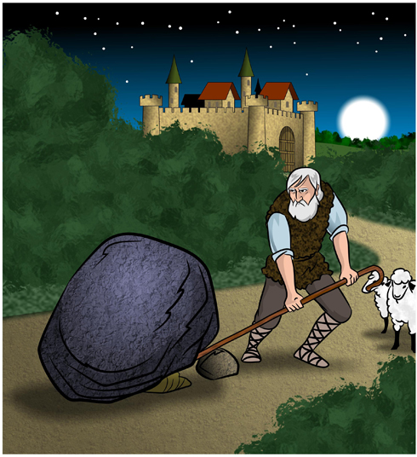
Many years ago, there lived a very rich man who wanted to do 51 for the people of his town. But first he wanted to find out whether they deserved his 52 . So he placed a very large stone in the center of the main road into town. Then he hid behind a tree and waited.
Soon an old man came along with his cow. "Who put this stone in the center of the road?" said the old man, but he did not try to remove the stone. 53 , he passed around the stone and 54 on his way. Another man came along and did the same thing; then another came, and another. All of them 55 the stone in the center of the road, but none of them tried to remove it.
Late in the afternoon, a young man came along. He saw the stone and said, "It will be very
56 at night. Some people will come along later in the dark and will fall against the stone. "
The young man then began to move the stone. He pulled with all his strength to move it to one side. But imagine his surprise when he found a bag 57 money and this message under the stone: "This money is 58 the thoughtful person who removes this stone from the road. Thank you."
IV. Complete the sentences with the given words in their suitable forms.（用括号中所给单词的适当形式完成下列句子。每空格限填一词。） （共8分）
59. All over Shanghai, you can find many _____________. (church)
60. Help ____________ to the birthday cake, my dear! (your)
61. If you answer this question ____________, you will get the first prize. (correct)
62. After graduating from a junior middle school, he went to a senior school. (satisfied)
63. It is not a ____________ book and, what is more, not an expensive one. (useful)
64. The officials were waiting for the important _____________ at the airport. (visit)
65. It’s the ___________ time that I’ve been to America. (twelve)
66. It was amazing that the boy was able to ____________ the problem so quickly. (solution)
V. Rewrite the following sentences as required.（根据所给要求，改写下列句子。每空格限填一词。) (共14分)
67. My classmate Lucy washes her clothes at the weekend. (改为否定句)
My classmate Lucy ___________ ____________ her clothes at the weekend.
68. We hold our school sports meeting once a year. (对划线部分提问)
___________ ____________ do you hold your school sports meeting?
69. English dictionaries are very useful to our study. (改为感叹句)
___________ ____________ English dictionaries are to our study!
70. A British man spent more than two years making a map of the world. (保持句意基本不变)
It a British man more than two years to a map of the world.
71. The government plans to take many old vehicles off the road so that we can reduce the pollution. (改为简单句)
The government plans to take many old vehicles off the road ________ ________ to reduce the pollution.
72. Doctors warned people not to stay outdoors for a long time in foggy weather.(改被动语态)
People not to stay outdoors for a long time in foggy weather.
73. Did Peng Liyuan sing a Russian song in Russia? Could you tell me? (改为宾语从句)
Could you tell me __________ Peng Liyuan ___________ a Russian song in Russia?
Part 3 Reading and Writing (第三部分 读写)
VI. Reading comprehension (阅读理解): (共50分)
A. Choose the best answer.（根据短文内容，选择最恰当的答案。) ( 12分)

In classes, your teachers will talk about topics that you are studying. The information they provide will be important in your tests. You must take good written notes from what your teachers say. Here are the three stages of notetaking and what you should do during each stage.

Get Ready to Take Notes (Before Class)
- Review your notes from the previous(前) class before you come to class. This will help you remember what you have learned before and get you ready to understand new information.
- Complete the assigned (布置的) material before class. Your teacher will expect you to have done this for further understanding.
- Bring your pens and pencils as well as your notebook.

Take Notes (During Class)
- Focus on what your teacher is saying. Listen for "signal statements" such as "The most important point..." and "Remember that...". Be sure to write down what your teacher repeats or writes on the blackboard.
- Write quickly so that you can include all the important information in your notes. Do this by writing abbreviated words such as med for medicine, using symbols such as % for percent, and writing short sentences.
- Place a ? next to information you write in your notes but about whose meaning you are not sure.
Rewrite Your Notes (After Class)
- Rewrite your notes to make them more complete by changing abbreviated words into whole words, symbols into words, and shortened sentences into longer sentences.
- Make your notes more accurate by using your textbook and reference sources. If necessary, ask your teacher or other students for help.
- Check with other students to be sure you did not leave out important information.
Having good class notes will help you to be better prepared for tests.
74. Review your notes from the previous class so that you can .
A) focus on what your teacher is saying B) remember better and learn better
C) write quickly D) ask your teacher for help
75. Your teacher will expect you to have done this. Here this refers to (指的是)________.
A) completing the assigned material B) reviewing your notes
C) bringing your pens and pencils D) taking notes
76. The underlined word “ abbreviated ” probably means____________________.
A) widened B) invented C) suggested D) shortened
77. We place a ? next to information when we ____________________________.
A) are not sure B) are writing C) review the notes D) check with friends
78. We should change symbols into words ________________________________.
A) before class B) after class C) during class D) while listening
79. The best title for this passage is _____________________________________.
A) Preparing for tests B) Focusing on signal statements
C) Taking notes in class D) Listening carefully in class
B. Choose the words or expressions and complete the passage.（选择最恰当的单词或词语完成短文。) （12分）
What will the home of the future look like? A team of architects (建筑师) in Hong Kong say that city homes will be tiny, as populations continue to 80 and space becomes more expensive.

They have designed “spaceflats” that are only 30 square meters in 81 . These flats have small rooms: a living room, a bathroom and a bedroom, as well as a balcony (阳台), but everything is 82 planned to make good use of the limited space.
The living room is the main room of the flat. It can be used as an office, a kitchen even a second bedroom. There is a sofa that can be changed into a bed. The dining table can be changed into a computer desk．And, if not needed, both the sofa-bed and the table can be folded away (折叠收拢) and stored into a small space in the wall. There is a flat-screen TV, which can also serve as a computer monitor. In one of the room, a small cooker, a microwave oven and a small refrigerator are 83 out of sight.
The other rooms are small but practical (实用). The bathroom contains a toilet and a shower．The double bed in the bedroom can also be a sofa, if 84 . The balcony has enough room for two people to sit and enjoy the view from the block of flats. All the rooms have high ceiling to provide as much storage space as possible, while the flat has large windows to let in 85 sunlight.
“Spaceflats” are now being tested in a building in Hong Kong. “It's wonderful,” said one citizen. “The flat is so well designed that you feel that here is plenty of space.”
80. A) reduce B) grow C) move D) protect
81. A) size B) length C) height D) distance
82. A) seriously B) clearly C) quickly D) carefully
83. A) eaten B) fallen C) hidden D) stolen
84. A) difficult B) thirsty C) necessary D) primary
85. A) plenty of B) full of C) a bit D) a little
C. Read the passage and fill in the blanks with proper words.（在短文的空格内填入适当的词，使其内容通顺，每空格限填一词，首字母已给。) （14分）

Do you have sleeping problems? Is it hard for you to remember or pay attention in class? Do you get angry e 86 ? If your answer is yes, you may be under stress (压力).
Stress is a normal physical response to things that make people feel worried. In China, 70 percent of the 2,000 students about to take the college or high school entrance examination are under high stress, according to a recent s 87 by Wuhan University of Hubei province.
Sometimes stress is good for people. It p 88 people to do their best, like while getting ready before a big competition or exam. H 89 , too much or long-term stress makes people feel a stress overload (负荷过多), and affects people’s health.
When you feel stressed, there are some ways you can deal with it. Learning to work out small problems in everyday life is h 90 . It can help build confidence to move on to life’s bigger ones. Try s 91 some positive (积极的) words to yourself, like “I will do the best that I can,” or “I can handle (处理) this if I take one step at a time.” That encourages you to work toward your goal. It is also important to relax sometimes, for example by getting a good night’s sleep, doing exercises or taking a bath.
But if you are under high stress and can’t deal with it by yourself, it is also good to ask parents or friends for help. Everyone has stress. It is not a shame to tell o 92 that you are having a hard time. They may comfort (安慰) you or give you some useful advice. You may feel better from sharing your problems with them.
D. Answer the following questions.（根据短文内容回答下列问题。) ( 12分)

Many Europeans have not only weekends and bank holidays but also five to seven weeks paid leave. Usually parents plan to spend three or four weeks with the family in summer. Because of my earlier years in China, I found it difficult to understand the European attitude towards holidays.
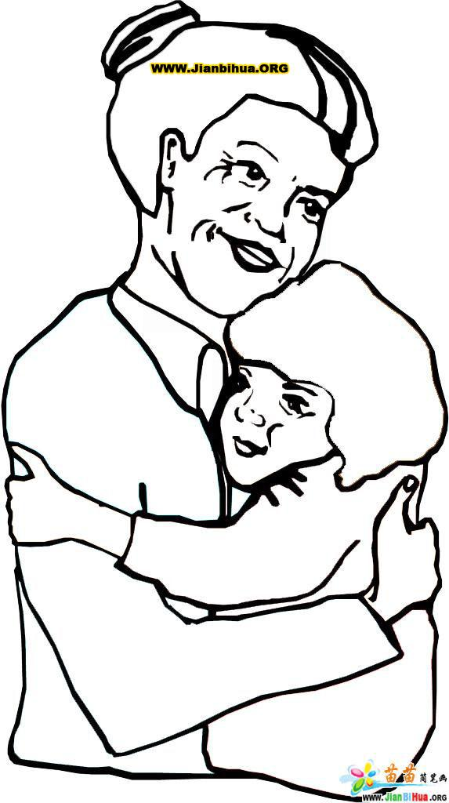
During my childhood in the 1960s, my parents were always busy with work and meetings. I was left alone with Grandma. The only long period of time we could get together once a year was the Spring Festival. I missed our parents badly, but didn’t say so because I had been told that hard work was everyone’s duty and that we could not have our own small family without a big family.
Later I was a hard-working student at university. I was always told holidays were a waste of time and I felt as if I had done something wrong if I did nothing during a holiday.
I didn’t change this idea until I met my boss abroad. When I called him at home after office hours for business, he politely told me he preferred talking about work with me in the office.

When the holiday season came near, he asked me to plan my holidays. He told me holiday was a right for everyone.
Giving up a holiday for the company is encouraged in China, but is foolish here. I began to think about holidays.
Nowadays, Chinese take long weekends and have paid holidays. But do they use their holidays to enjoy family life? I hope so because my experience in China and Europe has helped me understand that work is not my whole life and that a family is also very important. I do not want to feel sorry in the future and I certainly spend as much time with my son as possible.
There is nothing wrong with either working hard or taking holidays, but we shouldn’t have one instead of the other. It is important to keep a balance between work and play.
93. Did the writer find it easy to understand the European attitude towards holidays at first?
_______, __________________________________________________.
94. Why was the writer left alone with Grandma during his childhood?
.
95. When did the writer change his idea on holidays?
.
96. Who thought holiday was a right for everyone?
.
97. What has helped the writer understand the meaning of holiday better?
.
98. Which do you prefer when a holiday comes, working hard or taking holidays? Why?
.
VII. Writing (作文): (共20分)
99. Write at least 60 words about the topic “ A success experience in my memory” (以“我记忆中的一次成功经历”为题，写一篇不少于60词的短文，标点符号不计入在内。)
Use the following points as reference. (以下问题仅供参考)
- When did you have your success experience?
- How did it happen? (Please write in detail.)
- What have you learnt from the experience?
（注意：短文中不得出现任何人名、校名及其它相关信息，否则不予评分。）
2012学年第二学期初三模拟考试
英 语 试 卷
听力部分及参考答案
Part 1 Listening (听力)
I. Listening Comprehension ( 听力理解 ): (共30分)
A. Listen and choose the right picture.（根据你听到的句子，选出相应的图片。）（共6分）
1. For me, listening to music is an important part of my life. (C )
2. Planting more trees can make our environment more comfortable. ( D)
3. Educational visits to America can make us speak English more fluently. ( G)
4. The Adventure of Tom Sawyer is a book written by Mark Twain. (A)
5. Smoking is not allowed in many places in Shanghai. ( B)
6. Spring is here. Let’s go to the beach and fly kites there. (E )

B. Listen to the dialogue and choose the best answer to the question you hear.（根据你听到的对话和问句，选出最恰当的答案。） （共10分）
7. M: Did your sister go to the concert with you yesterday?
W: No, she didn’t. My cousin went with me.
Q: Who went to the cinema with the girl? B
8. W: Have a look at our new jeans, please. They’ve just arrived and they’re not expensive.
M: O.K. Thanks. I’ll let you know if I need help.
Q: What’s the woman’s job? D
9. W: Do you know Li’an, the director of the film “Life of Pi”?
M: Of course. He is my favourite director. He was born in Taiwan and studied films in America.
Q: Where is Li’an from? A
10. M: Hi, Jenny, I’ve got two tickets for tonight’s concert. It’s on the City Beach. Would you like to go with me?
W: Thank you, Paul. It’s too crowded there. I’d rather watch it on TV.
Q: What is the woman going to do? C
11. M: Would you like to go cycling with me this weekend?
W: I’d love to. But the air is so dirty these days. It’s harmful to go out in such terrible weather.
M: Oh, yes. Then let’s do something indoors, shall we?
W: That’s a good idea.
Q: What does the woman think of the weather these days? C
12. M: Oh, it’s 9: 25. I’m afraid I’ve got to leave now.
W: Why are you in such a hurry?
M: I’m going to watch the TV news. It will begin in 5 minutes.
Q: When will the news begin? D
13. M: I hear you’ve bought a new bike recently. What colour is it?
W: Well, it’s green, and my old bike was black.
M: Yeah, I still remember your old one.
W: I change my bike mainly because of the colour.
Q: What colour is the woman’s old bike? A
14. W: Jack, why are you always late these days?
M: Because there are more and more cars on the road. You know, I used to get up at 7:00, and I could arrive here on time. But now it takes me more time to get here.
W: Then you’d better get up and set off earlier next time.
M: O.K. I’ll have to take your advice.
Q: Why is the man late for work? B
15. W: What a pity!
M: What’s the matter?
W: I missed the singing contest on TV last night.
M: Never mind. You can watch it on the Internet at any time.
Q: What does the man mean? B
16. W: I went to Professor Wang’s lecture this morning.
M: Really? He’s so famous. What do you think of the lecture?
W: Most of the people left during the lecture. So did I.
Q: What can you learn from the dialogue? C
C. Listen to the passage and tell whether the following statements are true or false.（判断下列句子是否符合你所听到的短文内容，符合的用“T”表示, 不符合的用“F”表示。） （共7分）
Hi, my name is Jim! One year ago, when I was fifteen, I was always very happy and I thought I would live forever. I had great friends and did well in all the subjects.
One Friday afternoon, I played volleyball with my good friend Chris. Then we got into his car and started to go back home.
When we waited at a traffic light, we talked about one of our teachers. There were no other cars around. But when the light turned green, a car suddenly ran into our car. I was thrown out of the car. I saw our car fly into a tree, and I thought about Chris. Was he dead? Neither of us was wearing a seat belt.
I didn't know how long I lay there. Later, I woke up in a room with my family. I looked around and thought, "Wow, I am still alive!"
"Where is Chris?" I asked.
"He is all right. He went home two days ago." My mother looked at me with tears on her face.
Then a doctor told me that my backbone was broken and that I could never run or walk again.
The next day, Chris came to see me. He told me he was afraid I was going to die. I told him I was afraid for him, too. I'm glad I haven't had to face the death of a friend.
Love your friends and family. To love others is happy and you will be loved. Remember that you are alive, and you can be happy if you want to.
17. T 18. F 19. F 20. T 21. F 22.T 23. F

D. Listen to the passage and complete the sentences. ( 听短文完成句子，每空格限填一词。) （共7分）
Earth Day is a day to remember to take care of our planet, the earth. It is on April 22nd every year. We can take care of our planet by keeping it clean. We need to keep our rivers, lakes, and ponds clean for us to have good water to drink. We need to keep trash cleaned up so our world will be beautiful. We can all help to keep our earth clean.
We can keep the earth clean by following the rule of “reduce, reuse, recycle (Three Rs)”. “Reduce” means use less. We can reduce our use of resources like water or gas. “Reuse” means use again, rather than throw things away. We can reuse many things, such as plastic bags, and boxes. “Recycle” means to make something new from something old. We can keep the earth clean by recycling materials such as paper, and plastic. If we take these materials to a recycling center, they can be used again in a different way.
On Earth Day, we remind ourselves and everyone on the earth that we must do these things. We must do these things every day, not just on Earth Day. We must all do our part, and we can make a difference. On April 22nd, remind everyone you know that Earth Day is every day!

24. April 25. so 26. less 27. gas 28. different 29. ourselves 30. just

Part 2 Vocabulary and Grammar (第二部分 词汇和语法)
II. Choose the best answer. (选择最恰当的答案。) （共20分）
31. A 32. B 33. A 34. D 35. C 36. A 37. D 38. C 39. D 40. A
41. D 42. D 43. B 44. C 45. D 46. C 47. C 48. B 49. B 50. C
III. Complete the following passage with the words or phrases in the box. Each word can only be used once.（将下列单词或词组的序号填入空格。每空格限填一词/词组，每词/词组只能填一次。） （共8分）
51. C 52. I 53. A 54. D 55. B 56. H 57. F 58. E[来源:学科网ZXXK]
IV. Complete the sentences with the given words in their suitable forms.（用括号中所给单词的适当形式完成下列句子。每空格限填一词。） （共8分）
59. churches 60. yourself 61. correctly 62. satisfying
63. useless 64. visitor(s) 65. twelfth 66. solve
V. Rewrite the following sentences as required.（根据所给要求，改写下列句子。每空格限填一词。) (共14分)
67. doesn’t wash 68. How often 69. How useful 70. took make
71. in order/ so as 72. were warned 73. if/whether sang

Part 3 Reading and Writing (第三部分 读写)
VI. Reading comprehension (阅读理解): (共50分)
A. Choose the best answer.（根据短文内容，选择最恰当的答案。) ( 12分)
74. B 75. A 76. D 77. A 78. B 79. C
B. Choose the words or expressions and complete the passage.（选择最恰当的单词或词语完成短文。) （12分）
80. B 81. A 82. D 83. C 84. C 85. A
C. Read the passage and fill in the blanks with proper words.（在短文的空格内填入适当的词，使其内容通顺，每空格限填一词，首字母已给。) （14分）
86. easily 87. survey/study 88. pushes 89. However 90. helpful 91. saying 92. others
D. Answer the following questions.（根据短文内容回答下列问题。) ( 12分)
93. No, he didn’t.
94. Because his parents were always busy with work and meetings.
95. He didn’t change his idea until he met his boss abroad.
96. His/The writer’s boss./The boss.
97. His / The writer’s experience in China and Europe.
98. I prefer taking holidays because I don’t think work is my whole life.
I prefer working hard because…
VII. Writing (作文): (共20分)
99. Write at least 60 words about the topic “ A success experience in my memory” (以“我记忆中的一次成功经历”为题，写一篇不少于60词的短文，标点符号不计入在内。)
Use the following points as reference (以下问题仅供参考)
- When did you have your success experience?
- How did it happen? (Please write in detail.)
- What have you learnt from the experience?
作文评分标准与中考评分标准基本一致。（内容除外）

