2012学年度第二学期九年级英语学科期中练习卷 (2013.4)
二模
(考试时间：100分钟，满分：150分)
考生注意：本卷有7大题，共99小题。试题均采用连续编号，请务必将所有答案写在答题纸上，写在试卷上不给分。

Part 1 Listening (第一部分 听力)
I. Listening Comprehension (听力理解): (共30分)
A. Listen and choose the right picture (根据你听到的内容，选出相应的图片): (共6分)
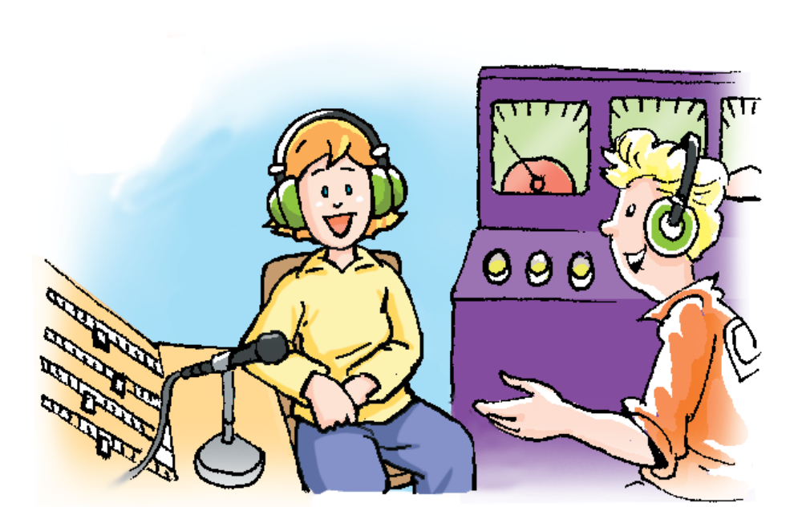 | 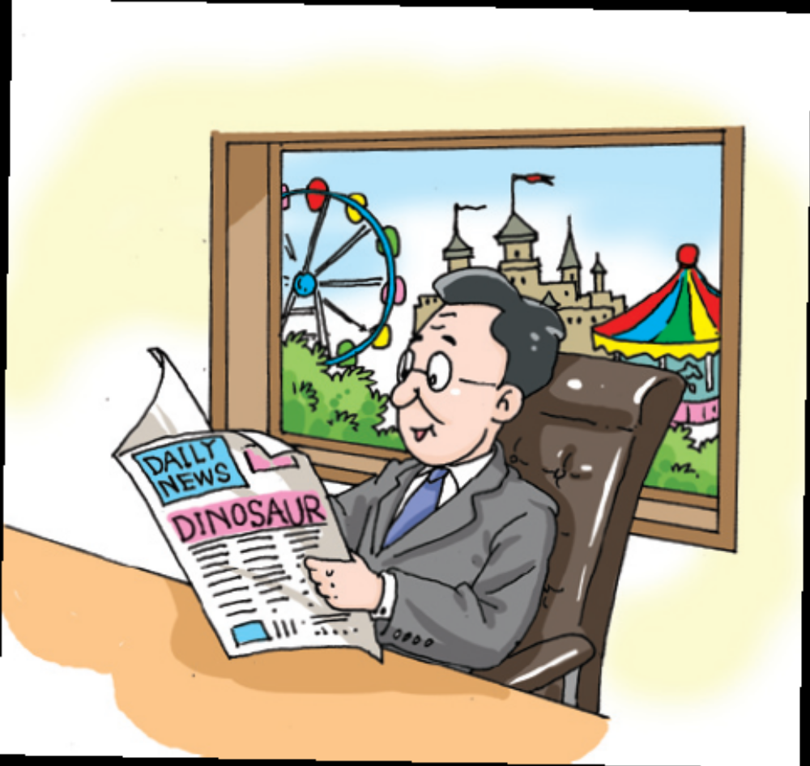 |  |  |  | 
A | B |  | C |  | D
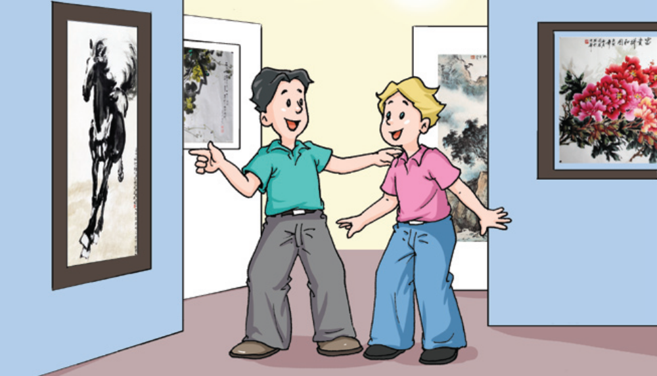 |  | 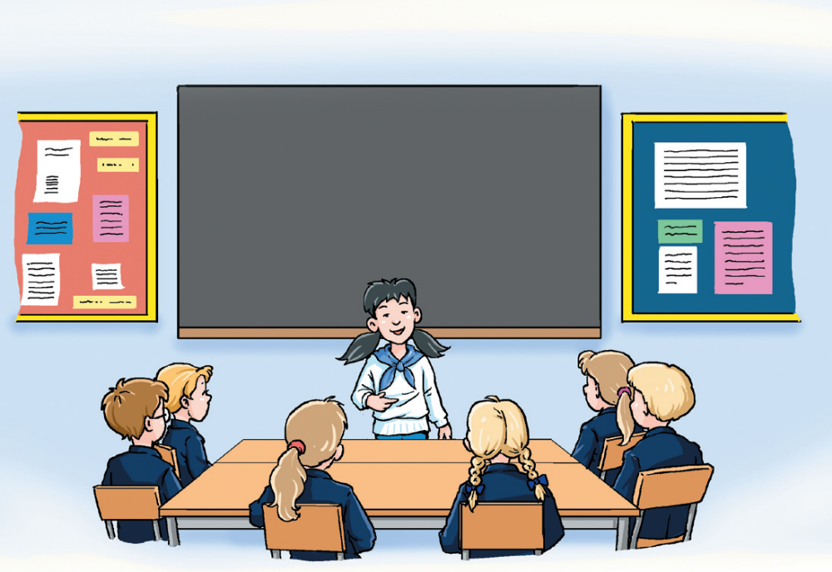 |  | 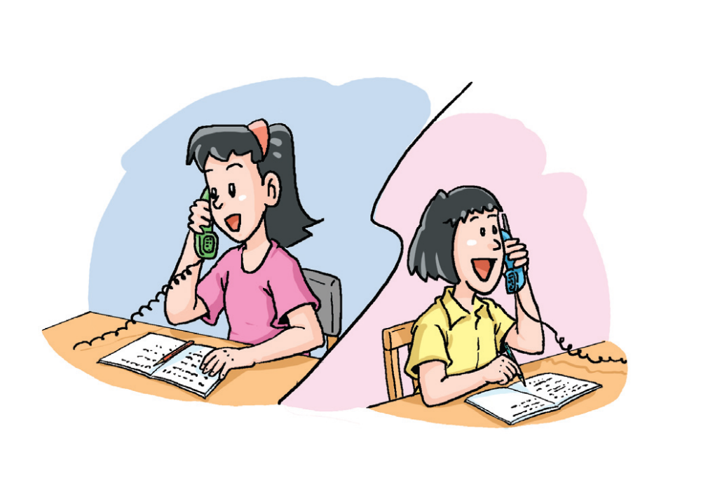
E |  | F |  | G
B. Listen to the dialogue and choose the best answer to the question you hear (根据你听到的对话和问题，选出最恰当的答案): (10分)
7. A) German. B) Chinese. C) Japanese. D) Asian.
8. A) Fish. B) Soup. C) Fried chips. D) Chicken wings.
9. A) Radio. B) Weather. C) Holiday. D) Season.
10.A) At 9:30. B) At 10:00. C) At 10:30. D) At 11:30.
11.A) In a school. B) In a shop. C) At home. D) At a concert.
12.A) He’s having a rest. B) He’s having a test.
C) He’s going over his lessons. D) He’s going on a diet.
13.A) By joining an English club. B) By listening to the tape.
C) By reading English novels. D) By taking lots of notes.
14.A) More sandstorms. B) Less pollution.[来源:学科网]
C) Planting more trees. D) Cutting down fewer trees.
15.A) To say “hello”. B) To ask for help.
C) To make a phone call. D) To move into his house.
16.A) She’ll invite the man to dinner. B) She’ll have dinner with the man tonight.
C) She’ll have dinner at Jinjiang Restaurant. D) She’ll have dinner with other people.

C. Listen to the dialogue and tell whether the following statements are true or false (判断下列句子是否符合你听到的对话内容, 符合的用“T”表示，不符合的用“F”表示):
(7分)

17. The interview happened in Carol’s jewellery(珠宝) shop.
18. She became a jeweler(珠宝商) by going to college.
19. She taught both adults and teenagers to make jewellery in Bond Street.
20. Bond Street is a place full of expensive shops in London.
21. It’s too bored for Carol to make jewellery in the shop.
22. She put the workshop(车间) in the shop because people like to see her making their jewellery.
23. She even made a wedding ring for Queen Elizabeth.
D. Listen to the passage and complete the following sentences (听短文，完成下列内容，每空格限填一词): (7分)
24. Since you can’t feel the clothes, the quality might be ________.
25. Some people buy something that isn’t as good as the advertisements ________.
26. ________ percent consumers failed to fight for their rights.
27. According to consumer protection laws in China, consumers have ________ rights.
28. ________ the label and read the information carefully before you buy something.
29. If there’s any problem with your goods, try to get your money back or get an ________.
30. If you can’t reach an agreement, go to your ________ consumers association for help.

Part 2 Vocabulary and Grammar

（第二部分 词汇和语法）
Ⅱ. Choose the best answer (选择最恰当的答案): (共20分)
31. Australia is a great country with ______ amazing places and lovely animals.
A) a B) an C) the D) /
32. ______ the national day of Ireland, people wear green to celebrate the life of St. Patrick.
A) In B) On C) At D) During
33. If you love someone, you’ll like all that belong to ______.
A) he B) his C) him D) himself
34. ______ is simple and common for people to expect a dark or a colorful life.
A) It B) This C) That D) There
35. Hello. This is Linda. Dorothy is away from her desk now. Will you leave a ______?
A) paper B) message C) notice D) bill
36. Miss Zhang is satisfied with Helen because she has made ______ mistakes than before.
A) few B) fewer C) little D) less
37. ______ study trip in the U.S. has changed my friend a lot in his life style.
A) Three year B) Three years C) Three-years D) Three years’

(反面还有试题)
38. I’m afraid the food is delicious at this restaurant, but the service seems ______.
A) good B) well C) poor D) badly
39. Believe your teacher. She has various methods to make you speak English ______.
A) clear B) clearer C) more clearly D) most clearly
40. ______ sad movie! It brought tears to my eyes.
A) What B) What a C) How D) How a
41. Parents ______ encourage their children to enter music contests, science fairs and debates.
A) should B) shouldn’t C) must D) mustn’t
42. Often James Bond 007 was in a difficult and dangerous situation, ______ he always managed to escape.
A) because B) so C) but D) though
43. ______ some more cases of H7N9 have been found, more research has been done on it.
A) When B) Since C) If D) Whether
44. I will tell you the secret if you promise ______ a word of it.
A) don’t breathe B) not breathe C) to not breathe D) not to breathe
45. My cousin said she ______ to work in the west of China after she graduated from university.
A) will go B) went C) had gone D) would go
46. Lei Feng ______ for his warm heart and kind deeds. We should learn from him.
A) knows B) is known C) was known D) has known
47. He is not the first boss here to ______ and say a lot of rude words.
A) lose his life B) lose his way C) lose temper D) lose weight
48. Do you know ______ my mail will be received by the other end?
A) how long B) how soon C) how often D) how far
49. –Miss Liu, I am terribly sorry. I left my physics exercise books at home.
– ________
A) I’m sorry to hear that. B) That’s all right. C) Not at all. D) You’re welcome.
50. –May I open the window? It’s a bit hot inside.
–______
A) I’m glad to hear that. B) It doesn’t matter.
C) Yes, I will. Thank you. D) Go ahead, please.
Ⅲ. Complete the following passage with the words or phrases in the box. Each word or phrase can only be used once（将下列单词或词组填入空格。每空格限填一词，每词或词组只能填一次）:（共8分）
A. others B. regular C. easily D. connected E. control
F. variety G. respect H. get familiar with I. deal with

A police officer’s job responsibilities are varied. Police make sure that people follow the law. They solve crimes, direct and 51 traffic, help in emergencies such as car accidents, collect evidence at the scene of a crime, and even testify(作证) in court.
Police also work in a wide 52 of places. Some work in offices or police stations, but __53__ patrol(巡逻) communities on foot, by car, on a motorcycle, or even on a horse! Still other types of police officers ride in boats to protect rivers, lakes, and harbors.
Most police wear a uniform. These are the police you can 54 recognize. But other police may not be as easy to spot: Detectives or special agents wear 55 street clothes.
Police can be men or women, and they have a very dangerous job. This is because police often 56 people who have broken the law. Many police officers carry weapons, such as a gun or nightstick, to protect them from harm. Sometimes police officers are 57 to car chases or have to go to risky places, such as the scenes of fires and explosions. Police officers always put themselves in harm’s way to keep us safe, so it’s important to 58 them.
Ⅳ. Complete the sentences with the given words in their proper forms（用括号中所给单词 的适当形式完成下列句子，每空格限填一词): (共8分)
59. Good ___________ serve their country. (citizen)
60. Nice, the fifth largest city in ___________, attracts people from all over the world. (French)
61. I entered a chess competition and finished ___________. (three)
62. People like to change things around to go on with ___________. (they)
63. The little child was ___________ to see a figure in the dark. (frighten)
64. Alice sang to the music with her hand waving ___________. (gentle)
65. The only way to ___________ is through hard work. (success)
66. The most ___________ car was a Benz which had only three wheels. (usual)
Ⅴ. Rewrite the following sentences as required（根据所给要求，改写下列句子。每空格限填一词): (共14分)
67. The students have many exercises to do every day. (改为否定句)
The students _________ _________ many exercises to do every day.
68. They tried everything they could to improve the situation. (改为反意疑问句)
They tried everything they could to improve the situation, _________ _________?
69. We must train them to think independently. (改为被动语态)
They must _________ _________ to think independently.
70. Ben Rogers came along the road, singing happily and carrying an apple. (对划线部分提问)
_________ _________ Ben Rogers come along the road?
71. I didn’t make a phone call. I sent an e-mail. (保持句意基本不变)
I sent an e-mail _________ _________ making a phone call.
72. The music at the cafe sounded so noisy that I couldn’t stay any longer. (改为简单句)
The music at the cafe sounded _________ _________ for me to stay any longer.
- Eddie couldn’t remember. What happened after the accident? (合并为一句)
Eddie couldn’t remember _________ _________ happened after the accident.

Part 3 Reading and Writing (第三部分 读写)
Ⅵ. Reading comprehension (阅读理解): (共50分)
A．Choose the best answer（根据短文内容，选择最恰当的答案): (12分)
Visit the ancient kingdom of Nepal(尼泊尔)
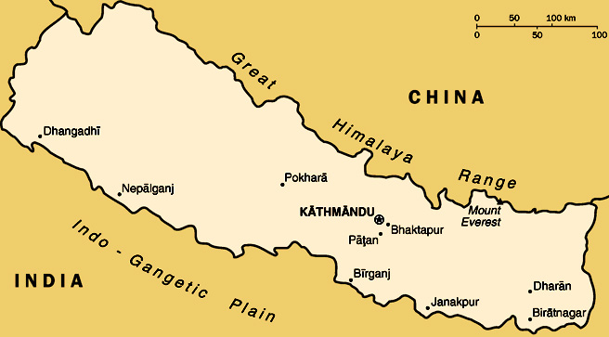
Why not take a holiday somewhere completely different? Visit Nepal – a land of excitement and adventure! From Everest Base Camp high in the Himalayas, to the jungles of the Royal Chitwan National Park, to the ancient city of Bhaktapur, Nepal’s amazing scenery and fascinating culture make it a great holiday destination.
Any trip to Nepal starts in the Kathmandu valley, with a visit to the Nepali capital. The old centre of Kathmandu with its crowded old streets and beautiful architecture is very different from the expensive modern hotels, shops and restaurants on the city’s outer areas.
The valley is also home to two other cities. Patan is quieter and less crowded than Kathmandu, and is famous for its temples and other old buildings. However, the oldest and probably the most attractive of the three cities is Bhaktapur. Many of its beautiful temples and palaces were built in the seventeenth century, when it was the capital of Nepal.
Travel eight hours by bus west of Kathmandu to reach the beautiful lakeside city of Pokhara. This is a perfect place to relax – row a boat on the lake, read a novel, or just hang out in one of many great restaurants. If you are feeling more energetic, you can go for a three- or four-day journey around Mount Annapurna.
Northeast of Kathmandu, near the border with China, is Mount Everest, the world’s tallest mountain. Everest Base Camp is where teams of climbers prepare to climb the mountain, and it is a popular destination for tourists. However, there have been problems with tourists leaving litter at Base Camp – so remember to take your rubbish away with you!
In the south of the country, near the border with India, is the Royal Chitwan National Park. Very different from the cool mountains of the Himalayas, Chitwan is a hot and sticky tropical jungle. In the past, this was where rich British and Nepalese hunters shot elephants, rhinoceros, tigers, leopards and deer, but today all these animals are protected. You can take a tour of the park, riding on the back of an elephant.
74. This passage is probably .
A) an advertisement B) a newspaper article
C) a report D) a letter
75. The main point of the first paragraph is that Nepal ________.
A) is very ancient B) is very exciting and interesting
C) has mountains and jungles D) has amazing scenery
76. Bhaktapur is ________.
A) one of the three cities in the Kathmandu valley B) the capital of Nepal
C) less crowded and more attractive than Patan D) bigger than Kathmandu

77. The underlined word ‘it’ in the fifth paragraph refers to ________.
A) Mount Everest B) Kathmandu C) Everest Base Camp D) China
78. As a tourist, you can do all the things to relax in Pokhara except________
A) rowing a boat on the lake B) doing some reading
C) hanging out in a certain restaurant D) swimming in the sea
79. According to this passage, which sentence is NOT TRUE?
A) Kathmandu is famous for its crowded old streets and beautiful architecture.
B) Patan is famous for its temples and other old buildings.
C) Everest Base Camp is a place for climbers to prepare to climb the mountain.
D) The Royal Chitwan National Park is now a place to hunt animals.
B. Choose the words or expressions and complete the passage（选择最恰当的单词或词语完成短文):（12分）
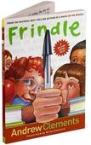
Book Report
Frindle
By Andrew Clements

The book Frindle is about a troublemaker named Nick who makes up a new word. His teacher, Mrs. Granger, really likes the dictionary. When Nick asks Mrs. Granger where all the words in the dictionary came from, she makes Nick write a report about it! The report makes Nick wonder if he could invent his own word. Nick’s classmate Janet drops her pen, and he 80 and calls it a “frindle”. Pretty soon, everyone in class is saying “frindle” instead of pen.
A war begins between Mrs. Granger and Nick. Nick likes to challenge the rules, but he’s not all bad. He is creative and has lots of 81 . It’s too bad that people think something is wrong just because it’s new and different. Mrs. Granger is too hard on Nick and the way she treats him is unfair.
The best part is when the kids in Nick’s class protect him by actions. They are __82__ willing to stay after school and be punished for saying “frindle”. When a class sticks together like that it’s really special.
Mrs. Granger wants to stop Nick from spreading his word. But the “frindle” is unstoppable. People across the country are saying it. Nick gets a lot of 83 for inventing this word. He sees that one person can have a big effect.[来源:学科网]
The book has a very 84 ending. Nick is in college, and he is rich from all the money he has made off his word. Mrs. Granger sends him a dictionary that has the word “frindle” and a letter about how she is proud of him. She ends up being the most interesting character in the book!
Everyone should read Frindle 85 it’s such a great book. Kids who are troublemakers would especially like this book.
80. A) picks it up B) picks it out C) looks it up D) find it out
(反面还有试题)
81. A) inventions B) suggestions C) ideas D) stories
82. A) also B) even C) only D) never
83. A) advice B) attention C) discussion D) experience
84. A) amusing B) serious C) surprising D) terrible
85. A) if B) unless C) until D) because
C. Read the passage and fill in the blanks with proper words（在短文的空格内填入适当的词，使其内容通顺，每空格限填一词，首字母已给):（14分）
How Do You Get to School? —by Wayview School Newspaper
How did you get to school today? A recent survey shows that Wayview students get to school by riding the bus, driving, biking, walking and riding a scooter.
Our survey shows that 25% of Wayview students take the bus to school. Fourth grade student Wesley Gibson explained, “The bus is the best way to get to school. I can relax and chat with my friends while the bus driver does all the work. S 86 I even finish my homework on the bus!” Another 25% of Wayview students are d 87 to school by their parents every day. In all, 50% of Wayview students get to school in a vehicle, e 88 the bus or a car.
The other 50% of Wayview students ride their bikes, walk, or ride a scooter. Fifth-grader Alexis Wang is one of the 20% of Wayview students who walk to school each day. She said, “Walking to school is better than the bus or car because you get m 89 exercise.” Another 20% of Wayview students ride their bikes. Chris Madsen said he likes riding his bike because “it’s faster than walking, and you can race with your friends.”
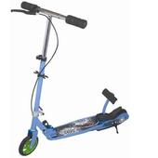
The last group of Wayview students get to school by riding scooters. The number of students riding scooters to school has i 90 . Last year, only 5% of the students rode scooters, and this year it’s 10%. Ella Peterson said, “Riding a scooter is the most f 91 way to get to school. It’s as fast as a bike, and scooters are cool.” Headmaster Wang wanted to remind all Wayview students that a 92 riding a bike or scooter to school must wear a helmet.
As you can see, Wayview students find all kinds of ways to get to school. In the end it doesn’t really matter how you get here, as long as you get here on time!

D. Answer the questions（根据短文内容回答下列问题): (12分)
Super Singers

Imagine yourself singing in front of an audience, performing in other countries, and having your music put on a CD! All this excitement isn’t just for rock stars. Joining a children’s chorus gives kids the chance to do these exciting activities. What does it take to get into a children’s chorus? You don’t need years of singing lessons. You just need to have a love for singing and be willing to learn and follow directions.
It all starts at the audition(试唱). The choirmaster, or conductor, will have you sing with a group of kids. As the group sings, the conductor listens to how your voice comes together. You’ll also probably be asked to sing by yourself. The conductor wants to figure out what type of voice you have. A girl with a high voice is a soprano while a girl with a low voice is an alto. A boy with a high voice is a tenor, while a boy with a low voice is a bass. When the whole chorus sings together, the different types of voices sing different notes to the same song. This is called “singing parts”.
Once you pass the audition, you might be assigned to a specific group. Beginning singers are often grouped together in a “Treble Chorus”. More advanced singers might be in a “Concert Chorus”. Different choirs have different names for these groups. No matter which group you’re in, you’ll need to go to rehearsals. Most children’s choirs rehearse once a week.
93. What do you need to join a children’s chorus?
_____________________________________________________.
94. What are you required to do at the audition?
_____________________________________________________.
95. What will Jane probably be if she has a low voice?
_____________________________________________________.
96. Beginning singers are often grouped together in a “Concert Chorus”, aren’t they? __________________________________________________.
97. How often do most children’s choirs rehearse?
_____________________________________________________.
98. What good is being a member of a choir?
_____________________________________________________.
Ⅶ. Writing (作文): (共20分)
99. Sometimes we need someone to share something with. What do you often share with others? Write a passage of at least 60 words on the topic ‘Sharing’. (以“分享”为题，写一篇不少于60个词的短文。标点符号不占格。)
（ 注意：短文中不得出现考生的姓名、校名及其他相关信息，否则不予评分。）
Use the following points as a reference. （以下问题仅供参考）
- When do/did you often share … with others?
- Who do/did you share … with?
- Why do/did you want to share with him/her?
- How do/did you feel?[来源:学科网ZXXK]

九年级英语学科期中练习卷
听力文字和参考答案

Part 1 Listening
Ⅰ. Listening comprehension（听力理解）:
A. Listen and choose the right picture (根据你听到的内容，选出相应的图片):
1. Jack was surprised to find his wife laughing loudly when reading magazines. (C)
2. Whenever you make a phone call, smile when you pick up the phone. (G)
3. Computers have made our life easier and more convenient. (D)
4. Our class teacher was glad to join us in the discussion. (F)
5. Rose became more nervous as the interview continued. (A)
6. It’s fun to enjoy beautiful pictures at the art exhibition. (E)
B. Listen to the dialogue and choose the best answer to the question you hear (根据你听到的对话和问题，选出最恰当的答案):
7. W: Angela is German, but she lives in Asia for most of the time.
M: No wonder she can speak Japanese and Chinese so well.
Q: What’s Angela’s nationality? (A)
8. W: Yummy, Yummy. The fish is so delicious and the soup tastes nice, too.
M: I like the chicken wings best.
Q: What is the boy’s favourite dish? (D)
9. W: The radio says it’s going to be fine tomorrow.
M: Really? I hope so. It has been raining so many days. I don’t like wet days.
W: Neither do I.
Q: What are they talking about? (B)
10.M: Excuse me, is this shop open on Sundays?
W: Yes, of course.
M: What time does it usually open?
W: It usually opens at ten during weekdays but half an hour later on Saturdays and Sundays.
Q: When does the shop open at the weekend? (C)
11.M: I really like this pair of jeans, but I’m afraid it isn’t my size.
W: Which size would fit you? We have jeans of different sizes here.
M: Do you have any light blue jeans of medium size?
W: Oh, yes, here they are. Would you please try them on?
Q: Where are they probably talking? (B)
12.W: What are you doing, Peter?
M: I’m going over my lessons. We are going to have a test tomorrow.
Q: What’s Peter doing now? (C)
13. M: Cherry, what is the best way for you to learn English grammar? By reading English novels or listening to the tape?
W: I learn English grammar by taking lots of notes.
Q: How does Cherry learn English grammar? (D)
14.M: There are more sandstorms this year. We should plant more trees and cut down fewer trees.
W: I agree with you, or we will destroy ourselves in the end.
Q: What happened this year according to the dialogue? (A)
15.W: Good morning. I’ve come over to say “hello”. My family has just moved into the house next door.
M: Great! Nice to meet you, Miss...
W: Call me Jones.
M: How do you do, Jones?
Q: Why does Jones come to the man’s house? (A)
16. M: Would you please have dinner with me at Jinjiang Restaurant tonight?
W: Oh, I’d love to. But I’ve already had dinner plans for tonight. Another time perhaps?
Q: What does the woman mean? (D)
C. Listen to the dialogue and tell whether the following statements are true or false (判断下列句子是否符合你听到的对话内容, 符合的用“T”表示，不符合的用“F”表示):
A: Come with me and meet Carol. She designs and makes beautiful gold and silver jewellery in Winchester. This is her small shop and workshop which is in a building that is 500 years old! Today my job is to interview her.
A: Good morning, Carol. I’m so pleased to meet you. First, I would love to know how you became a jeweler.
C: I went to college to study Art for three years, then I decided to make jewellery so I had to study for three more years.
A: And then what did you do?
C: For a few hours a week, I taught adults to make jewellery. I also worked in a jeweler’s shop in Bond Street, London.[来源:Z§xx§k.Com]
A: Bond Street! That is full of very expensive shops! The Beckhams go shopping there! Can you tell me what you enjoy about your job?
C: I am a very creative person. I never find it difficult to think of new designs for my work! But making jewellery is a lonely job so I enjoy meeting people in my shop, too. At any time, I am making about 6 pieces of jewellery so I am never bored!
A: This is very interesting! Please tell me more about your design work.
C: I make some jewellery to sell in my shop so there is always plenty for people to choose from. But most of all I enjoy designing jewellery for customers who want something individual. I listen to what they want but sometimes people cannot explain very well. As I am talking to them, a design comes into my mind. And you can see that my workshop is here in the shop and people like to see me making their jewellery. Shall I tell you about my very special customer? She is the daughter of Queen Elizabeth, Princess Anne! I was asked to make her wedding ring!
A: That must have been so exciting! I wish I were a princess so you could design some jewellery for me! As soon as I have enough money, I will visit you again!
(17. T 18. T 19. F 20. T 21. F 22. T 23. F)
D. Listen to the passage and complete the following sentences (听短文，完成下列内容，每空格限填一词):
Shopping online is easier than actually going to a store and saves your time. However, it’s not always that easy. Sometimes, you may have a few problems.
Xu Zijiao, 21, a student at Sichuan University, often buys clothes on Taobao. “The colours might be different. And since you can’t feel the clothes, the quality might be bad,” Xu said.
Many people had similar experiences to Xu – buying something that isn’t as good as the advertisements suggest, or going into a store for a special offer but still paying a lot. What would you do? Guangzhou daily reported that according to a research, 60 percent consumers would give up without fighting for their rights.
March 15 is World Consumer Rights Day. According to consumer protection laws in China, consumers have nine rights, including the right to guaranteed safety, truthful information, free choice and respect.
How can we fight for our consumer rights? Here are some tips:
1. Learn some of the differences between real and fake goods.
2. Check the label and read the information carefully before you buy something.
3. Get a receipt for all your goods and services.
4. If you find there’s any problem with your goods, talk to the seller first, and try to get your money back or get an exchange. If you can’t reach an agreement, call 12315 or go to your local consumers association for help.
(24. bad 25. suggest 26. 60 27. nine 28. Check 29. exchange 30. local)

Part 2
Ⅱ. 31. D 32. B 33. C 34. A 35. B 36. B 37. D 38. C 39. C 40. B 41. A 42. C 43. B 44. D 45. D 46. B 47. C 48. B 49. B 50. D[来源:学§科§网]
Ⅲ. 51. E 52. F 53. A 54. C 55. B 56. I 57. D 58. G
Ⅳ.59. citizens 60. France 61. third 62. themselves 63. frightened 64. gently 65. succeed 66. unusual
Ⅴ. 67. don’t have 68. didn’t they 69. be trained 70. How did 71. instead of 72. too noisy 73. what had

Part 3
Ⅵ. A) 74.A 75.B 76.A 77.C 78.D 79.D
B) 80.A 81.C 82.B 83.B 84.C 85.D
C) 86. Sometimes 87. driven 88. either 89. more 90. increased 91. fun 92. anyone
D) 93. You need to love singing and be able to follow directions.
94. You sing with a group of kids and by yourself.
95. An alto.
96. No, they aren’t.
97. Once a week.
98. Any reasonable answer is acceptable.
Ⅶ. 略

