北京市石景山区2014年初三第一次统一练习暨毕业考试
英 语 试 卷
考 生  须 知 | - 本试卷为闭卷考试，共12页，满分120分，考试时间为120分钟。  - 请在试卷和答题卡上准确填写学校名称、姓名和准考证号。  - 试题答案一律填涂或书写在答题卡上，在试卷上作答无效。答题卡上的选择题用2B铅笔规范填涂，其他试题用黑色签字笔作答。  - 考试结束后，请将试卷和答题卡一并交回。

听力理解 (共26分)
- 听对话，选择与对话内容相符的图片。每段对话听两遍。（共4分，每小题1分）
1．
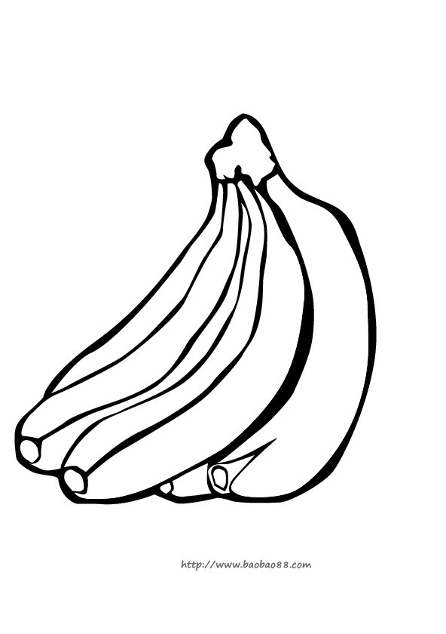 |  | 
A． B． C．
2．
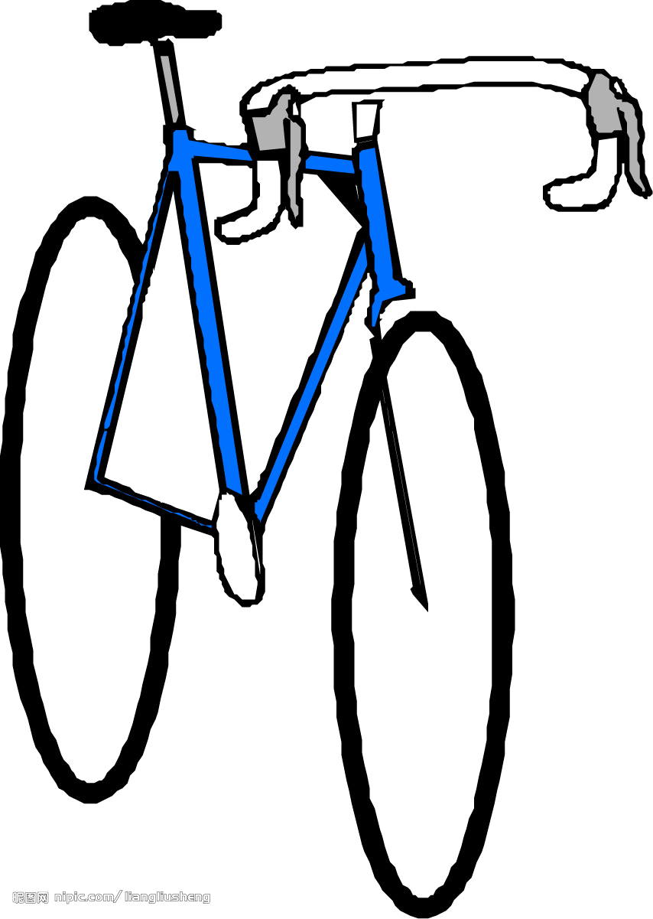 | 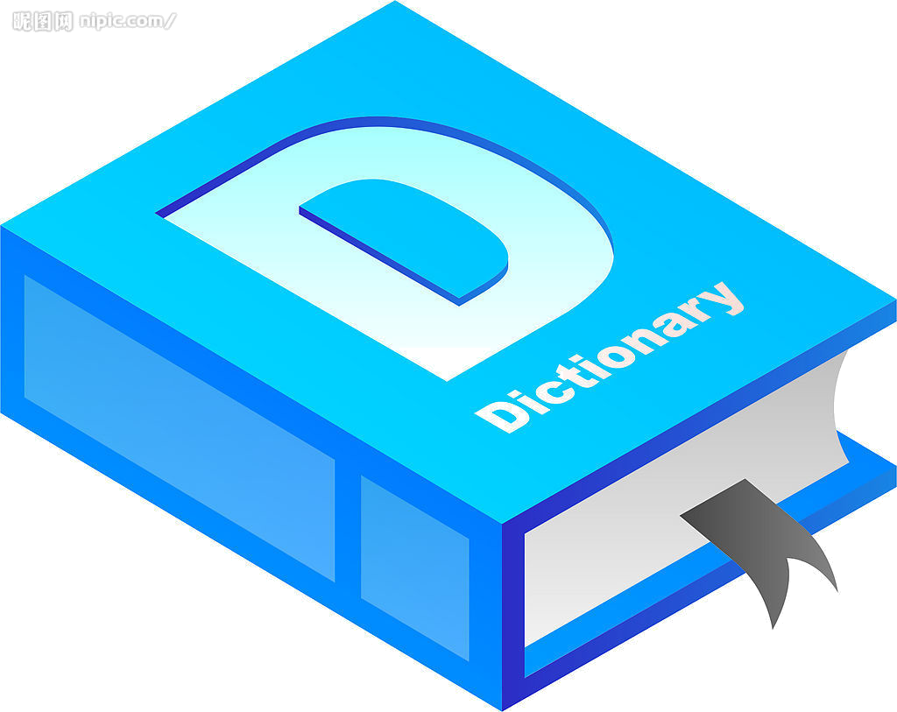 | 
A． B． C．
3．
 |  | 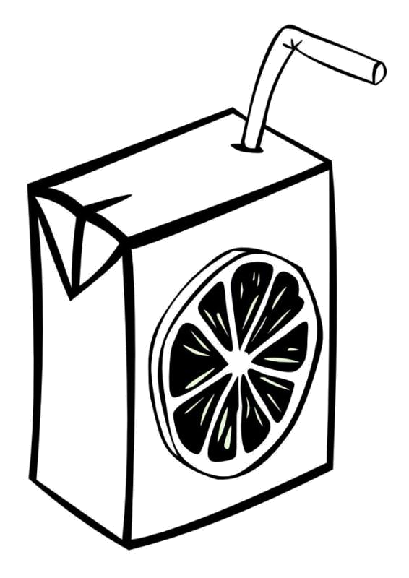
A． B． C．
4．
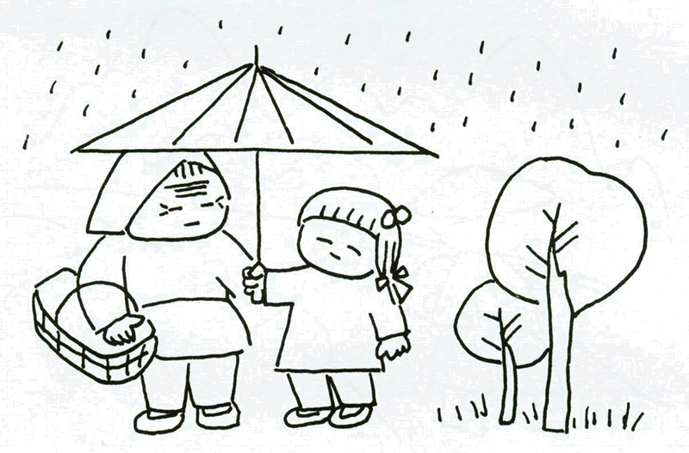 | 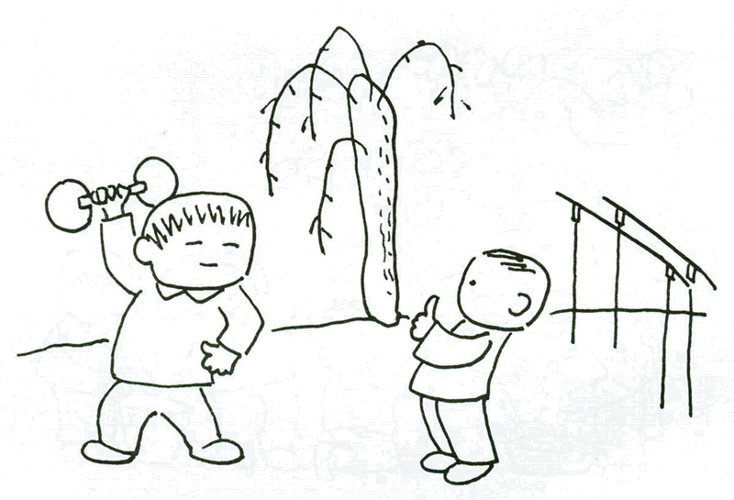 | 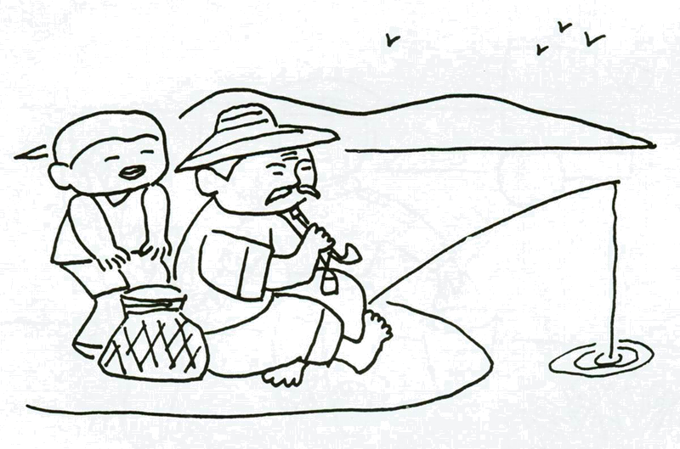
- B． C．

- 听对话，根据对话的内容，选择正确答案。每段对话听两遍。（共12分，每题1分）
请听一段对话，完成第5至第6小题。
5. How do the speakers talk?
A. Face to face. B. On the Internet. C. On the telephone.
6. What does the man want to do?
A. To buy a book.
B. To book a table.
C. To invite some groups.
请听一段对话，完成第7至第8小题。
7. Where may John come from?
A. England. B. America. C. Brazil.
8. What sports team did John join in high school?
A. Baseball. B. 400-meter race. C. Football.
请听一段对话，完成第9至第10小题。
9. What are the speakers mainly talking about?
A. Music. B. Books. C. Films.
10. Which one does the girl like best?
A. Sweetheart. B. Your Face. C. Cold Wind.
请听一段对话，完成第11至第13小题。
11. Why does the girl give up computer science?
A. She has no interest in it.
B. The teacher is so boring.
C. She doesn’t like the activities.
12. What subject does the boy suggest?
A. Geography. B. History. C. Chemistry.
13. What subjects does the girl choose finally?
A. Math, history, English and Chemistry.
B. Math, English, geography and physics.
C. Math, history, English and geography.
请听一段对话，完成第14至第16小题。
14. How many advantages does the woman mention about the house?
A. 3. B. 4. C. 5.
15. What does the man think of the house?
A. It really costs too much.
B. It’s not large enough to be shared.
C. It’s far away from the centre of the city.
16. What can we learn from the dialogue?
A. The man lives far from the university.
B. The woman will take the house finally.
C. The woman goes to college as she works.
三、听独白，记录关键信息，独白听两遍。（共10分，每小题2分）
请根据所听到的独白内容和卡片上的提示词语，将所缺的关键信息填写在下面卡片中的相应位置上。

Information about Science World
Program of special events:
◇Computer workshop on next 17 ;
◇Experiments with 18 on Wednesday;
◇Saturday evening talk about 19
Ticket price: £3 for adults and £ 20 for children
Telephone number: 21

知识运用 （共25分）
四、单项填空（共13分，每小题1分）
从下列各题所给的A、B、C、D四个选项中，选择可以填入空白处的最佳选项。
22. — Who’s that tall boy?
— ______ name is Tom and he is from the UK.
A. His B. Her C. Your D. My
23. — Where is Jenny?
— She must be ______ the reading room. She likes reading a lot.
A. on B. at C. to D. of
24. — ______ does the book cost?
— $ 19.80. A little bit expensive.
A. How far B. How much C. How soon D. How long
25. — I won’t go to the party tonight.
— ______ you told me you would. What’s the matter?
A. So B. Or C. Because D. But
26. — May I take this magazine out of the library?
— No, you ______.
A. may not B. couldn’t C. needn’t D. mustn’t
27. — How do you like the film, Jane?
— ______ interesting. It’s a waste of time.
A. Something B. Anything C. Nothing D. Everything
28. Mum asked me ______ the room at least once a week.
A. clean B. cleaned C. to clean D. cleaning
29. I think skiing is ______ than climbing. That’s why I like it.
A. exciting B. more exciting C. most exciting D. the most exciting
30. — Did you mail the cards to your friend?
— No, I ______ them tomorrow.
A. mail B. mailed C. have mailed D. will mail
31. Today train tickets can ______ online at any time.
A. buy B. bought C. be bought D. were bought
32. — Hi, Jack. Would you like to go to Hawaii for the summer holiday?
— I’d love to! Though I ______ there twice.
A. am B. was C. will be D. have been
33. If it ______ today, we’ll have to leave on Wednesday instead.
A. snows B. snowed C. will snow D. is snowing
34. — Could you tell me ______ to America for further study?
— Next month.
A. when will he fly B. when he will fly
C. when did he fly D. when he flew
五、完形填空（共12分，每小题1分）
阅读下面的短文，掌握其大意，然后从短文后各题所给的A、B、C、D四个选项中，选择最佳选项。
The passengers on the bus watched with sympathy（同情）as Susan made her way carefully up the steps. She paid for the drive and then, using her hands to 35 the seats, settled （安顿）in one of them.
It had been a year since Susan became blind. As the result of an accident she was suddenly thrown into a world of 36 . Susan’s husband Mark watched her fall into hopelessness and he decided to use every possible means to help his wife.
Finally, Susan felt ready to 37 to her job, but how would she get there? She used to take the bus, but she was now too afraid of getting around the city by herself. Mark 38 to ride the bus with Susan each morning and evening until she could 39 it by herself.
For two weeks, Mark went with Susan to and from work each day. He taught her how to depend on her other 40 , specifically her hearing, to decide where she was.
At last, Susan decided that she was ready to try the trip on her own. Monday morning arrived. Before she left, she held her husband tightly, her eyes filled with tears of thankfulness. She said good-bye and, for the first time, they went their 41 ways. Each day went perfectly, and a wild excitement took hold of Susan. She was 42 it!
On Friday morning, Susan took the bus to work as usual. As she was getting off the bus, the driver said, “Miss, I sure envy（嫉妒）you.” Surprisingly, Susan asked the driver 43 .
“You know, every morning for the 44 week, a fine-looking gentleman in a military uniform has been standing across the corner watching you until you enter your office building 45 ,” the bus driver said.
Tears of happiness ran down Susan’s cheeks. She was so lucky for he had given her a gift more powerful than 46 . That is the gift of love that can bring light where there is darkness.
35. A. touch B. choose C. count D. feel
36. A. weakness B. sickness C. darkness D. sadness
37. A. return B. keep C. belong D. stick
38. A. volunteered B. continued C. promised D. afforded
39. A. try B. manage C. control D. follow
40. A. feelings B. parts C. senses D. skills
41. A. opposite B. separate C. fixed D. normal
42. A. passing B. doing C. taking D. getting
43. A. what B. how C. why D. where
44. A. next B. same C. first D. past
45. A. quickly B. silently C. happily D. safely
46. A. courage B. direction C. sight D. service
阅读理解 （共44分）
六、阅读理解（共26分，每小题2分）
阅读下面的四篇短文，根据短文内容，从短文后各题所给的A、B、C、D四个选项中，选择最佳选项。
A
Unique customs
St. Anthony’s Day
January 17 is St. Anthony’s Day in Mexico. It’s a day when people ask for protection for their animals. They bring their animals to church. But before the animals go into the church, the people usually dress them up in flowers.
Chusok
On August 15 of the lunar calendar, Koreans celebrate Chusok to give thanks for the harvest. Also on Chusok, a big meal with moon-shaped rice cake is eaten.
New Year’s Eve
One of the biggest celebrations in Argentina is New Year’s Eve. On the evening of December 31, families get together and have a big meal. At midnight, fireworks set everywhere and continue throughout the night. Friends and families meet at parties, which last until the next morning.
Setsubun
On the evening of February 3, people in Japanese families take one dried bean（豆）for each year of their age and throw the beans around their homes, shouting “Good luck in! Evil sprits out!” This is known as “Setsubun,” a time to celebrate the end of winter and the beginning of spring.
47. When is St. Anthony’s Day?
A. December 31. B. August 15. C. February 3. D. January 17.
48. Why do Koreans celebrate Chusok?
A. To celebrate the end of winter.
B. To give thanks for the harvest.
C. To wish their families good luck.
D. To ask for protection for their animals.
49. What do Japanese people do on Setsubun?
A. Bring their animals to church.
B. Meet friends and families at parties.
C. Throw the beans around their homes.
D. Eat a big meal with moon-shaped cake.
B
The phone rings. It’s a friend who wants to tell you his or her latest health problems. You hate to be impolite and cut your friend off, but what can you do? Stephanie Winston, author of Stephanie Winston’s Best Organizing Tips, offers his advice:
Don’t ask questions like “What’s new?” They give the information that you have time to talk. After “hello”, get right to the heart of the matter.
Time your calls wisely. If you make a call right before lunch or dinner, or at the end of the workday, people chat less.[来源:学科网]
Set a time limit. Start with, “Hi, I’ve only got a few minutes, but I wanted to talk to you about….” Or, “Gee, I’d love to talk more, but I only have a couple of minutes before I have to leave.”
Jump on a pause（间歇）. Even the most talkative caller has to pause now and then. Quickly say, “It has been great talking with you.” Then end the conversation.
Forget niceties. Some people just don’t take a hint. Cut your caller off and say, “I’d like to talk to you longer, but I’m afraid I have no enough time. Good bye.” Then hang up.
Find “a partner in crime”. If nothing else works, ask someone in your home to help you. For example, one woman gives a sign to her husband, who shouts, “Jane, I think the roast chicken is burning.”
Avoid the phone completely. Use an answering machine to screen calls. If you have an important message for a chatterbox（唠叨的人）, leave the message when he or she isn’t in.
50. What’s the good time to make a call so that people can chat less?
A. After lunch or dinner. B. In the middle of the workday.
C. Before lunch or dinner. D. At the beginning of the workday.
51. “Finding a partner in crime” means ______.
A. finding someone to answer the call
B. getting right to the heart of the matter
C. telling the caller you are just cooking
D. asking someone to help you end the call
52. What’s Winston’s advice about?
A. How to talk on the phone.
B. How to make calls wisely.
C. How to make a phone call.
D. How to keep phone calls short.
C
People from East Asia tend to have more difficulty than those from Europe in differentiating facial expressions – and a new report published online in Current Biology explains why.
Rachael Jack, University of Glasgow researcher, said that rather than scanning evenly (均匀的) across a face as Westerners do, Easterners fix their attention on the eyes.
“We show that Easterners and Westerners look at different face features to read facial expressions,” Jack said. “Westerners not only look at the eyes, but also the mouth, but Easterners prefer the eyes and don’t look at the mouth very often.”
According to Jack and his coworkers, the discovery shows that human communication of emotion is more difficult to understand than what was believed before. As a result, facial expressions that had been considered commonly understandable cannot be completely used to convey（传递）emotion in cross-cultural situations.
The researchers studied cultural differences in the understanding of facial expressions by recording the eye movements of 13 Western Caucasian and 13 East Asian people while they observed pictures of expressive faces and put them into different categories: happy, sad, surprised, fearful, angry, or dissatisfied. They compared how correctly people who took part in the research read those facial expressions by using their eye movements.
It turned out that Easterners focused much greater attention on the eyes and made more mistakes than Westerners did. “The cultural difference in eye movements that they show is probably a reflection（反射）of cultural difference in facial expressions,” Jack said. “Our research suggests that while Westerners use the whole face to convey emotion, Easterners use the eyes more and mouth less.”
In short, the research shows that facial expressions are not universal messages of human emotion. From here on, examining how cultural factors have diversified（使多样化）these basic social skills will help our understanding of human emotion. If not, when it comes to communicating emotions across cultures, Easterners and Westerners will find themselves lost in translation.
53. What does Jack’s research show about Westerners?[来源:Zxxk.Com]
A. They consider facial expressions more believable.
B. They pay attention to both the eyes and the mouth.
C. They have more difficulty in telling facial expressions.
D. They observe the eyes and the mouth in different ways.
54. What does the underlined word “they” in Paragraph 6 refer to?
A. The researchers who took the study.
B. The mistakes made during the study.
C. The people who took part in the study.
D. The Easterners who made more mistakes.
55. What can be the best title for the passage?
A. A New Report on Human Emotion.
B. Eye Movements in Communication.
C. Cultural Differences in Reading Emotion.
D. How to Increase Cross-cultural Understanding.
D
According to an official report on youth violence（暴力）, “The greatest danger to the lives of children is not disease or food shortage, but violence”. Why aren’t students taught to manage conflict（冲突）the way they are taught to solve math problems, drive cars, or stay physically fit?
First of all, students need to realize that conflict is unavoidable. A report on violence among middle school students shows that most violence between students begin with small things. For example, a fight could start over the fact that one student eats a peanut butter sandwich each lunchtime. Laughter over the sandwich can then lead to a fight. The problem isn’t in the sandwich, but in the way students deal with the conflict.
Once students realize that conflict is unavoidable, they can practice the golden rule of staying calm（平静的）. Once the student feels calmer, he or she should choose words that will calm the other person down as well. Rude words only make things worse. On the other hand, soft words can put out the fire before it is out of control.
After both sides have calmed down, they can use another key way to help: listening. Listening allows the two sides to understand each other. One person should describe his or her side, and the other person should listen without getting in a word. Afterwards, the listener can ask some questions to make the speaker’s position clear. Then the two people should change roles.
Finally, students need to consider what they are hearing. This doesn’t mean trying to work out what’s wrong with the other person. It means understanding what both sides are trying to deal with. For example, a shouting match over a peanut butter sandwich might happen because one person thinks the other person is unwilling to try new things. Students need to ask themselves questions such as these: How did this start? What do I really want? What am I afraid of? As the problem becomes clearer, the conflict often simply becomes smaller.
There will always be conflict in schools, but that doesn’t mean there needs to be violence. Learning to resolve conflicts can help students deal with friends, teachers, parents and coworkers. In that way, conflict resolution（解决）is a basic life skill that should be taught in schools across the country.
56. What is the passage mainly about?
A. The lives of school children.
B. The causes of fights in schools.
C. How to explain youth violence.
D. How to deal with school conflicts.
57. What can we learn from Paragraph 2?
A. A small conflict can lead to violence.
B. Students seem to lose their temper easily.
C. Violence is more likely to happen at lunchtime.
D. The eating habit of a student often causes a fight.
58. Why do students need to ask themselves the questions in Paragraph 5?
A. To make clear what the real problem is.
B. To find out who should take responsibility.
C. To show more considerations for both sides.
D. To work out how to stop the shouting match.
59. What’s the writer’s purpose for writing this passage?
A. To tell the latest studies on school violence.
B. To teach students different skills for school life.
C. To describe some problems in school education.
D. To suggest teaching conflict management in schools.
七、阅读还原句子（共8分，每小题2分）
阅读下面短文，从短文后方框中所给的五个句子中选出四个，分别填入文中相应的序号后，使短文语义连贯，结构完整。
When I was a kid, I wanted to be a pop star. 60. __________. You get to sing and dance and make moves. People are willing to pay you money and, of course，many fans love you. However, what could be the problems of a pop star?
61. __________. And one of the biggest problems is “crazy” fans who love their idols（偶像） too much. Andy Lau, the Hong Kong superstar, experienced that last year. A fan was so crazy about Andy that she persuaded her parents to spend all of their money and travel to Hong Kong to meet him. Andy is a nice man so he met the girl and talked with her for a few minutes.
62. __________. The family used up their savings and had no money to return home. In despair（绝望）, the father even jumped into the sea. It’s a very sad story and it shows what can happen to pop stars.
We like famous persons, and we enjoy listening to them. Sometimes we think we know them as much as our closest friends. But pop stars have their own personal lives. They have their own families and friends. 63. __________, just appreciate the joy, the happiness and the entertainment that your favorite pop star brings you.
A. So, don’t be a “crazy” fan
B. Pop stars are too busy to meet you
C. Well, clearly, there are a lot of problems
D. It seems like the coolest jobs in the world
E. That should be the end of the story but it wasn’t
八、阅读与表达（共10分，每小题2分）
阅读短文，根据其内容回答问题。
Self-images are our own mind’s pictures of ourselves. These images（意象）include the way we look, the way we act, the way we talk and the way we think. When we find that believing in ourselves is a bit hard, it is time we build positive（积极的）self-images and learn to have happy lives.
Interestingly, our self-images are often quite different from the images others hold about us. Unluckily, most of these images are more negative（消极的）than they should be. Thus changing the way we think about ourselves is the key to change our self-images and our whole world.
The best way to destroy a passive（被动的）self-image is to step back and decide to pay attention to our successes. That is, make a list if we need to, but write down all of the great things we do every day. Don’t allow doubts to happen on us.
It very well might be that we are experiencing negative self-images because we can’t move past the weakness that we see about ourselves. Well, make a change of it as our primary tasks. If we think we’re silly because we aren’t good at math, find someone to help us. If we think we’re weak because we can’t run a mile, get more practice. But remember, what we think doesn’t mean it’s true.
The best way to get rid of a negative self-image is to realize that our images are far from the goals, and to actively make ourselves believe that we have positive personalities. Changing the way we think and working on those we need to improve will go a long way to create new positive self-images. When we can pat ourselves on the back, we’ll know we’re well on our way.
64. What are self-images?
65. When do we need to build positive self-images?
66. What’s the key to change our self-images?
67. How can we destroy passive self-images?
68. What does the writer mainly want to tell us?

书面表达（共25分）
九、完成句子（共10分，每小题2分）
根据中文意思完成句子。
69. 干嘛不给他买本英文字典？他太需要了。
 ______ buy him an English dictionary? He is in great need of it.
70. 雨下得太大了，你最好别出去。
It’s raining so hard. ______ go out.
71. 我们不仅要学知识，还要学技能。
We should learn ______ knowledge ______ skills.
72. 小明直到攒够了钱才把那个飞机模型买回来。
Xiao Ming _____ the model plane ______ he saved enough money.
73. 我认为阅读时没必要逢词便查。
 ______ in a dictionary while reading.

十、文段表达（15分）
根据中文大意和英文提示词语，写出意思连贯、符合逻辑、不少于60词的留言。留言的开头和结尾已给出，其词数不计入所完成的留言内。所给英文提示词语供选用。请不要写出你的真实姓名和校名。
74. 初中生活即将结束，新的生活将要开始。某国际学校的论坛正在征集毕业留言，假设你叫Tony，请为你最要好的同学李文写一段留言：描述他（她）给你留下的印象，你们在一起度过的快乐时光，以及你对他（她）的美好祝愿。
提示词语：friend, helpful, smile, remember, dream, forever
Dear Li Wen,
____________________________________________________________________________
____________________________________________________________________________
________________________________________________________________________________________________________________________________________________________
Yours,
Tony

北京市石景山区2013年初三英语第一次统一练习暨毕业考试
答案及评分参考

一、听对话，选择与对话内容相符的图片（共4分，每小题1分）
1. A 2. B 3. A 4. C
二、听对话，根据对话内容，选择正确答案（共12分，每小题1分）
5. C 6. B 7. B 8. A 9. A 10. B
11. C 12. A 13. B 14. C 15. A 16. C
三、听独白，记录关键信息（共10分，每小题2分）
17. Tuesday afternoon 18. water 19. future life
20. 1.75 21. 284311
四、单项填空（共13分，每小题1分）
22. A 23. B 24. B 25. D 26. D
27. C 28. C 29. B 30. D 31. C
32. D 33. A 34. B
五、完形填空（共12分，每小题1分）
35. D 36. C 37. A 38. A 39. B 40. C
41. B 42. B 43. C 44. D 45. D 46. C
六、阅读理解（共26分，每小题2分）
47. D 48. B 49. C 50. C 51. D 52. D
53. B 54. C 55. C 56. D 57. A 58. A 59. D
七、阅读还原句子（共8分，每小题2分）
60. D 61. C 62. E 63. A
八、阅读与表达（共10分，每小题2分）
64. Self-images are our own mind’s pictures of ourselves.
65. When we find that believing in ourselves is a bit hard.
66. Changing the way we think about ourselves.
67. By stepping back and deciding to pay attention to our successes.
68. What self-image is and how to build a positive self-image.

- 根据中文意思完成句子（共10分，每小题2分）
69. Why not
70. You’d better not
71. not only…but also…
72. didn’t buy…until
73. I don’t think it’s necessary to look up every word
十、文段表达（共15分）
74. One possible version:
Dear Li Wen,
You are not only the friendliest but also the most helpful friend I have ever met.
I will always remember the sweet smile you gave to me on the first day. You are the one who offered to help me out when I was in trouble and the one who cheered me up when I was down. Do you still remember my 15th birthday? We really had a great time in the park, didn’t we?
Finally, I hope your dream will come true and our friendship will last forever.
Yours,
Tony

书面表达评分标准：
第一档：（13~15分）
完全符合题目要求，表达思想清楚且积极向上，内容丰富。使用多种句型结构和丰富的词汇，语言通顺，语意连贯，具有逻辑性。 [来源:Zxxk.Com]
第二档：（9~12分）
基本符合题目要求，表达思想基本清楚，内容完整。语法结构和词汇基本满足文章需要。语言基本通顺，语意基本连贯。有少量语言错误，但不影响整体理解。
第三档：（5~8分）
部分内容符合题目要求，表达思想不够清楚，内容不够完整。语法结构和词汇错误较多，语言不通顺，影响整体理解。
第四档：（0~4分）
与题目有关内容不多，只是简单拼凑提示词语，所写内容难以理解。
北京市石景山区2013年初三英语第一次统一练习暨毕业考试
听力测试

一、听对话，选择与对话内容相符的图片。每段对话听两遍。[来源:Z,xx,k.Com]
1. W: Have we got any fruit in the fridge? I want to make a salad.
M: Let me see. We’ve got some bananas.
2. W: Excuse me. May I use your dictionary, please?
M: Sure. Here you are.
3. W: What would you like to drink, dear?
M: A cup of coffee, please.
4. W: What did you do last weekend?
M: Last weekend? Oh, I went fishing with my grandpa.
二、听对话，根据对话的内容，选择正确答案。每段对话听两遍。
请听一段对话，完成第5至第 6小题。
W: POMPOUS. How may I help you?
M: I’d like to book a table for dinner.
W: How large a group are you expecting?
M: Six couples.
W: All right. May I have your name, sir?
M: My name is Ron Kollitz. K-O-L-L-I-T-Z.
W: What time will you be arriving?
M: Around 7:30 p.m.
W: All right, Mr. Kollitz. We’ve reserved a table for you at 7:30 p.m. Thanks for calling.
请听一段对话，完成第7至第8小题。
W: Look, this place is so big!
M: It has to be. Football is the number one sport in Brazil. In the United States we have the Big Three: baseball, football and basketball, but there’s only one here in Brazil: football.
W: Can you play football, John?
M: I never have. I think my high school had a team, but I went out for baseball. Did you join any sports teams in school, Lily?
W: In high school I went out for 400-meter race.
M: Wow! Amazing!
W: Yeah. Were you a good baseball player?
M: I was so so….
请听一段对话，完成第9至第10小题。
W: Hi, Ben, here are the Top Ten of this week’s Top Chart.[来源:学科网]
M: Oh, great!
W: Which is your favorite in these ten?
M: I like No. 4.
W: You mean “Sweetheart”?
M: Yes. I think it’s much better than this week’s No. 1. The singer’s voice is really sweet and moving.
W: What do you think about “Cold Wind”?
M: I like it as well, but I don’t think this song is as good as “Sweetheart”.
W: So, No. 4 is your favorite. Which one don’t you like?
M: Well, I don’t like “Your Face” very much.
W: Why?
M: I think it’s too slow and too long. It makes me sleepy. In fact, it’s the worst in this week’s Top Ten, if you ask me.
W: Really? But it’s my favorite!
请听一段对话，完成第11至第13小题。
M: Hi, what’s up?
W: Hi. I’m trying to decide what subjects to take next term. Well, first, I don’t know whether to take math or computer science. I like both subjects and I’m pretty good at them too.
M: What’s the teacher like in math?
W: The teacher is funny and he actually makes math interesting.
M: What about computer science?
W: Hmm, the teacher is alright, but the activities are boring. I think I’ll pick math.
M: What other courses are you thinking about?
W: English and history. English is a required course, so I have to take it. I’m not that interested in history though.
M: Well, why not take geography instead of history? Geography can be fun because you get to go on field trips.
W: Hmm, I think that’s a good choice. And I have to include one of the sciences. It’ll probably be physics because I find it more interesting than chemistry. Well, it looks like I now have my courses for next term. Thanks for your help.
请听一段对话，完成第14至第16小题。
W: This is the house I want to rent, Tom.
M: Why is it, Ann?
W: First, it’s comfortable and cozy. Second, it has a lovely view of the city. Third, it has all kinds of electric appliances we need, such as fridge, washing machine and TV. Fourth is the most important, the electricity is free to use. Finally, it’s in the centre of the city and it’s easy to go anywhere.
M: There is something in what you said. But how much do you need to pay for each week?
W: $ 200.
M: I think it’s much more expensive than that in other areas.
W: It certainly is, but the room is so large that I can share it with someone else and that will cut down the amount of the money.
M: But what if no one would like to share with you? You will have to pay for it all by yourself.
W: Don’t you think I can save some bus fares since it’s near the place where I work?
M: I agree with you in this way, but how often do you go to work each week?
W: Twice.
M: In my opinion, you have to go to the university every day. If you live here far away from the university, the bus fare will cost you more.
W: That’s true. OK, I’ll think about it.
三、听独白，记录关键信息，独白听两遍。
请根据所听到的独白内容和卡片上的提示词语，将所缺的关键信息填写在下面卡片中的相应位置上。
Attention, please! This week in the local activities part of the show, we are taking a look at Science World, the new place to visit for a family day out. During your visit you’ll be able to find out about all the developments in science, as well as trying lots of experiments for yourself. This is not an ordinary museum. I promise you! There’s a program of special events, which includes a computer workshop on next Tuesday afternoon, and the chance to do some experiments with water on Wednesday morning. Of special interest is the regular Saturday evening talk: next week Science World welcomes a famous American scientist who is going to talk about future life.
It isn’t expensive to visit Science World, with tickets priced at 3 pounds for adults and 1.75 pounds for children. If you want to go to a special event or talk, then book your tickets direct from Science World on 284311, or pick them up from the tourist office.
And now let’s look at …

听力测试到此结束，请同学们继续完成其它试题。

