江苏省淮安市2012年初中毕业暨中等学校招生文化统一考试
英 语 试 题

欢迎参加中考，相信你能成功！请先阅读以下几点注意事项：
1.本卷分为第I卷和第II卷两部分，共8页，满分120分。考试时间120分钟。
2. 第I卷每小题选出答案后，请用2B铅笔把答题卡上对应题目的答案标号涂黑，如需要改动，请用橡皮擦干净后，再选涂其他答案。答案答在本试题卷上无效。
3.做第II卷时，用0.5毫米黑色墨水签字笔将答案写在答题卡上相应题号后的横线上，答案答在本试题上或规定区域以外的无效。
4.考试结束，将本试卷和答题卡一交交回。

第I卷 （选择题 共55分）

一、单项选择（共15小题；每小题1分，满分15分）
从A、B、C、D四个选项中，选出可以填入空白处的正确答案。
【2012江苏淮安】1. This summer, I’m going to visit Great wall.
A. a B. an C. the D. /
【答案】C
【2012江苏淮安】2. Han Han is very popular among the teenagers. We all like .
A. him B. he C. his D. himself
【答案】A
【2012江苏淮安】3. nice the ice cream looks! I can’t wait to taste it.
A. How a B. How C. What a D. What
【答案】B
【2012江苏淮安】4. — can we find your brother at weekends?
— On the football field.
A. When B. Which C. Why D. Where
【答案】D
【2012江苏淮安】5. On the way the mountain village, we found the local houses different from ours.
A. to B. by C. at D. on
【答案】A
【2012江苏淮安】6.— Must we wear our school uniform this afternoon?
—No, you . All of us will go on an outing.
A. mustn’t B. can’t C. needn’t D. couldn’t
【答案】C
【2012江苏淮安】7. Lin Shuhao is one of the best basketball in NBA.
A. actors B. players C. waiters D. writers
【答案】B
【2012江苏淮安】8.Alice some advice on how to improve her listening skills, and she gladly accepted Miss Green’s.
A. gave B. was given C. gives D. is given
【答案】B
【2012江苏淮安】9. —Do you know the moving story of Jack and Rose?
— Of course. I the film Titanic several times.
A. see B. saw C. have seen D. had seen
【答案】C
【2012江苏淮安】10. the great teacher Zhang Lili was in hospital, many people hoped she would get better soon.
A. If B. Until C. Before D. After
【答案】D
【2012江苏淮安】11. — Mum, my little sister is crying all the time.
— Mary, be ! she feels sick. You should take good care of her.
A. patient B. lazy C. polite D. fair
【答案】A
【2012江苏淮安】12. It’s cold outside. You’d better your coat and scarf.
A. work out B. put out C. have on D. put on
【答案】D
【2012江苏淮安】13. We just need one of you for the game. you your brother can join us.
A. Both; and B. Neither; nor C. Either; or D. Not only; but also
【答案】C
【2012江苏淮安】14.— How about climbing the hill?
—I would rather along the river than the hill. I’m a bit tired.
A. walk; climb B. walking; climbing
C. walking; to climb D. walk; to climb
【答案】A
【2012江苏淮安】15. Over these years I have had a new understanding of people traditionally call a perfect person.
A. how B. what C. who D. whom
【答案】A
二、完形填空（共15小题；每小题1分，满分15分）
【2012江苏淮安】阅读下面短文，掌握其大意，然后从各题所给的四个选项中选出一个最佳答案。

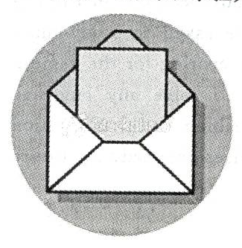
On my first job, I worked as a sports editor for a small newspaper. I never got a letter from my readers, so I was 16 that there was an envelope on my desk one morning. From the 17 , I could see it was from a most popular newspaper.
When I opened it, I found a note and it read, “You did a good job. Go on!”
The note was 18 by Mr John, a famous sports editor. As I was a green hand (新手), his words made me 19 . After that, I kept the note in my desk drawer. Whenever I doubted 20 I had the ability to be a good editor, I would read John’s note and become 21 again.
Later, when I made friends with Mr John, the note writer, I learned that he often wrote notes to 22 young people in many fields. “When I make 23 feel happy,” he told me, “I feel happy, too.”
24 , why are there few note writers like John in our life? In my 25 , many people are afraid that they cannot be well understood. Also, writing takes more time and it is 26 to pick up the phone. The problem with phone calls is that they cannot 27 a long time, but a note is a good way of record and our words can be read 28 .
So, when you find some people around you need 29 , please write a note of encouragement to bring them more confidence. Maybe, you are not sure what will 30 , but remember Mr John’s words—making others feel happy makes you happy, too.
16.A. certain B. sure C. surprised D. frightened
17.A. calendar B. envelope C. book D. photo
18.A. signed B. picked C. copied D. practised
19.A. unhappy B. sleepy C. excited D. sad
20.A.why B. that C. what D. whether
21.A. serious B. confident C. strict D. humorous
22.A. expect B. describe C. introduce D. encourage
23.A. other B. the other C. others D. the others
24.A. But B. However C. Therefore D. Actually
25.A. opinion B. advice C. idea D. decision
26.A. stronger B. weaker C. harder D. easier
27.A. wait B. last C. stop D. rest
28.A. once B. only once C. more than once D. less than once
29.A. thanks B. truth C. trouble D. help
30.A. happen B. matter C. turn D. hold
【答案】16-20 C B A C D 21-25 B D C B A 26-30 C B C D A
三、 阅读理解（共15小题；A、B两篇每小题2分，C篇每小题1分，满分25分）
阅读下文，从所给的四个选项中选出一个最佳答案。
A【2012江苏淮安】 （216）
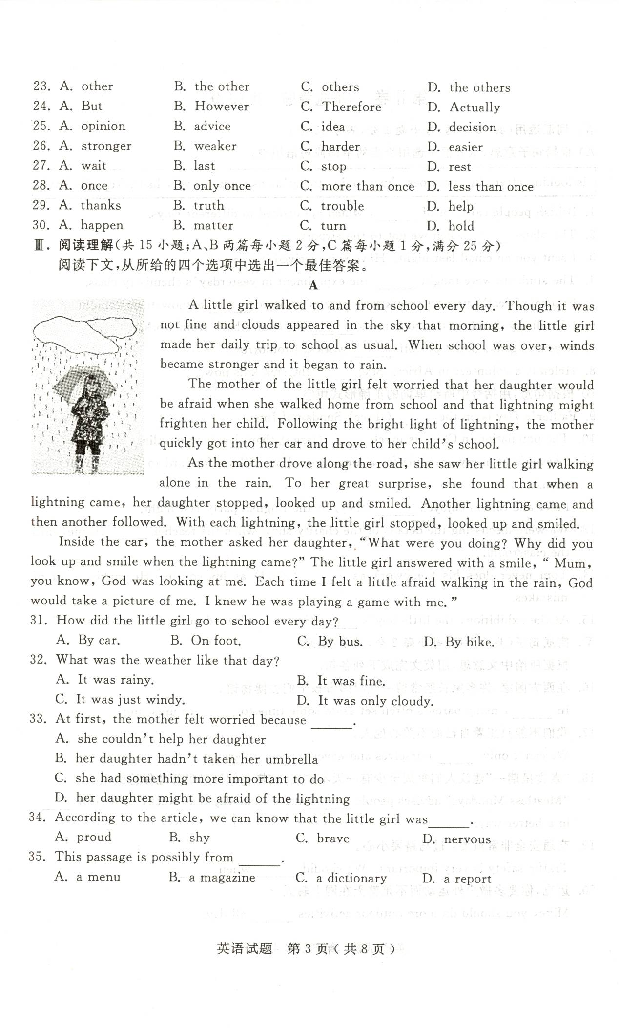
A little girl walked to and from school every day. Though it was not fine and clouds speared in the sky that morning, the little girl made her daily trip to school as usual. When school was over, winds became stronger and it began to rain.
The mother of the little girl felt worried that her daughter would be afraid when she walked home from school and that lightning might frighten her child. Following the bright light of lightning, the mother quickly got into her car and drove to her child’s school.
As the mother drove along the road, she saw her little girl walking alone in the rain. To her great surprise, she found that when a lightning came, her daughter stopped, looked up and smiled. Another lightning came and then another followed. With each lightning, the little girl stopped, looked up and smiled.
Inside the car, the mother asked her daughter, “What were you doing? Why did you look up and smile when the lightning came?” the little girl answered with a smile, “Mum, you know, God was looking at me. Each time I felt a little afraid walking in the rain, god would take a picture of me. I knew he was playing a game with me.”
31. How did the little girl go to school every day?
A. By car. B. On foot. C. By bus. D. By bike.
32. What was the weather like that day?
A. It was rainy. B. It was fine. C. It was just windy. D. It was only cloudy.
33. At first, the mother felt worried because .
A. she couldn’t help her daughter B. her daughter hadn’t taken her umbrella
C. she had something more important to do D. her daughter might be afraid of the lightning
34.According to the article, we can know that the little girl was .
A. proud B. shy C. brave D. nervous
35. This passage is possibly from .
A. a menu B. a magazine C. a dictionary D. a report
【答案】31-35 B D D C B
B【2012江苏淮安】
The spring festival is celebrated not only in China but also in other parts of the world. The traditional holiday is the most important to Chinese both home and abroad.
United Kingdom
Celebrations for Spring Festival in the UK started in 1980, with the first evening party held in 2002. Every new year, people get together and have a lot of activities. They sing songs, dance to music, share photos with friends or enjoy films in a cinema.
United States
Spring Festival has become a key time for Chinese living or working in the US. They join in a large evening party to welcome the traditional new year. It is a good chance for people to build a circle of friends and feel that they are not alone because they share the same culture and values.
Australia
The Chinese new year will be welcomed with three weeks of celebrations across Australia. Many people come to Sydney’s Chinatown or Little Bourke in Melbourne. They enjoy fireworks, lion dances, dragon boat races and many other traditional activities. The celebrations are also a bridge towards better understanding between Chinese and non-Chinese.
Singapore
The family dinner on new year’s eve is an important tradition for Chinese whether they were born in Singapore or moved there from China. They place traditional food on a table as an act of remembering their past. Then the whole family enjoy their dinner together. They usually hold it at home because having it in a restaurant takes away the meaning of the tradition.
36. Celebrations for Spring Festival in the UK started in .
A. 1890 B. 1980 C. 2000 D. 2002
37. At Spring Festival, American Chinese join in a large evening party to .
A. say hello to the new year B. refuse a good chance
C. tell others they are alone D. share different cultures
38. Chinese in Australia enjoy the following activities except .
A. fireworks B. lion dances C. bridges D. dragon boat races
39. In Singapore, Chinese families don’t hold the new year dinner at a restaurant but at home because .
A. they were born in Singapore B. they moved there from other places
C. the restaurant is far away D. dragon boat races
40. After reading the passage above, we might say .
A. all parts of the world celebrate Spring Festival
B. the Chinese new year is celebrated only in china
C. celebrations for Spring Festival are just held in four foreign countries
D. Chinese across the world have a strong feeling towards Spring Festival
【答案】36-40 B A C D D
C【2012江苏淮安】
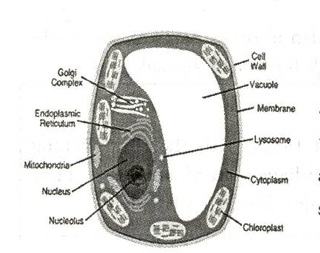
It may seem easy to say that plants and animals are different. Any child can tell the difference between a tree and a dog. But those differences are far deeper then just what they look like. The cells (细胞) that plants are made up of are different. In other words, the cell wall of plants has something special.
First of all, it’s important to find that not all plant cells have a cell wall. Besides, there are many differences of a cell wall based on the kinds of plant. The following is meant to be what a plant cell wall is like.
The cell wall of a plant is on the our side of the cell membrane (膜). It is usually hard and cannot be bent easily, but the degree of flexibility (韧性) of the cell wall is different. It is based on the special use that the cell has in keeping the plant alive. Cells that make up the trunk of a tree are clearly less flexible than cells on a leaf.
Cell walls act in many ways. They serve to protect the plant. They provide support, as well as help in the movement of chemicals and wastes into and out of the cell. More importantly, they control the water that goes in and our. Plants must have good water controlling systems (系统), allowing them to keep water during dry seasons, and get rid of unnecessary water. Plants can’t walk around to find water, so being able to control water is very important.
So there you have it — what a plant cell wall is. Of course, there are many other things that are not talked about here. Knowing more about plant cell walls requires further study and research.
41. The best title of the passage can be .
A. Different Plants B. Different Animals
C. The Plant Cell Wall D. The Uses of Cells
42. From the first two paragraphs we can find that .
A. all plants have a cell wall
B. plant cells and animal cells are the same
C. different kinds of plant have different cell walls
D. there are no differences between the cells of a tree and a dog
43. The underlined word “bent” in the passage is the closest in meaning to .
A. shape-changed B. water-kept C. sun-burnt D. skin- broken
44. Cells in the trunk of a tree are those on a leaf.
A. as flexible as B. not so flexible as
C. more important than D. less important than
45. What is the most important use of a plant cell wall?
A. to protect the plant. B. To provide support.
C. To move chemicals and wastes. D. To control the water.
【答案】41-45 C C D B D
第II卷（非选择题 共65分）

四、词汇运用（共15小题；每小题1分，满分 15分）
A) 【2012江苏淮安】根据句子意思，从方框中选用恰当的单词或短语填空。
is looking after, be, potatoes, how to do, today’s , as soon as, yet, had taken off, have
1. British people eat a lot of , which are cooked in different ways.
2. Te plane when we got to the airport.
3. I sent you an email last night. Have you received it ?
4. The students were taught the experiment in yesterday’s chemistry class.
5. From the weather report, we know there is going to a snowstorm tonight.
6. I’ll tell my daughter the good news she comes back from work.
7. Boys and girls, don’t put off work till tomorrow.
8. Helen is a volunteer in Africa. She the sick kids now.
【答案】1. potatoes, 2. had taken off 3. yet 4. how to do 5. be 6. as soon as 7. today’s 8. is looking afterB) 【2012江苏淮安】根据句意，用括号中所给单词的正确形式填空。
9. Father’s Day is on the (three) Sunday of June.
10. The population in China is much (large) than that in Australia.
11. I haven’t seen my grandma for a long time. I’m looking forward to (visit) her soon.
12. Peter and Simon enjoyed (they) at the English party last night.
13. We were discussing the details of the charity show when the teacher (come) into the classroom.
14. Tome never does his homework as (good) as his cousin. He makes a lot of mistakes.
15. At the exhibition, the little boy’s (invent) attracted many IT engineers.
【答案】9. third 10. larger 11. visiting 12. themselves 13. came 14. well 15. invention
五、完成句子（共5小题，每小题2分，满分10分）
【2012江苏淮安】根据所给中文意思，用英文完成下列各句。
16.在西方国家，许多家长经常留一些时间带孩子们去博物馆。
In , many parents often set aside some time to to museums.
17. 我们不能只想着自己而不关心他人。
We can’t only ourselves and never others.
18.“素食星期一”建议人们每周至少有一天不吃肉，这样我们可以更好地保持健康。
“Meatless Mondays ” advises people at least one day each week, so we can in a better way.
19.交通安全非常重要，过马路要小心。
Traffic safety is very important. We should when .
20.迈克，你要多做户外运动而不是整天在网上聊天。
Mike, you should do more outdoor activities all day.
【答案】16. western countries, take their children
17. think of, care about
18. don’t eat meat, keep healthy
19. be careful, we walk cross it
20. instead of chatting online
六、任务型阅读（共10小题，每小题2分，满分20分）
阅读下面短文，根据要求完成下列各题。

A【2012江苏淮安】 （ 233）
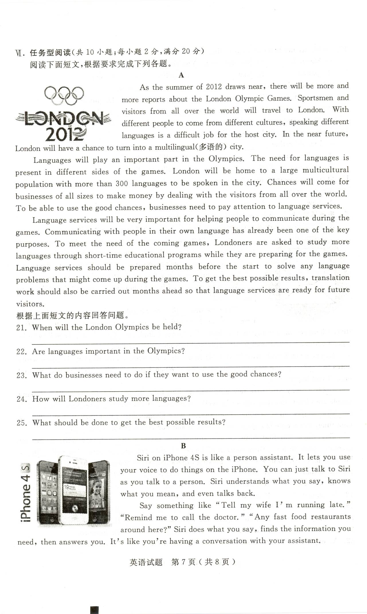
As the summer of 2012 draws near, there will be more and more reports about the London Olympic Games. Sportsmen and visitors from all over the world will travel to London. With different people to come from different cultures, speaking different languages is a difficult job for the host city. In the near future, London will have a chance to turn into a multilingual (多语的) city.
Languages will play an important part in the Olympics. The need for languages is population with more than 300 languages to be spoken in the city. Chances will come for businesses of all sizes to make money by dealing with the visitors form all over the world. To be able to use the good chances, businesses need to pay attention to language services.
Language services will be very important for helping people to communicate during the games. Communicating with people in their own language has already been one of the key purposes. To meet the need of the coming games, Londoners are asked to study more languages through short-time educational programs while they are preparing for the games. Language services should be prepared months before the start to solve any language problems that might come up during the games. To get the best possible results, translation work should also be carried out moths ahead so that language services are ready for future visitors.
根据上面短文的内容回答问题。
21.when will the London Olympics be held?

22. Are languages important in the Olympics?

23. What do businesses need to do if they want to use the good chances?

24. How will Londoners study more languages?

25. what should be done to get the best possible results?

【答案】21. In the summer of 2012
22. Yes, they are.
23. Pay attention to language services
24. through short-time educational programs
25. translation work should be carried out months ahead
B【2012江苏淮安】 285
Siri on iphone 4S is like a person assistant. It lets you use your voice to do things on the iphone. You can just talk to siri as you talk to a person. Siri understands what you say, knows what you mean, and even talks back.
Say something like “Tell my wife I’m running late.” “Remind me to call the doctor.” “Any fast food restaurants around here?” Siri does what you say, finds the information you need, then answers you. It’s like you’re having a conversation with your assistant.
Siri not only understands what you say, but it’s also smart enough to know what you mean, So when you ask, “Any fast food restaurants around here?” Siri will reply, “I found a number of restaurants near you.” Then you can say, “Hmm. How about hamburgers?” Siri remembers that you just asked about restaurants for something to eat, so it will look for KFC restaurants in the neighborhood. And Siri is active, so it will question you until it finds what you’re looking for.
When you want to do something, just ask Siri to help you do it. Siri uses almost all the built-in a p p s on iphone 4S. It plays the songs you want to hear. It gives you directions and shows you around. It makes calls, plans meetings, helps you remember and wakes you up. In fact, ask Siri what it can do — it even speaks for itself.
Siri is easy to use and does so much. You’ll keep finding more and more ways to use it.
根据上面短文内容填空。
26.Siri is like and lets you to do things on the iphone.
27. When you like “Tell my wife I’m running late.”, Siri will for you.
28. Siri is to know what you mean and it will until you get what you want.
29. If you are lost somewhere, you can say to siri, “ ”. Then Siri will and show you around.
30. The word “a p p s”in the passage are possibly on iphone 4S.
【答案】26. a person assistant, use your voice
27. say something, finds the information
28. smart enough, question you
29. where am I in? , give you directions
30. programs
七、书面表达（满分20分）
【2012江苏淮安】2012年4月23日，我市“周恩来读书节”开幕了。我们班将组织“与好书为友，以读书为乐”的主题活动。请根据以下提示，用英语写一段话，词数在80～100之间，内容必须包括表格中提示的要点：
读书意义 | 活动计划 | 个人愿意或感受
了解世界 | 找些好书 | ……
带来快乐 | 用好时间 | ……
培养习惯 | 做好笔记 | ……

注意：1.文中不得出现真实的人名、校名和地名；
2.文章的开头已给出，不计入总词数。

参考词汇：develop培养

On April 23, 2012, Zhou Enlai Reading Festival in our city opened. Our class will organize a reading activity — Be Friends with Good Books and Take Delight in Reading.
I think

【答案】

